Name: __________________________________ APES
Quiz
(14pts)
Completeness
(10pts)
GRADE:
Mr. Crisci
Lab: WATER QUALITY AND LAKE ZONES Date: _________

PART 1: Dissolved Oxygen Test
Dissolved oxygen is the form of oxygen in water that is freely available to aquatic plants and animals. Dissolved oxygen is vital to fish and other aquatic life and for the prevention of odors. Oxygen is transferred from the atmosphere into surface waters, as well as being produced by aquatic plants, algae and phytoplankton as a by-product of photosynthesis. Once dissolved in water, oxygen diffuses throughout a water body very slowly since distribution depends on the movement of aerated water by turbulence and currents, water flow and thermal upwelling.

Dissolved oxygen is one of the best indicators of the health of a water ecosystem. Dissolved oxygen can range from 0-18 parts per million (ppm), but most natural water systems require 5-6 parts per million to support a diverse population. When organic matter such as animal waste or improperly treated wastewater enters a body of water, algae growth increases and the dissolved oxygen levels decrease as the plant material dies off and is decomposed through the action of the aerobic bacteria. Decreases in the dissolved oxygen levels can cause changes in the types and numbers of aquatic macroinvertebrates which live in a water ecosystem.
Follow the procedures carefully for the D.O. test. Be careful you are using harmful chemicals. Wear you goggles
Record your D.O. in the box provided:

5–6 ppm Sufficient for most species
< 3 ppm Stressful to most aquatic species
< 2 ppm Fatal to most species

- By looking at the lake would you consider it oligotrophic/mesotrophic/ or eutrophic? _________________________
Explain why you chose the one you did:

- If you were to graph B.O.D. versus D.O. how would they relate to each other?

- Is having a high D.O. or a low D.O. better for the organisms in the pond? _______ Explain:

- How does air bubbles mistakenly trapped in your sample affect D.O. results?

- Explain the significance of “fixing a sample” out in the field:

PART 2: Lake Zones
In the space provided draw the different zones of the pond. Make sure you include these zones: Littoral zone, Limnetic Zone, Photic Zone, Profundal (Aphotic) Zone, and Benthic zone. ALSO draw in or describe the organism you may have found and/or observed in each zone.

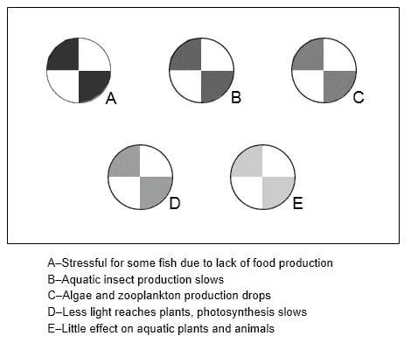
Part 3: Turbidity Test
Record results in the space below
___________________________
___________________________
___________________________
___________________________
___________________________
___________________________
___________________________
___________________________
___________________________
___________________________
___________________________
___________________________

Part 4: Nitrate Level and pH Level TEST Nitrate pH
Indication of nutrient level in the lake
and acidity of lake
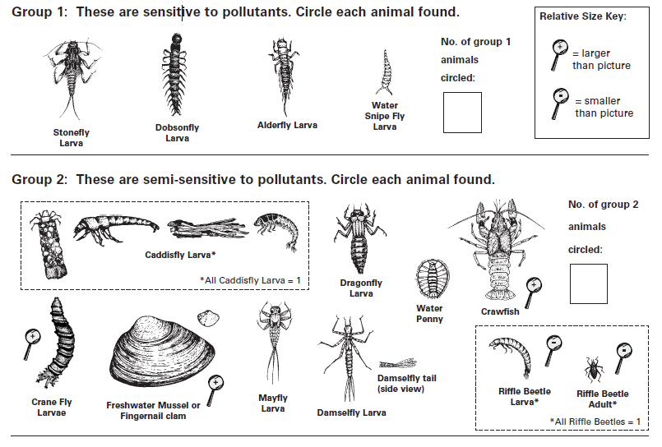
PART 5: Macroinvertebrates and Water Quality
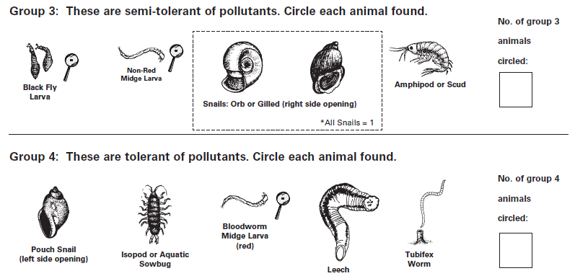

At this point, you should have collected a wide variety of aquatic macroinvertebrates from your three sites.

You will now categorize your sample, using the Key to Macroinvertebrate Life in the River to help you identify the macroinvertebrates found. The number of animals found is not important; rather, the variety of types of macroinvertebrates and their tolerance to pollution tells us the biotic index score. Before you begin, check off the habitats from which you collected your sample

- You should have removed large debris (e.g. leaves, rocks, sticks) from your sample and placed this material in a separate basin (after removing macroinvertebrates from it).

- Check the basin with the debris to see if any aquatic macroinvertebrates crawled out. Add these animals to your prepared sample.

- Fill the ice cube tray half-full with water.

- Using plastic spoons or tweezers, (be careful not to kill the critters – ideally, you want to put them back in their habitat after you’re finished) sort out the macroinvertebrates and place ones that look alike together in their own ice cube tray compartments. Sorting and placing similar looking macroinvertebrates together will help insure that you find all varieties of species in the sample.

- Refer to the Key to Macroinvertebrate Life in the River and the Citizen Monitoring Biotic Index to identify the aquatic macroinvertebrates:

  - On the back of this page, circle the animals on the index that match those found in your sample.
  - Count the number of types of animals that are circled in each group and write that number in the box provided. Do not count individual animals in your sample. Only count the number of types of animals circled in each group.
  - Enter each boxed number in work area below.
  - Multiply the entered number from each group by the group value.
  - Do this for all groups.
  - Total the number of animals circled.
  - Total the calculated values for all groups.
  - Divide the total values by the total number of types of animals that were found: TOTAL VALUES (b.) / TOTAL ANIMALS (a).
  - Record this number.
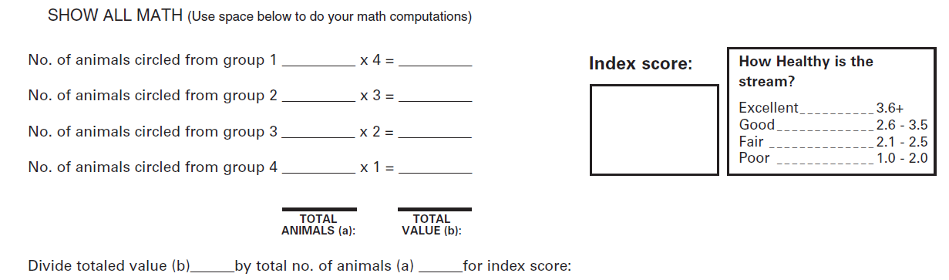

- Does your D.O. level match up with the index score you calculated? ______________ Explain why or why not:

