Unit 8 Hydrosphere Under
Attack!

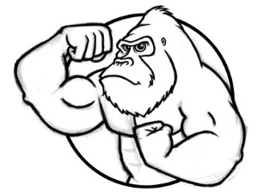
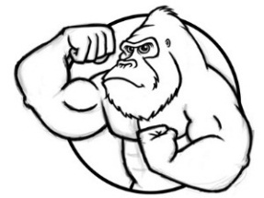

Water is one of the most abundant resources on Earth, but almost half the people on the planet lack access to clean water. Can you imagine life without an endless supply of clean drinking water? Have you ever lived – or even traveled – where you had to boil the water before you drank it? Or lived with water rationing where you were limited to 3 minute showers twice a week? It is just ugly. There are careers in water treatment, monitoring, measuring, trading, and engineering. Cleaner and faster water treatment plants need to be created and built. Innovation in home water treatment needs to be designed and marketed. YOU could become inspired to turn one of these environmental issues into a career, helping to save the planet and at the same time, making yourself a nice income!

Flooding (Video 8.1 Hydroeletric Power due ____________) (pages 299-305 in Textbook)
- Why do People Live on Floodplains? / soil is fertile (farming), it is flat and easy to build on, close to transportation. (most major cities are by water)
- How do Levees Make Flooding Worse? / generally built by the U.S. Army Corps of Engineers, instead of water overflowing natural levee heights and discharging some of the water, water is pushed downstream, they don’t go on forever, or can break (like during Hurricane Katrina) making the flooding much worse
- How does Urbanization (Increase in Pavement) Affect Water Quality? / increases flooding (runoff), increases amount of sediment (turbidity), less groundwater recharge (less water going back into the ground)
- How Can Homeowners Control Flooding? / install rain barrels, build a rain gardens to absorb excess water, install permeable pavement or remove some pavement and plant
- Dam Pros / creates a body of water for year round supply of water (irrigation), makes electricity, recreation (like boating/fishing), and controls flooding DOWNSTREAM from dam only, NOT upstream
- Dam Cons / threatens wetlands b/c no fertile soil or freshwater downstream, no way for the mud/fertile silt to get through - dam fills up with sediment and must be periodically dredged, more evaporation - increase in surface area of reservoir, expensive to build a dam, block salmon swimming upstream to spawning sites, people must be relocated due to flooding of reservoir
- Aswan High Dam, Egypt / built by Russia in 1960, the silt that made the Nile region fertile fills the reservoir. Losing 1/3 of the water due to evaporation, no more flooding because of dam - now farmers must pay for fertilizers to grow crops instead of it naturally happening
- Three Gorges Dam, China / world’s largest dam on Yangtze River drowns ecosystems, cities, archeological sites, fragment habitats, and displaced 1.5 million people

Drought and Conservation (Video 8.2 Water Use and Conservation due _______) (pages 308-316)
- Drought is a Major Problem because / 40% of the world lives in arid or semi-arid areas that is around (2.5 billion people) which has led and will lead to more war disputes/drought refugees (Middle East-Syria)
- Desertification / is the development of a desert where there was not one before. Erosion from native plant loss (grazing) contributes to this by washing away of precious topsoil therefore inhibiting plant growth
- Aral Sea in Uzbekistan/Kazakhstan (former Soviet Union) / large inland sea is drying up because water diversion for cotton farms created a tipping point. The sea starting drying up, killing vegetation, then the winds blew harder b/c no break to slow it, which evaporated the sea more, creating positive feedback loop
- Owens/Mono Lake in Northern California / water diversion projects for Los Angeles, removing freshwater from the lake, losing lots volume, doubling its salinity destroying the biodiversity
- Salt Water Intrusion / near the coast, over-pumping of groundwater causes saltwater to move into the aquifer (happens on Long Island)
- Subsidence / an area where the ground has given way with little warning caused by depletion of water from an aquifer, may cause structural damage to building (can also be caused by subsurface mining)
- Worldwide water is used for / irrigation 70%, industrial 20%, and public use (municipal) 10%; No you don’t need to memorize the percentages just know order
- Furrow or Gravity Flow Irrigation / LEAST (50 – 60%) efficient, rows dug by farmers are flooded in the field, very wasteful, most of world uses this
- Wheel Line or Center Pivot Irrigation / 70 – 80% efficient, shoots water into the air increasing evaporation, also wasteful
- Drip Irrigation Systems / MOST (90 – 95%) efficient, delivering slow and steady drips of water near the plants roots eliminating evaporation loss
- Ways to Conserve Water Around Your House / install low flow or dual flush toilets, repair leaks, low flow fixtures, plant drought tolerant landscaping, water your lawn at 3 or 4 am to reduce evaporation loss, use gray water, rain barrels….(IF ITS YELLOW LET IT MELLOW, IF ITS BROWN FLUSH IT DOWN!)
- Gray Water / wastewater from sinks, showers, and laundry, EXCEPT TOILIET WATER which can be treated and reused for landscape water
- Xeriscaping / landscaping using native and drought tolerant plants, which minimize the need for additional water instead of a high water demanding grass lawn

Water Pollution and Drinking Water (Video 8.3 Water Pollution due _________) (pages 481-486, 491-508)
- Point Source / source from specific location such as pipe, smokestack, or a place like a landfill or factory
- Non-Point Source / spread over an area such as agricultural/feedlot runoff, urban runoff, golf courses, and traffic runoff
  - estimated 64% of all water pollution in US; storm water causes 33% of contaminates
- The Cuyahoga River / in 1969 a river in Ohio that was so polluted with industrial compounds it caught on fire, led to environmental regulation
- Clean Water Act (C.W.A. 1972) / 1. Set maximum permissible amounts of water pollutants that can be discharged into waterways; 2. Attain water quality levels making surface waters swimmable and fishable
- Exxon Valdez Oil Spill / March 24, 1989 tanker hits submerged rocks in Prince William Sound killing many animals and the majority of plankton for 1,000 miles Second Worst Oil Spill in US waters
- Deep Water Horizon Oil Spill / massive release of oil in the Gulf of Mexico due to BP’s drilling rig exploding; biggest oil spill & one of the worst environmental disasters in U.S. Loss of fishing/shrimping
- Containment and Remediation (cleanup) of Oil Spills / contaminated organisms cleaned by hand. Surface contamination: containment booms which facilitate vacuuming or absorbent booms; also use dispersants (can be even more toxic than the oil) Bioremediation using genetically engineered bacteria to consume the oil. Coastlines: use high pressure hot water
- Oil /
  - Source: oil spills only about 20% most comes from leaking motors from cars and boats
  - Effects: coats animals like birds and otters makes mobility and keeping warm more difficult, destroys wetland habitat. Economically decreases tourism and fishing industry
- Turbidity / the amount of sediment suspended in water
- Source: mining, construction, overgrazing, forest fires, and clear cutting
- Effects: fish can’t breathe it clogs their gills, light can’t reach plants, bottom feeders get buried
- Fecal coliform / indicator of sewage contamination a.k.a. black water
- Source: human or animal feces in the water from runoff from farms or when it rains a lot sewage treatment plants cannot handle the load and must discharge untreated water
- Effects: get sick/infected by pathogens like E. Coli, Hepatitis A, Cholera, Dysentery, and Typhus
- B.O.D. (Biological Oxygen Demand) / amount of dissolved oxygen needed by aerobic decomposers to break down organic materials (see attached diagram)
- Measure the amount of sewage in water by measuring B.O.D.
- Oxygen Sag Curve / represents the effect that these oxygen demanding wastes like sewage, have a on a body of water (see attached diagram)
- What are the 5 zones of an oxygen sag curve? / Clean zone (trout, bass, mayflies, and stoneflies), Decomposition zone (carp and gar), Septic zone (No fish present, leeches), Recovery zone (carp and gar), Clear zone (trout, bass, mayflies, and stoneflies) (see attached diagram)
- Cultural Eutrophication / rapid algal growth (algal bloom) caused by an excess of nitrogen and phosphorous
- Sources: fertilizers (N & P), house products like detergent or dishwasher soap, and sewage
- Effects: Algae grows rapidly → Algae dies → Aerobic (with oxygen) Decomposition → Low dissolved oxygen (D.O.) → Fish die (positive feedback loop as more die more hypoxic)
- Hypoxic Dead Zone / area in a body of water with extremely low oxygen levels and little life due to cultural eutrophication & harmful algal blooms (red or brown tides) Ex. Mouth of Mississippi, Great Lakes
- Chesapeake Bay Case Study / encompasses a large geographic area receiving inputs from a variety of urban, suburban, and agricultural areas leading to dead zones, decline in blue crabs, and the feminization of bass. Recent efforts to improve water quality and restore the ecosystem by reseeding the bay with filter feeders like oysters which naturally filter the water
- Organic Compounds / man made (synthetic) chemicals, contain carbon (hydrocarbons) which persist in the environment because nothing in nature breaks them down
- Examples: PCBs (Poly Chlorinated Biphenyl = Hudson River), Benzene (in gasoline), TCE (Trichloroethyene come from dry cleaners) and Atrazine (herbicide can runoff; endocrine disruptor)
- Effects: linked to cancers and reproductive/endocrine issues (Atrazine)
- Lead (Heavy Metal) / Source: was used in gasoline and paint, older plumbing corrodes used lead pipes and lead in solder
- Effects: can delay physical & mental development in kids, and can cause kidney problems & high blood pressure; No safe level in water
- Mercury (Heavy Metal) / Source: enter water from natural deposits, burning of coal-factory exhaust, runoff from landfills & agricultural lands, used in some batteries, fluorescent bulbs, smoke detectors…
- Effects: kidney damage, birth defects, neurological issues (The Mad Hatter)
- Minamata, Japan / mental impairments, birth defects, and deaths caused by mercury being dumped in the Minamata Bay by the Chisso Corporation. Mercury entered humans through their diet (fish). Noticed in the 1950’s dumping went on from 1932-1968
- Thermal Pollution / Source: the cooling process involved in electricity production often by nuclear powerplants
- Effects: higher temps create thermal shock, fish don’t migrate, warm water contain less oxygen

Improving Water Quality (Video 8.4 Water Treatment due ____________) (pages 306-307, 487-490)
- Primary Sewage Treatment / first step of sewage treatment; eliminates most particulate material from raw sewage using grates, screens, and gravity (settling). The resulting solid waste (use your imagination) are removed and disposed of in a landfill
- Secondary Sewage Treatment / is a biological process; bacteria breakdown organic waste; adding oxygen accelerates the process. The water is then disinfected using three methods chlorine, ozone, or UV light
  - Chlorination / Good: disinfection of water; Bad: forms trihalomethanes (this group of compounds are byproducts of chlorination and are known carcinogens)
- Tertiary Sewage Treatment / is a physical and/or chemical process used to remove inorganic nutrients such as nitrogen or phosphorus to help prevent cultural eutrophication; most sewage treatment plants do not have this final stage
- Desalinization / the removal of salt from seawater either by distillation (evaporation then condensing the vapor) or reverse osmosis, both require lots of energy and create a salty brine. Mostly done in the Middle East (used on cruise ships to make freshwater)
- Safe Drinking Water Act (SDWA, 1974) / set maximum contaminant levels (MCLs) for pollutants in drinking; protects the quality of bodies of water, above or below ground, that are used for drinking water

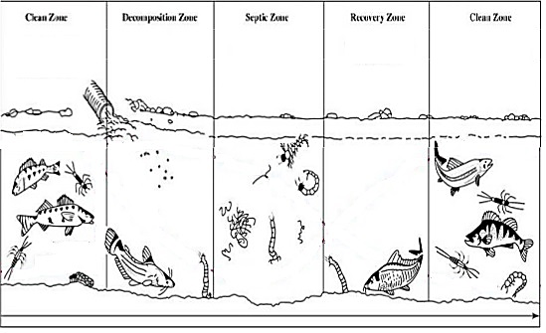

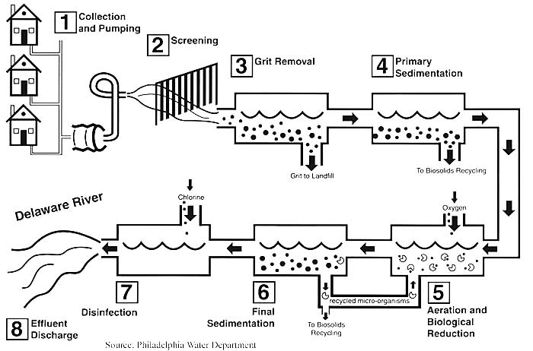

Pollutant | Source | Effects
Turbidity
Fecal Coliform
Phosphates/Nitrates
PCB’s
(Poly Chlorinated Biphenyl)
Atrazine
Heavy Metals
(Lead/Mercury)
Thermal
Oil

Draw the steps in eutrophication:

Draw the steps in a sewage treatment process:

EXTRA SPACE FOR NOTES:

__________________________________________________________________________________________________________________________________________________________________________________________________________________________________________________________________________________________________________________________________________________________________________________________________________________________________________________________________________________________________________________________________________________________________________________________________________________________________________________________________________________________________________________________________________________________________________________________________________________________________________________________________________________________________________________________________________________________________________________________________________________________________________________________________________________________________________________________________________________________________________________________________________________________________________________________________________________________________________________________________________________________________________________________________________________________________________________________________________________________________________________________________________________________________________________________________________________________________________________________________________________________________________________________________________________________________________________________________________________________________________________________________________________________________________________________________________________________________________________________________________________________________________________________________________________________________________________________________________________________________________________________________________________________________________________________________________________________________________________________________________________________________________________________________________________________________________________________________________________________________________________________________________________________________________________________________________________________________________________________________________________________________________________________________________________________________________________________________________________________________________________________________________________________________________________________________________________________________________________________________________________________________________________________________________________________
______________________________________________________________________________________________________________________________________________________________________________________________________________________________________________________________________________________________________________________________________________________________________________________________________________________________________________________________________________________________________________________________________________________________________________________________________________________________________________________

