Unit 6 Human Health, Food, and Pesticides

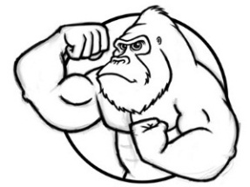
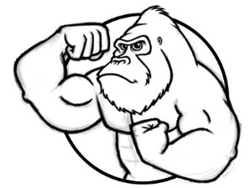

You are what you eat! By the end of this section on agriculture, you should know what monoculture agriculture is, how many people it feeds, and why it isn’t sustainable (i.e. which “rules of ecology” are being ignored). You should know the basics of sustainable agriculture and some suggestions for ensuring that all people have an adequate, safe, and healthy diet.

Human Health (Video 6.1 Human Health due ______________) (pages 589-620 chapter 17 in Textbook)
- Lethal Dose-50% (LD50) / the amount of a chemical that kills 50% of the organisms in test population
- Effective Dose-50% (ED50) / the dose that affects 50 % of the pop. (with a response other than death)
- Threshold Level / level below which there are no noticeable toxic effects observed (attached graph)
- Mutagen / causes changes to DNA that may result in hereditary changes; common mutagens include ethidium bromide, formaldehyde, dioxane, and nicotine
- Teratogen / causes fetus deformities (birth defects); common teratogens include ethanol, mercury compounds, lead compounds, phenol, carbon disulfide, toluene and xylene
- Carcinogen / substance that causes cancer; common carcinogens include benzene, vinyl chloride, formaldehyde, dioxane, and acrylamide (Everything does NOT cause CANCER!)
- Endocrine disruptor / chemicals which mimic human hormones such as estrogen, thereby interfering with their normal functions; common endocrine disruptors include: BPA, Phthalates, PBDE’s (flame retardants)
- Bioaccumulation / when a pesticide is not metabolized or excreted it gets stored in fat cells in a SINGLE organism.
- Biomagnification / organisms at higher levels of food webs tend to have greater concentrations of chemicals stored in their bodies because they must consume more to survive. (aka 10% rule) Ex. DDT caused problems in large predatory birds (Osprey) Think magnification = MULTIPLE organisms!
- Rachel Carson / wrote a book called Silent Spring detailing use of DDT and its effects on birds (eggs)
- Dioxin / one of the most toxic human-made chemicals. Mainly by-products of industrial processes including smelting, chlorine bleaching of paper pulp, and the manufacturing of some pesticides
- Polybrominated diphenyl ethers (PBDEs) / group of highly toxic chemicals that are persistent in the environment; flame-retardants that are used in many consumer products to make them difficult to burn like couches, mattresses, pillows, etc.
- BPA or Bisphenol A / is a chemical that has been used since the 1960s to make lightweight, hard plastics; used in canned food and drink packaging, water bottles, infant and baby bottles, reusable cups, receipts, etc.; Possible health effects of BPA on the brain, behavior and prostate gland of fetuses, infants and children
- Phthalates / are a group of chemicals used to soften and increase the flexibility of plastic and vinyl. Used in cosmetics and personal care products, like hair spray, soap, shampoo, nail polish, plastic and vinyl toys,; implicated as a cause of breast cancer, increased obesity, insulin disruption, testicular disease
- Synergism / when the sum of the effects is more than each chemical individually. This can create hazardous situations because each chemical might not be that dangerous but many combined in the body creates unknown risk (this is scary stuff!)
- Stockholm Convention on Persistent Organic Pollutants (POPs) / seeks to protect human health and the environment from the 12 most toxic chemicals on Earth: These 12 chemicals, commonly called the “dirty dozen,” are aldrin, chlordane, DDT, dieldrin, dioxins, endrin, furans, heptachlor, hexachlorobenzene, mirex, PCBs, and toxaphene

Modern Industrial Farming (Video 6.2 Agriculture and Pesticides due ______________) (pages 357-372)
- World’s Main Food Source / Wheat, rice, and corn provide more than ½ of the calories in the food consumed by the world’s people
- Slash-and-burn / agriculture method that involves burning a forest or field of vegetation and using the resulting ash as fertilizer—this is an ancient technique that pre-dates modern fertilizers. This is the method of the natives clearing the forests of the Amazon to farm and raise cattle.
- Green Revolution / began in the 1940’s, greater increase in food production due to genetically altered crops, improved synthetic fertilizers, man-made pesticides and using fossil fuels to power machines
- Monoculture / farm focuses on just one organism; all resources are focused on producing it efficiently, highly susceptible to disease/pests, needs high amounts of synthetic fertilizers and pesticides
- Advantages of CAFO (Concentrated Animal Feeding Operations) / a large percentage of meat is produced on factory farms, maximizing profit by increasing the yield and decreasing cost by cramming animals into small spaces. This provides humanity with high quality protein at reasonable prices for millions
- Disadvantages of Factory Farming (CAFO) /
  - Contamination of groundwater due to the high volume of animal waste from runoff. This contributes to cultural eutrophication when the runoff enters lakes and streams
  - Using antibiotics and hormones poses unknown risk to human health
  - Poor/unethical treatment of animals
  - Takes a tremendous amount of energy to produce a small amount of meat (Beef is the most energy intensive) which is a major contributor to climate change
- Genetically Modified Organisms (GMO’s) / involves taking a few beneficial genes from an organism and inserting into the genome of the crop species. These beneficial genes include drought resistance, pesticide resistance, need for less fertilizer, or even more nutritional value. Corn is GMO
- Problems with GMO’s / create new food allergens, lead to the new plant toxins, lower biodiversity, and could be unethical (birds with no feathers or more legs)

Pesticides (Video 6.2 Agriculture and Pesticides due ______________) (pages 368 – 369 in Textbook)
- Pest / any species that competes with humans for food, invades lawns and gardens, destroys wood in houses, spreads disease or is simply a nuisance
- First Generation Pesticides / made from natural substances
  - Examples are sulfur, arsenic, lead, mercury
  - Abandoned due to human poisoning
  - Also botanically derived pesticides like nicotine sulfate from tobacco leaves
- Borneo Story / a man-made solution to a problem has unexpected consequences like spraying a pesticide to kill mosquitoes (all things are interconnected – butterfly effect)
- Chlorinated Hydrocarbons / second generation pesticide Examples are DDT, Aldrin, Methoxycholor
- Contain chlorine
- Broad Spectrum which kill many species
- Slow to degrade aka persistence (2 – 15 years)
- Biomagnifies and bioaccumulates; Suspected carcinogen & endocrine disruptor
- Organophosphates / second generation pesticide; examples are Malathion, Parathion, Diazonon
  - Contain phosphorus; derived from nerve gas (German research during WWII)
  - More poisonous than others, high level of toxicity to mammals
  - Degrades more easily because it is water soluble (several weeks)
- Neonicotinoids / relatively new class of pesticide similar in chemistry to nicotine
- Highly toxic to most insects by attacking their nervous system, but less toxic to birds and mammals
- Most widely used insecticide, persists for years (about 4)
- Linked to colony collapse disorder (CDC) which are killing pollinators. (Bees are dying!!!!)

- Roundup (Glyphosate) / is an extensively used herbicide made by the Monsanto Corporation
  - World Health Organization (WHO) listed it as “probably” causing cancer in humans
  - Similar in structure to a natural growth hormone (endocrine disruptor)
  - Broad spectrum; used to kill dandelions and many other “weeds”
  - 2,4-D & 2,4,5 aka Agent Orange was a used to defoliate leaves in the jungle
- Pesticide Pros / saves lives from insect-transmitted disease; increases food supply and lowers food costs therefore increasing profits for farmers; works faster than alternatives
- Pesticide Cons / genetic resistance, ecosystem imbalance, pesticide treadmill, persistence, bioaccumulation and biomagnification, can runoff, can kill unintended species
- Pesticide Resistance / when a pesticide is applied it kills most organism except for organisms that are naturally resistant to the chemical. These “pesticide resistant” organisms reproduce and overtime the entire population is now evolves a resistance the pesticide.
- Pesticide Treadmill / as the development of pesticide resistance increases the farmer requires increased applications, which then leads to more resistance! (like a drug addict needs more/stronger drugs to get same high)
- Circle of Poison /
  - US pesticide companies can make and export pesticides that have been banned or never approved in the US
  - Foreign farmers assume they are safe because the US is making them
  - Residues of these chemicals return to US consumers on imported produce (25% of all produce consumed in the US is produced overseas)
- Pesticides Effects on Humans /
  - Short Term Exposure
    - Farm workers poisoned
  - Long Term Exposure
    - Cancers, leukemia, birth defects
    - Disruption of human hormone systems (endocrine disruptor) ex. breast cancer, decrease in sperm counts

Sustainable Agriculture (Video 6.2 Agriculture and Pesticides due _________) (pages 376 – 380)
- Integrated Pest Management (IPM) / involves multiple strategies such as introduction of pest predators (lady bugs/praying mantis), pheromones traps, hormones to disrupt the pest’s life cycle, sterile males, and/or crop rotation to reduce the use of pesticides. GOAL: to learn more about pests, only use pesticides as a last resort and still making a profit
- IPM Examples / know a few examples for the test (this is what we use in our courtyard garden)
  - Agricultural Methods
    - Crop rotation or intercropping (monoculture invites pests)
    - Pick off insects or pick out weeds like dandelions (by hand or drill)
    - Adjust planting times (squash vine borer example)
    - Mosquitoes (drain standing water, wear long sleeves)
  - Natural Enemies / 129 beneficial insects are sold in the US
    - Parasitic wasps control the boll weevil
    - Lady bugs and praying mantis control aphids
  - Biological Agents
    - Milly spore fungus controls white grubs/Japanese beetles
    - Repellents: Fox/Coyote Urine or marigolds to keep pests like rabbit/deer away
    - Pheromones: chemical sex attractants to lure pests
  - Miscellaneous
    - Sterilize the males: fruit flies
    - Physical barriers like small fences, sticky materials or netting
    - Motion activated sprinklers
    - Diatomaceous earth: harm only insects with exoskeletons
    - Natural oil spray
- Pros and cons of becoming vegetarian or vegan /
Pros: Healthier for you, less cancers and heart disease, Animal rights/poor treatment, Feeds more people by eating lower on the food chain (10% rule), Reduces greenhouse gases (climate change) like methane from livestock and fossil fuel use (about 15% of all greenhouse gas emissions)
Cons: Could be protein deficient and must need to take B12 supplements due to scarcity in non-animal products
- Organic Food / food produced without antibiotics; growth hormones; and most (not all) conventional pesticides; petroleum - based fertilizers; bioengineering (GMO’s); or ionizing radiation

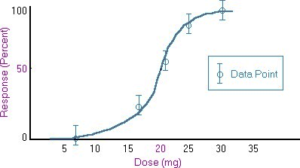

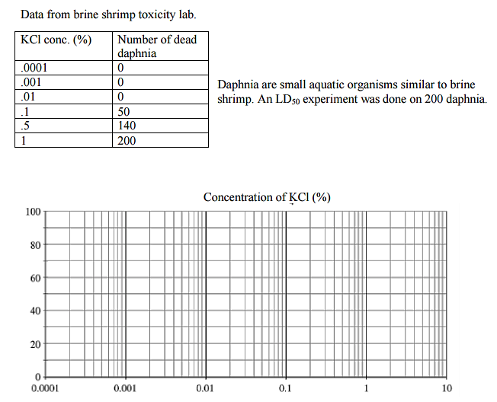

- Plot the results of the LD₅₀ test on the graph above and label the x and y axes.
- What is the threshold of the KCl for daphnia? _____________ Label this point on the graph.
- What is the LD₅₀ concentration of KCl for daphnia? _____________ Label this point on the graph.
- Cadmium nitrate is a while crystal chemical that is a known carcinogen that may affect kidneys and lungs. LD₅₀ testing has been done on rats. The LD₅₀ for rats was found to be 300mg/kg. Extend this result to humans. Assume an average mass of 70kg/person. Determine the potential LD₅₀ for humans for this chemical. Show your work and circle your answer.

- Uncle Wilbur dies and leaves you 10 Jersey Dairy Cows he had as pets, all young at about 2 years old. In his will it states that they cannot be sold or slaughtered, but can be milked.
EACH Cow:
Eats 40 lbs of hay/day
Produces 6 gallons of milk/day
- Calculate how much hay is needed per year to feed all of your cows? Show all work and include units throughout the problem.

- Along with the cows, Uncle Wilbur left you a farm and all of the farm equipment to grow your own hay. His former fields have been known to produce 10 tons/acre/year. Calculate how many acres of hay do you need to grow for your cows per year? (1 ton = 2,000 lbs) Show all work and include units throughout the problem.

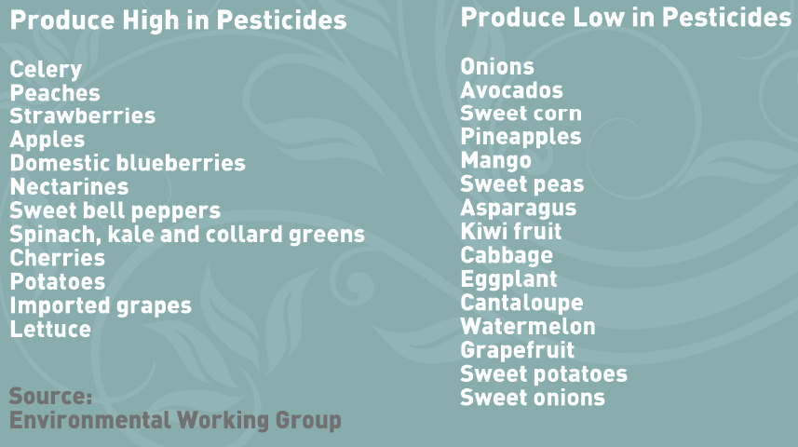
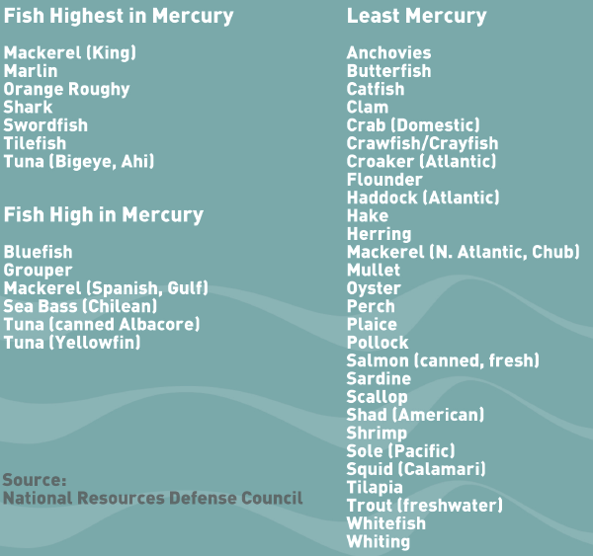

Pesticide | Examples | Target | Persistence | Issues
Chlorinated Hydrocarbons
Organophosphates
Neonicotinoids
Glyphosate

Extra Space for NOTES

______________________________________________________________________________________________________________________________________________________________________________________________________________________________________________________________________________________________________________________________________________________________________________________________________________________________________________________________________________________________________________________________________________________________________________________________________________________________________________________________________________________________________________________________________________________________________________________________________________________________________________________________________________________________________________________________________________________________________________________________________________________________________________________________________________________________________________________________________________________________________________________________________________________________________________________________________________________________________________________________________________________________________________________________________________________________________________________________________________________________________________________________________________________________________________________________________________________________________________________________________________________________________________________________________________________________________________________________________________________________________________________________________________________________________________________________________________________________________________________________________________________________________________________________________________________________________________________________________________________________________________________________________________________________________________________________________________________________________________________________________________________________________________________________________________________________________________________________________________________________________________________________________________________________________________________________________________________________________________________________________________________________________________________________________________________________________________________________________________________________________________________________________________________________________________________________________________________

