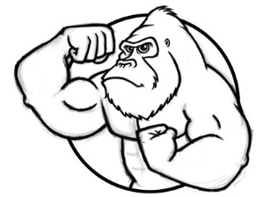
Unit 5 Natural and Human Populations

Know inside and out, forwards and backwards, the population verbal quizzes. By now, you should have a routine of studying every night for at least 15 minutes. You can decide now what grade you want for the quarter. That grade is based on your schedule of study. It’s called self-discipline and if you can master this skill, then you have a real chance of being successful.

Natural Populations (Video 5.1 Population Ecology due ______________) (pages 189-203 in Textbook)
- Order of Life for Smallest to Largest / Individual, Population, Community, Ecosystem
- Exponential growth / a population that does not have resource limitations; J-shaped curve (ex. 2,4,8,16)
- Logistic curve / a plot that shows how the initial exponential growth of a population is slowed and finally brought to a standstill by limiting factors; S-shaped curve (diagram 2)
- Carrying capacity (K) / the number of individuals of a given space that can be sustained indefinitely; determined by biotic potential and environmental resistance (diagram 2)
- Density-Dependent Limiting Factors / conditions that have a greater effect on the denser populations; an example is the transmission of infectious disease or food resources (higher density = spreads easily)
- Density-Independent Limiting Factors / affect all populations regardless of size or density; examples are natural disasters like flooding or hurricanes
- Random Dispersion / occurs when a population is spread through a habitat by chance alone; an example would be dandelions on a hillside
- Uniform Dispersion / is the result of intraspecific competition (same species competing) and leaves the population dispersed in an orderly fashion, an example is seabirds during breeding season (penguins)
- Clumped Dispersion / occurs when it is beneficial for the population to congregate together. This could be the result of isolated resources, like a watering hole in the dry season, or the safety of the species from predation
- Type I Survivorship Curve / younger organisms have high probability of survival and almost all individuals reach middle age, but after middle age there is an increasing probability of death ex. humans (K-strategists) (diagram 1)
- Type II Survivorship Curve / probability of death is equally likely in all age groups ex. song birds
- Type III Survivorship Curve / likelihood of death is very high at young ages, & most of individuals in pop die off quickly within 1st part of life. The few that survive to adulthood have high probability of surviving for some time ex. plants and insects (r-strategists) (diagram 1)
- r-strategist / reproductive strategy in which organisms reproduce early; bear many small; unprotected offspring which has small chance of surviving to maturity (ex. insects, most fish) (diagram 1)
- K-strategist / reproduce late in life; few offspring; care for offspring each of which has a relatively high probability of surviving to maturity (ex. elephants) (diagram 1)

Human Populations (Video 5.2 Human Pop. Impacts due ______________) (pages 225 – 248 in Textbook)
- What Does Anthropogenic Mean? / caused or produced by humans
- What is the Anthropocene? / human activities have altered to Earth so much that a new geologic epoch has been proposed, but has not been formally accepted yet
- Ecological Footprint / it is the amount of the environment necessary to produce the goods and services needed to support a particular lifestyle. US is highest – Africa is lowest
- Earth Overshoot Day / an annual changing date marking when humanity has exhausted natures budgeted of resources for that given year. Everything we use after that date is cutting into future generations. This year’s date was August 13th, last year it was August 19th
- The TWO factors that contributed to the exponential growth of humans / (diagram 3)
  - The Agricultural Revolution led to food surpluses for the first time in human history
  - The Industrial Revolution improved living conditions and modern medicines, leading to longer lifespans and decreased infant mortality

(Video 5.3 Human Population Size due ______________)
- World Population / 7.3 billion; U. S. Population: 322 million
- Top Four Most Populated Nations / 1) China 1.3 bil; 2) India 1.2 bil; 3) U.S.; and 4) Indonesia
- Most Important Factor Affecting Population Growth / low status/education of women
- Methods or Ways to Decrease Birth Rate / family planning, contraception, economic rewards and penalties (ex. one child policy in China, which changed in 2015)
- Malthus said / “human population cannot continue to increase exponentially; consequences will be war, famine and pestilence (disease).”

(Video 5.4 Human Population Dynamics due ______________)
- Growth Rate (r) using CBR and CDR / (r) = (CBR - CDR) / 10
- Rule of 70 / to find doubling time of population, equals 70 divided by the percent growth rate (r). For example, if a population is growing at 5% annually, it doubles in 14 years; 70/5 =14 years.
- Per Capita / average per person; statistic divided by the total population
- Immigration / the arrival of individuals from outside a population
- Emigration / the movement of individuals out of a given population
- Population Change / = (births + immigrations) – (deaths + emigration)
- Population Growth Rate / = (births + immigrations) – (deaths + emigration) / Population x 100
- Life Expectancy / the average number of years a newborn infant can expect to live
  - Life Expectancy: 75 years (developed countries); 64 years (developing countries)
  - Globally, life expectancy = 48 years (1955), 66 years (1998), 73 years (2025, projected)
  - Life expectancy in Africa is less 50 years
- Crude Birth Rate (CBR) / the number of live births per 1,000 people yearly in a population. Depends on education level and employment of women, cultural expectations, cost of raising a child and availability of birth control
- Crude Death Rate (CDR) / the number of deaths yearly per 1,000 people in a population. Depends on working conditions, medical care, good nutrition, access to clean water, and general living conditions
- Total Fertility Rate (TFR) / is an estimate of the average number of children a women will have during her childbearing years; useful for projection population change
  - Highest TFR / Africa at 5.3 children per woman
  - World TFR / is around 2.4 children per woman
- Replacement Level Fertility / the number of children a couple must have to replace themselves (averages 2.1 in developed nations, 2.7 in less developed nations
- Infant mortality rate / the number of babies out of every 1000 that die within their first year of life. Infant mortality is the single most important measure of a society's quality of life – because it reflects the general level of nutrition and health care
- Age Structure Diagrams / broad base, rapid growth (African nations); narrow base, negative growth (Japan and some eastern European nations) uniform shape, zero growth (United States) (diagrams 4)
- Pre-reproductive group / not yet mature enough to reproduce 0 -14 years old
- Reproductive group / capable of reproduction 15 - 44 years old
- Post reproductive / beyond their reproductive years. 44 plus years of age
- Demographic Transition Model / model shows how countries can transition from high birth/death rates to low ones through industrialization (diagram 5 KNOW THIS!)
- Pre-industrial / 1st stage in Demographic Transition Model (stable pop size)
  - Harsh living conditions, high infant mortality rates, high death rate; need a high birth rate. Population growth is small (or zero)
- Early developing (Transitional) / 2nd stage in Demographic Transition Model (pop grows rapidly)
  - Industrialization begins, rise in food production, improved health care, reduction in death rate, birth rate remains high. Population grows rapidly (2.5-3%/year)
- Late developing (Industrial) / 3rd stage in Demographic Transition Model
  - Industrialization is widespread. Birth rate drops and approaches the death rate. Better access to birth control, reduced infant mortality, increased job opportunities for women, high cost of raising children, HS and college educations. Population grows but at a slower rate.
- Developed (Post Industrial) / 4th stage in Demographic Transition Model (stable pop size)
- Birth rate declines further, equals death rate → Zero Population Growth. 37 countries (mostly western Europe, 12% of world's population) are in this stage
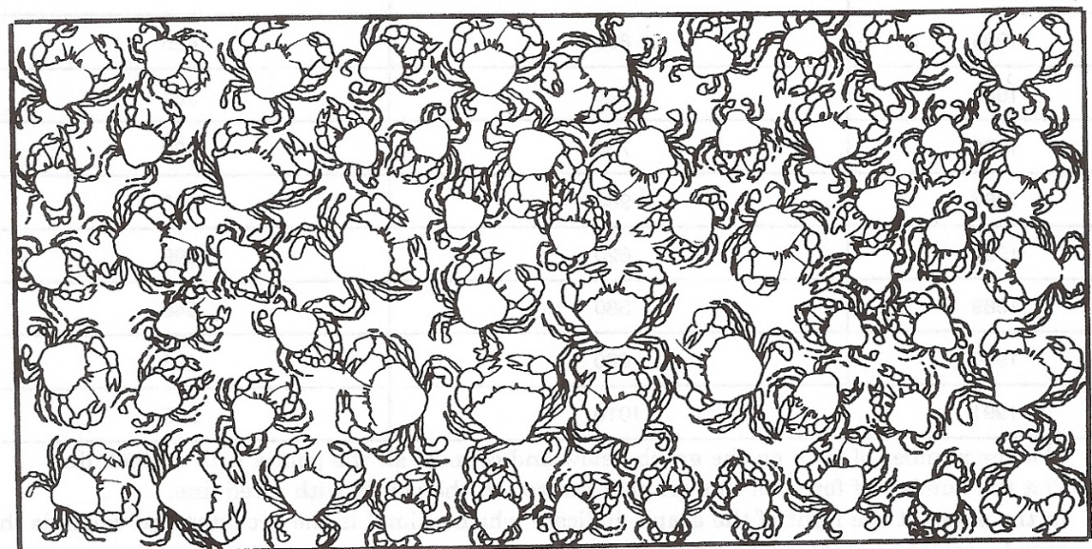

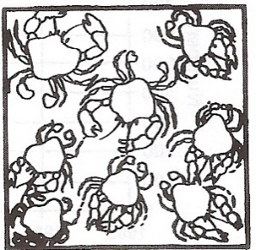
Total number = ___________________ Time it took = ___________________
A faster way to count a population is to use statistics and samples. Count the number of crabs in the small square to the right.

Total number = _________________ Time it took = ___________________

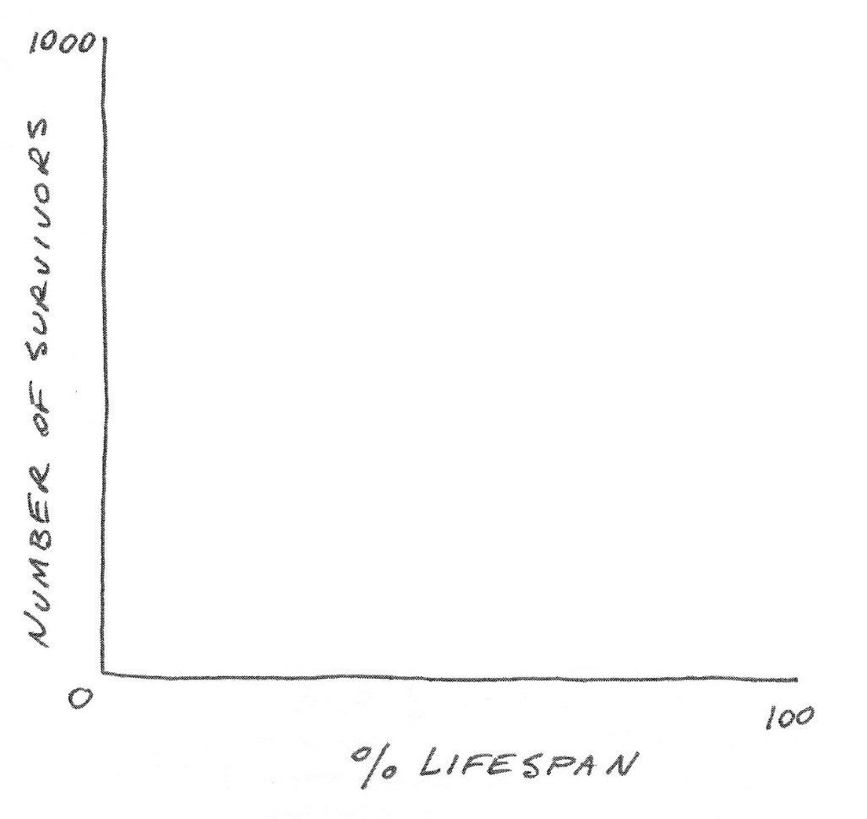
Diagram 1. Survivorship Curves

Diagram 2. Exponential/Logistic Growth and Carrying Capacity

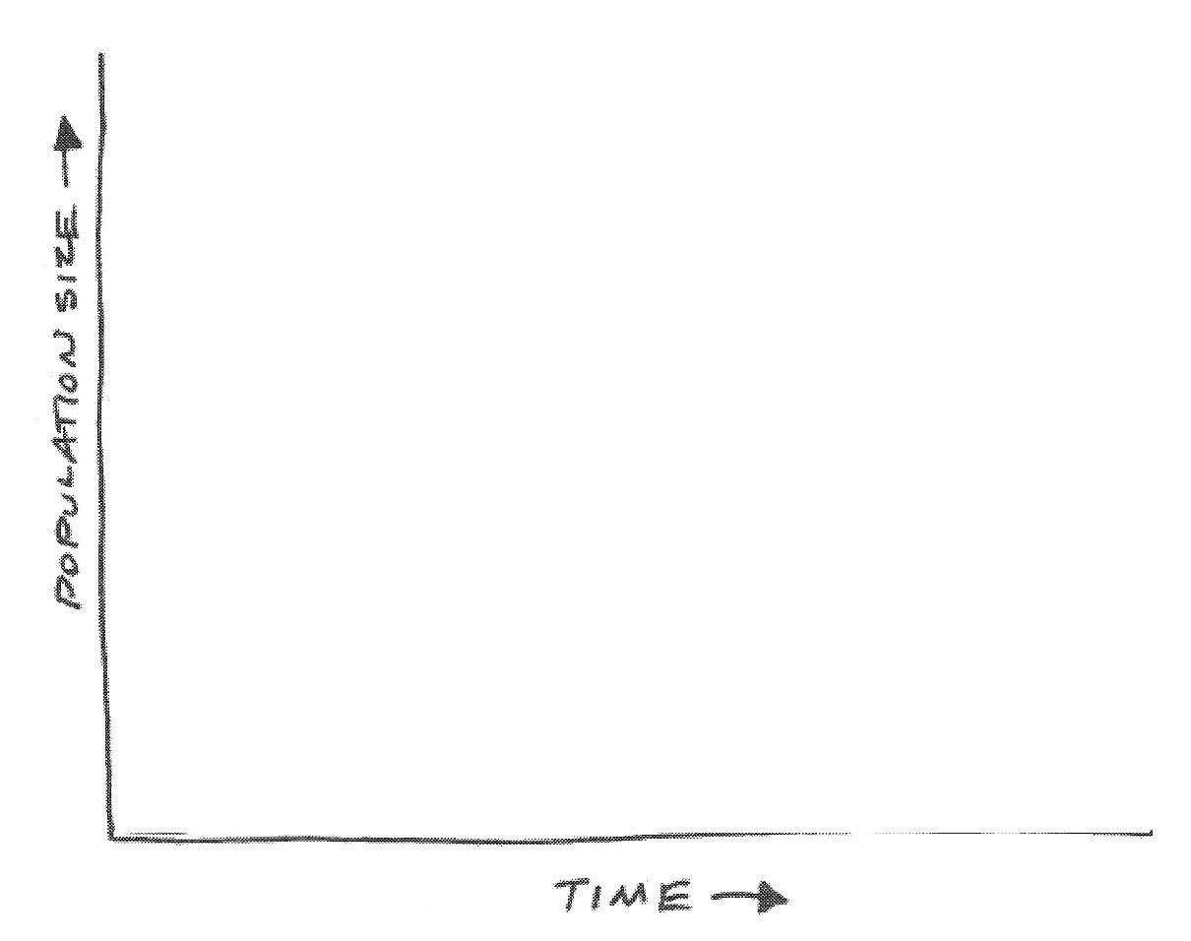

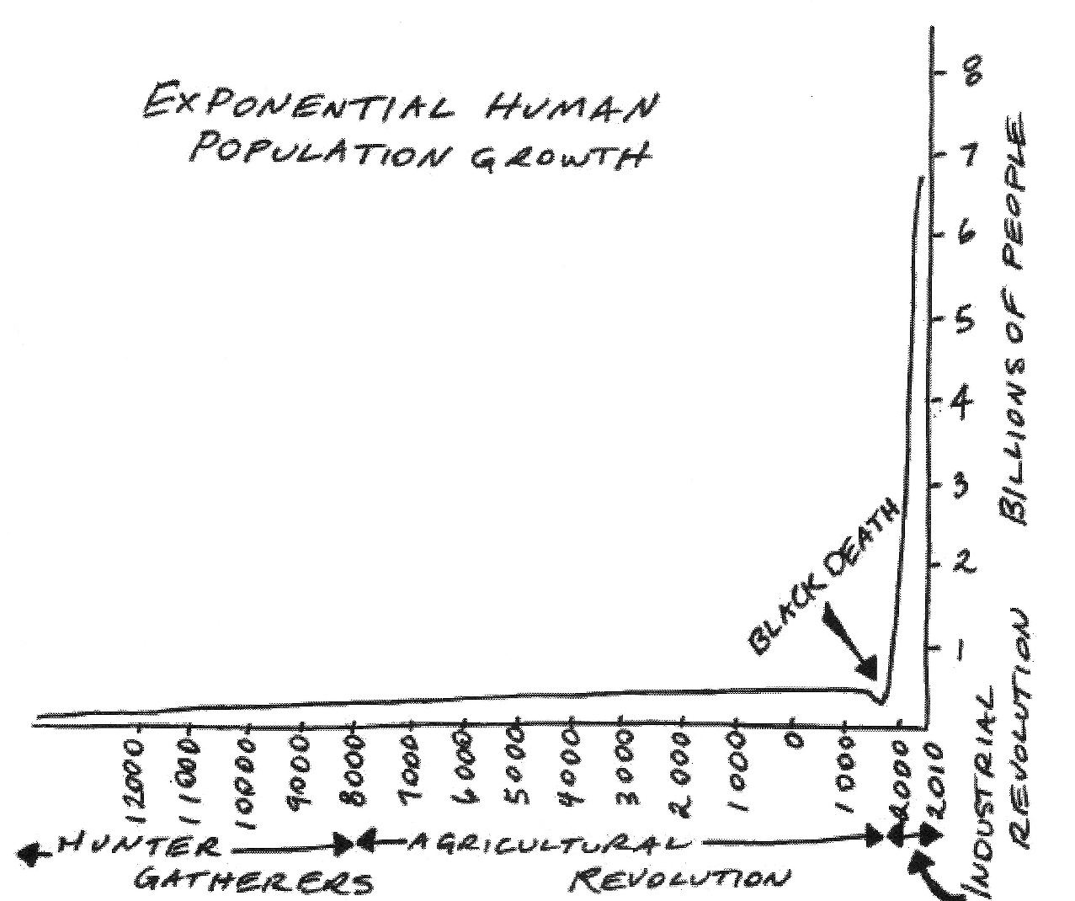
Diagram 3. Exponential Human Population Growth

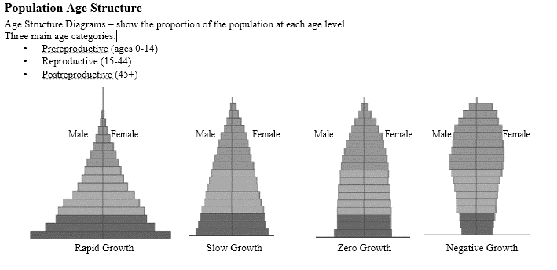
Diagrams 4. Population Pyramids

Demographic Transition Model

Stage 1 – Stage 2 – Stage 3 – Stage 4 –

Diagram 5. Demographic Transition Model

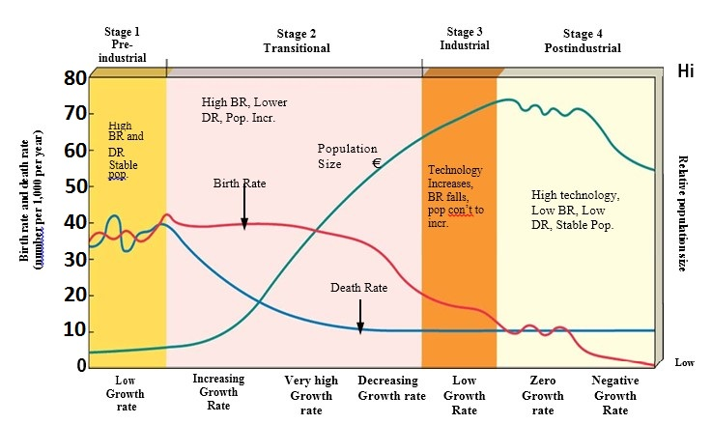
Population Math Formulas with Example Problems

Population Density: Total Population / Total Area
Crude Birth Rate: (Total # Births / Total Population) x 1000
Crude Death Rate: (Total # Deaths / Total Population) x 1000
Population Change: (births + immigrations) – (deaths + emigration)
Population Growth Rate (%): (births + immigrations) – (deaths + emigration) / Population x 100
Doubling Time: 70 / % Growth Rate = years to double
Growth Rate (r) using CBR and CDR: r = (CBR - CDR) / 10

Population density

( | population | ) | = Population Density
 | area

for example: | ( | 270,000,000 people | ) | = 29 people per square kilometer
 |  | 9,166,605 sq. km.

Birth or Death Rates:

( | # of births or deaths per year | ) | = Birth or Death Rate
 | total population

NOTE: to find Crude Birth/Death Rates, multiply the rate by 1,000

for example: | ( | 23,452 births | ) | = 0.025 = 2.5% birth rate
 |  | 942,721 people
25 = Crude Birth Rate

Finding Population Growth Rate (r):
(This does not include immigration or emigration)

( | crude births – crude deaths | ) | = r % |  | births – deaths | X 100 = r %
 | 10 |  |  |  | total population
OR
for example: | ( | 40 - 30 | ) | = 1.0% |  | 28,546 births – 24,389 deaths | X 100 = 0.9%
 |  | 10 |  |  |  | 455,387 total people

Finding the Doubling Time of a Population: THE RULE OF 70!!!
(This only applies if the population is growing exponentially)
Why 70? It is 100 x ln(2). What does that mean? Who cares…the math works!

( | 70% | ) |  |  | = Doubling Time (dt) in years
 | r (in percent form)

for example: | ( | 70% | ) |  |  | = 10 years
 |  | 7%

Population Math Practice Problems
You must show your work to receive credit

- One thousand two hundred deer are living on an island that is eight hundred square kilometers in size. What is the population density of the deer per square kilometer?

- A year ago, there were 1,332 million people living in China. China is the third largest country in the world with an area of 3.6 million square miles. What is the population density of China?
Estimate and show your reasoning in your work

- A small country of 744,000 people has 44,000 immigrants and 12,000 emigrants. They also experience 15,000 deaths and 35,000 births. What is the new population for this country? (Optional: calculate growth rate of this small country)

- In 1950, the population of a small suburb in Los Angeles, California, was 42,000. The birth rate was measured at 250 population per year, while the death rate was measured at 640 population per year. Immigration was measured at 600 per year while emigration was measured at 300 per year. Calculate the population size in 1951.

- Calculate crude birth rate and crude death rate from the previous question.

- A separate population on Long Island has a crude birth rate of 47 and a crude death rate of 12. How many years will it take for this population to double?

- The graph below shows the changes in the size of emperor penguin population in terms of numbers of breeding pairs on the island of Terre Adelie in the Antarctic. Use the graph to answer the questions below. Show your work.
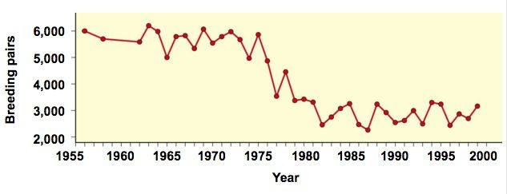
  - Assuming that the penguin population fluctuates around the carrying capacity, what was the approximate carry capacity of the island for the penguin population from 1960 to 1975? Mark this on the graph

  - What was the approximate carrying capacity of the island for the penguin population from 1980 to 2000? Mark this on the graph.

  - What was the percentage decline in the penguin population from 1975 to 2000?

- Legumeville is a newly formed volcanic island of 5000 square miles that is now part of the Canary Islands. In the year 2017, there are currently 2,500,000 inhabitants of the island. This year, the crude birth rate is 47 (all cute and very smart) and 40 is the crude death rate (mostly drunkards and hooligans).
  - What is the population growth rate (r) of Legumeville?

  - How many years will it take the population of Legumeville double?

  - What stage in the demographic transition model do the birth and death rates suggest for this society?
Why did you pick this stage?

- Calculate the growth rates and doubling times for the countries listed below.

Country | CBR (2011) | CDR (2011) | Growth Rate (r) | Doubling Time
United States | 13 | 8
Mexico | 19 | 5
Japan | 8 | 9
United Kingdom | 13 | 9
China | 12 | 7
India | 23 | 7
Nigeria | 41 | 16
South Africa | 21 | 14
Canada | 11 | 7
Italy | 9 | 10

Practice Scenario 1
Use the following information for the next six questions. There is an island just off the coast called Bird Island. Bird Island, rectangular in shape, is 20 km long and 15 km wide. 3,000 birds live on the island. Each year 300 chicks are born and 100 old birds die. In addition, 50 birds immigrate and 75 birds emigrate to and from the island.

- What is the density of birds on the island?

- What is the crude birth rate of birds on the island?

- What is the crude death rate of birds on the island?

- Accounting for births, deaths, immigration, and emigration how many TOTAL additional birds are added to the island each year?

- What is the total annual growth rate of birds on the island?

- How long will it take for the bird population to double?

Extra Space for NOTES

______________________________________________________________________________________________________________________________________________________________________________________________________________________________________________________________________________________________________________________________________________________________________________________________________________________________________________________________________________________________________________________________________________________________________________________________________________________________________________________________________________________________________________________________________________________________________________________________________________________________________________________________________________________________________________________________________________________________________________________________________________________________________________________________________________________________________________________________________________________________________________________________________________________________________________________________________________________________________________________________________________________________________________________________________________________________________________________________________________________________________________________________________________________________________________________________________________________________________________________________________________________________________________________________________________________________________________________________________________________________________________________________________________________________________________________________________________________________________________________________________________________________________________________________________________________________________________________________________________________________________________________________________________________________________________________________________________________________________________________________________________________________________________________________________________________________________________________________________________________________________________________________________________________________________________________________________________________________________________________________________________________________________________________________________________________________________________________________________________________________________________________________________________________________________________________________________________________

