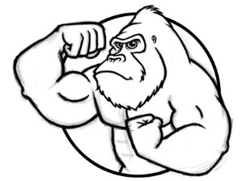
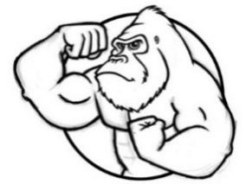
Unit 4 Geology, Mining, and Soil (Geography too!)

How did you do on the last exam? Was your score as high as you’d like? If so, hooray - your efforts are paying off! If not, be honest with yourself about what you should do for the next exam. It is up to you how much you get out of the course and, therefore, how well you do on the AP exam. I am going to do everything I can to help you, but I cannot read the text for you, study for you, or take the exam for you. These things you must do on your own. Remember, the most successful students study four to five hours per week.

Geologic History (Video 4.1 Geologic History due ______________) (pages 35, 422, 259-262 in Textbook)
- 4.6 Billion Years Ago / Earth and solar system formed! Cosmic dust cloud condensed to form Earth (heated from meteorite impacts and radioactive decay). As the Earth cooled, a hardened crust formed (no atmosphere and no water, yet)
- 3.8 Billion Years Ago / Scientists believe life formed; energy from lightning, heat from volcanoes and UV light and other solar radiation was available
- Around 500 Million Years Ago / “Cambrian explosion,” most major groups of animals first appear in the fossil record
- Most life forms (99%) from the geologic past have / become extinct (5 major extinctions);
  - Greatest extinction came at the end of the Permian (90% of all life died 250 million years ago)
  - The most famous extinction was the dinosaurs (Cretaceous) around 65 million years ago from a large meteor impact (killed about 75% of all life)
  - The most recent was end of last ice age 12,000 years ago, large mammals died like mammoths and saber-toothed tigers
- Urey-Miller Experiment / recreated the early Earth’s conditions in the lab which lead to the formation of the first organic molecules (aka abiogenesis)
- Panspermia / a hypothesis which states that the “seeds” of life exist all over the Universe and can be propagated through space by asteroids/comets from one location to another (Some believe that life on Earth may have originated through these “seeds”)
- Half-life / the time it takes for ½ the mass of an unstable radioisotope to decay and become stable; used to date fossils and rocks
- Estimate of how long a radioactive isotope must be stored until it decays to a safe level / approximately 10 half-lives
- Know how to do half-life problems / using a T or T.O.M. chart remember to add half-life on the time (left) side and divide (÷) by 2 on the mass (right) side. (# of decays = elapsed time / half-life)

Soil (Video 4.2 Soil and Soil Dynamics due ______________) (pages 274-282 in Textbook)
- Weathering vs. Erosion / weathering is the breaking down of rocks into smaller pieces called sediments while erosion is the movement of sediment
- Climate Factors that Affect Soil Formation /
  - Higher Temp.: more chemical weathering and biological activity, more soil formation
  - Higher Precip.: more biological activity and weathering more soil formation
  - Higher Wind: increases erosion, decreases rate of soil formation
- Why are Soils Important? / they sustain life by creating the perfect environment to grow life-giving producers, marriage of sediments (geology) and biological activity (biology)
- Soil Profile / horizons in order: O – A (E) – B (I) – C – R
  - O horizon / organic matter from animals & plant roots & leaves is located; often dark colored
    - Humus / organic, dark material remaining after decomposition by microorganisms
  - A horizon / considered the topsoil & contains inorganic/organic material called humus; Layer that supports agriculture (thicker = healthier = better for agriculture)
    - E horizon / zone of heavy leaching/eluviation, grayish in color do to loss of nutrients
      - Eluviation or Leaching / removal of dissolved materials from soil by water moving downwards
  - B horizon / considered the subsoil or zone of accumulation where minerals/nutrients leach into from A horizon, dark orange brownish (rust)
    - Illuviation / deposit of leached material in lower soil layers (B Horizons)
  - C horizon / transition b/t parent material below & soil, contains weathered pieces of bedrock
  - R Horizon / soil horizon that's bedrock; is parent material from which soil is made
- Permeability (aka infiltration or percolation) / how fast water flows through soil. As particle size increases, permeability increases
- Loam / perfect agricultural soil with optimal portions of sand, silt, clay (40%, 40%, 20%), ideal permeability not too fast and not to slow to promote water logging yet still able to hold onto nutrients
- Clay as a Soil / smallest particles (less than 0.002 mm) in diameter, least workable, least permeable (water logging), most water nutrient holding capacity
- Sand as a Soil / big particles (0.5 to 1.0 mm), most workable, most permeable (too quick for roots to absorb enough water), least water nutrient holding cycle capacity
- Dust Bowl / occurred in the 1930’s due to mainly removal of the native plants which adapted long roots to survive drought and overgrazing; large areas of the Southern Great Plains were reduced to desert
- Soil Salinization / when a field is irrigated the water leaves salts on the surface of the soil; ultimately the higher salt levels make in difficult for many plant species to thrive. This is a major contributor to crop loss in the United States
- Methods to conserve and improve soil /
  - No-till Farming / using special equipment to plant crop seeds directly into the soil without disturbing the soil. Reduces the impact of erosion
  - Contour Plowing and Planting / involved planting crops perpendicular to the slope of the land. This allows each row of plants to serves as a barrier to erosion instead of an alley for erosion
  - Terracing (essentially a more pronounced contour plowing) / allows farmers to plant crops on steep slopes; they act like shelves trapping soil as in erodes downhill, often used in rice farming
  - Shelterbelts, Buffer strips, or Windbreaks / are trees that are planted around the perimeter of cropland to help block wind preventing wind erosion. The tree roots also help hold soil in place.
  - Cover Crops / planted during the offseason to help hold soil in place and certain crops return nutrients to the soil like legumes
  - Crop Rotation / a crop conservation technique that includes cycling through different crops on the same land introduce different root structures, plant residues, nutrients like nitrogen, produced by legumes, into soil
  - Use Organic Fertilizer / breaks down slowly, improves fertility, reduces erosion, increases water retention

Geology (Video 4.3 Geology due ______________) (pages 262-273 in Textbook)
- Why is the Outer Core of the Earth Important? / it’s composed of liquid metal which is in motion hence creating magnetism. This magnetosphere protects Earth from deadly solar radiation
- What Keeps the Earth’s Interior Hot? / energy given off from radioactive elements and the left over heat from Earth’s formation
- Volcanoes and Earthquakes occur / at or near plate boundaries, the tectonic activity brings mineral resources closer to Earth’s surface making it easier to mine
- Earthquakes are / the natural shaking of Earth’s crust due to a release of built up pressure
- Crust (Lithosphere) / rigid surface of earth. Rigid and consists of continental crust: composed of lighter but thicker granitic rock, and oceanic crust: which is composed of thin but denser basaltic rock
- Plate tectonics / the earth’s lithosphere is divided into pieces called plates that move due to convection currents in the Earth’s asthenosphere
- Convergent / plates slowly collide forming a trench, volcanic chains (archipelago), and/or mountains (oceanic-continental, oceanic-oceanic, continental-continental)
- Subduction Zones / occurs at convergent plates because ocean crust is more dense than continental; creates trenches and as it dives into the mantle in melts; some rock rises creating volcanoes.
- Divergent boundary / plates move away, forms a mid-ocean ridge or rift valley where magma rises (less dense) forming new rock (basalt)
- Transform boundary / plates slide past each other causes shallow, destructive earthquakes ex. San Andreas Fault
- How Do Tsunami’s Form? / when the sea floor moves violently in an underwater earthquake, creating a surge of energy displacing large volumes of water.
  - Destruction of/loss of habitat such as mangrove forests, coral reefs, etc.
  - Flooding resulting from tsunami waves can create saltwater intrusion into coastal ecosystems
  - Drowning of terrestrial species
- Coal was formed by / organic matter (mostly plants, think swamps) exposed to increasing heat and pressure transforming it into a compact carbon based rock. The type of coal changes depending on how much heat and pressure it was exposed to. Peat → Lignite → Bituminous → Anthracite
  - Peat is / an early stage of coal that forms under minimal heat and pressure; has a high moisture content low heat and carbon content. Found mostly in higher latitudes of the northern hemisphere (ex. Ireland)
  - Lignite formed / under more heat, pressure, and time than peat; still low heat and carbon content with high moisture. It is burned for electricity but responsible for great deal of air pollution due to its high sulfur content
  - Bituminous Coal / formed under more heat and pressure than lignite; has a high heat content but also has a high sulfur content and used widely around the world
  - Anthracite (metamorphosed “hard” coal) / very valuable energy resource due to its high heat, low moisture and sulfur content. Took more heat, pressure, and time to form therefore is more expensive

Mining (Video 4.4 Mining due ______________) (pages 282 – 288 in Textbook)
- Subsurface Mining Pros /
  - Mines that are much smaller than open-pit mines; preserves more habitat
  - Less visible because less land at the surface is disturbed
- Surface Mining Pros / used for extracting mineral deposits that lie close to the earth's surface. Includes open-pit mining and mountain top removal
  - Cheaper and can remove more minerals than subsurface mining
  - Less hazardous to workers
- Subsurface Mining Cons /
- Are more expensive and hazardous to workers
- Can lead to subsidence (sinkholes) as the ground above the mine caves in over time
- Fires can start in underground coal deposits and burn for years
- Surface Mining Cons /
  - Disrupts vast areas of habitat which leads to loss of biodiversity
  - Disturbed soil is easily eroded
  - Often a mine company goes bankrupt or shuts down without restoring the disrupted land
- Overburden / the soil and rocks that are removed BEFORE actually mining the ore
- Tailings / solid waste left over AFTER mining the ore
- Acid mine drainage ***** KNOW THIS***** / occurs as rainwater leaches through mine waste (tailings) containing sulfides; water mixes with the sulfides creating sulfuric acid. This acid leaches heavy metals out of surrounding rock. Heavy metals like arsenic, lead, and aluminum are highly toxic to organisms. They then enter nearby waterways and drinking water wells. Neutralize the acid by putting limestone in ground
- Surface Mining Control And Reclamation Act (1977) / requires coal strip mines to reclaim the land to natural contours and replant with permanent vegetation
- Phytoremediation / the use of specific plants to remove heavy metals from former mining lands
- Madrid Protocol (1991) / Suspension of mineral exploration (mining) for 50 years in Antarctica
- National Environmental Policy Act (NEPA) (1969) / Environmental Impact Statements must be done before ANY project affecting federal lands can be started

GEOLOGIC TIMESCALE / HALF-LIFE

LABORATORY QUESTIONS:
- How many millions are there in a billion? _____________________________________________________

- How many millions of years ago did the Earth form? ____________________________________________

- How many millions of years ago did the Solar System form? _____________________________________

Fill in the charts and questions using page 8 and 9 of the Earth Science Reference Table:

 | Epoch |  | Period
a) Earliest coral groups
b) Earliest insects
c) Diverse bony fishes
d) Earliest fish
e) Earliest birds
f) Earliest reptiles
g) Humans
h) Earliest trilobites
i) Eurypterids abundant
j) Earliest sharks
 |  | Epoch |  | Period
a) Catskill delta forms
b) Uplift of Adirondack region begins
c) Iapetus Ocean deposition
d) Initial opening of the Atlantic Ocean
e) Pangea begins to break up

- During which geologic era were the first amphibians present? _____________________________________
- Which era in the Phanerozoic eon was the longest in duration? ____________________________________
- How many millions of years ago did the Phanerozoic Eon begin? __________________________________
- What geologic period did Earth’s first forest form? _____________________________________________
- How many millions of years ago were the first flowering plants? __________________________________
- Approximately how many millions of years have humans lived on Earth? ___________________________
- Which geologic era held the existence of the dinosaurs? _________________________________________
- How many millions of years ago did oxygen enter the atmosphere? ________________________________
- How many millions of years are the oldest known rocks on Earth? _________________________________
- What biological events occurred that separates the three Eras in the Phanerozoic Eon? _______________________________________________________________________________________
- List the following in order from oldest to youngest using numbers from 1 - 12
Birds / Modern mammals / Grasses / Stromatolites / Fish / Insects / Sharks / Trilobites / Reptiles / Humans / Dinosaurs / Multicellular Soft-bodied Organisms
Oldest

Youngest
Half-Life Problems:

- If an element has a half-life of twenty million years, and there is 6.25% of it remaining in a rock, how old is the rock?

- A sample of radioactive waste has a half-life of 100 years and an activity level of 50 curies. How many curies will be left after 600 years of decay?

- Uranium-235 has a half-life of 710 million years. It is determined that a certain amount of U-235 will only be considered safe when its radioactivity has dropped below 12.5% of its current level. How much time must the U-235 be stored to be considered safe?

- You find a human bone during an archeological dig. Your analysis shows the following C-14 and N-14 concentrations: 40g of C-14 of parent remaining and 280g of N-14 of daughter. How old is the bone if the half-life is 5,730 years.

- You have a sample of rock that you suspect is somewhere in the age range of 3.0-3.5 billion years. Would you choose to measure C-14 which has a half-life of 5,730 years? Why or why not?

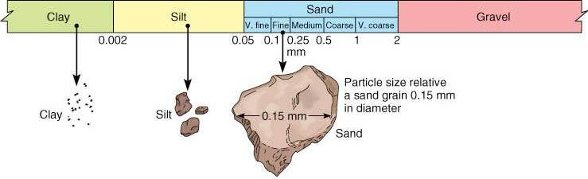

 | Nutrient-holding capacity | Water-holding capacity | Infiltration
Sand
Silt
Clay

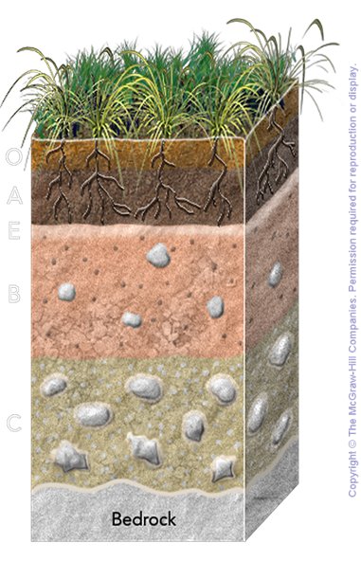
O
A

(E)

B

C

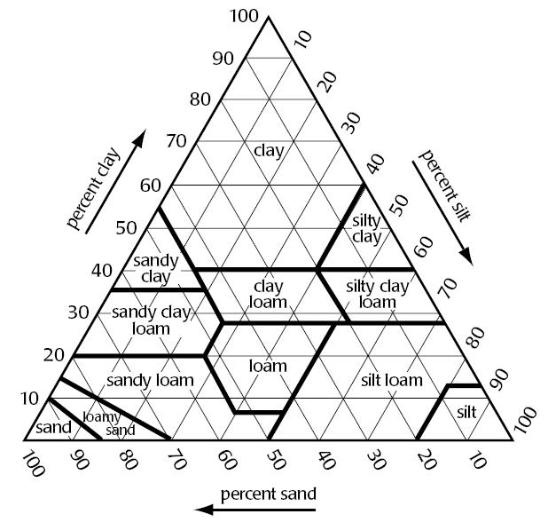
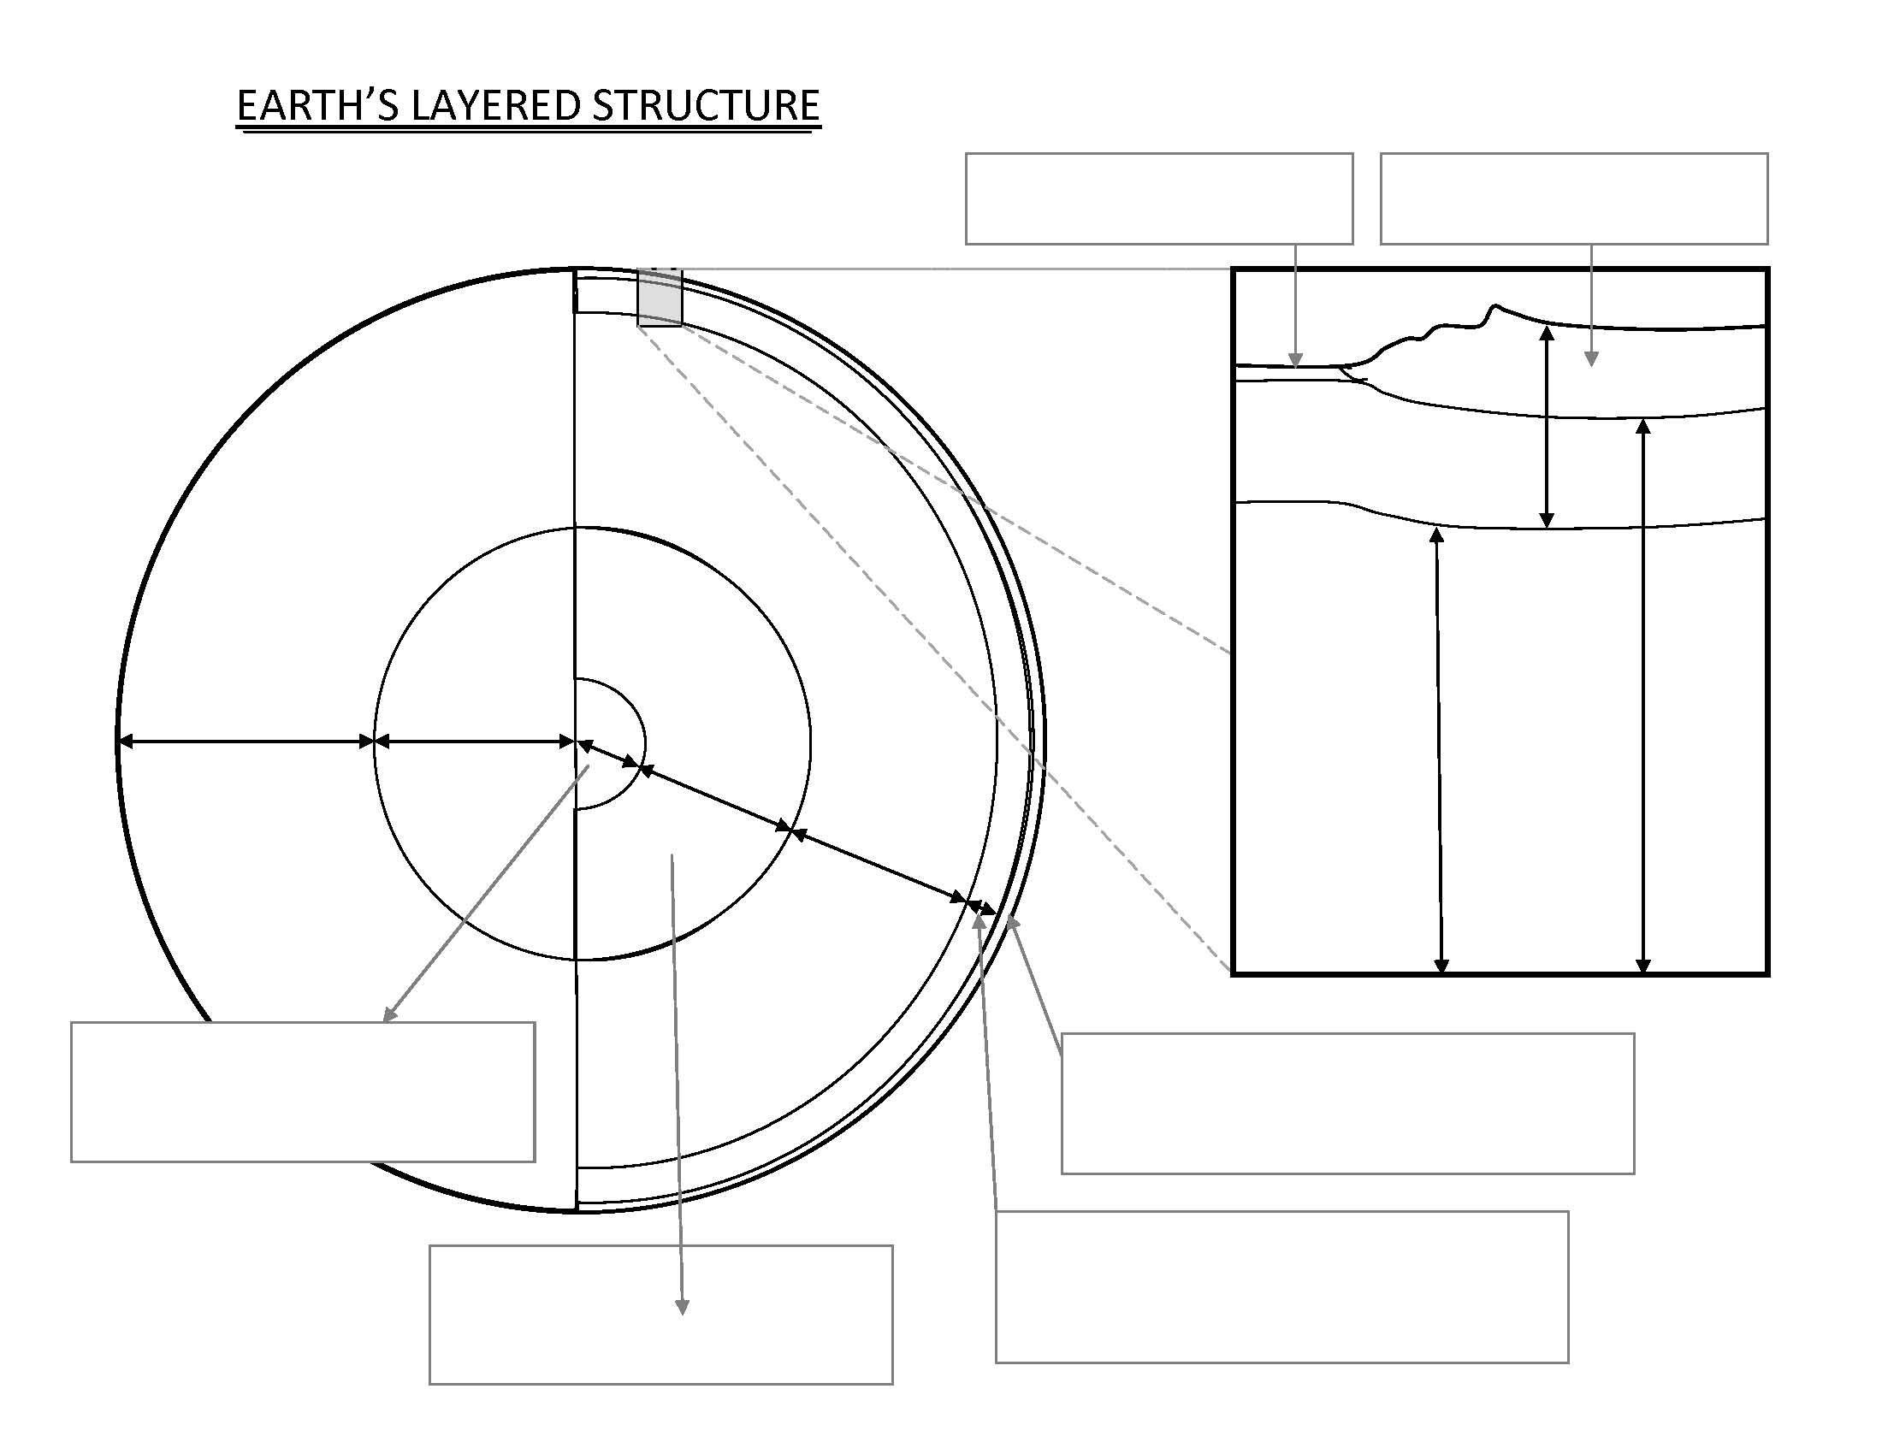

Type of Boundary | Sketch of Boundary | Direction of Movement | Description/Features of Plate Boundary (ex. Volcano chains or large earthquakes) | Examples (Use page 5 of ESRT to find examples.)
Diverging Plate Boundary
Transform Boundary
Convergent Plate Boundary  (Collision, no subduction) | Continental-Continental
Convergent Plate Boundary  (Subduction) | Oceanic-Continental or Oceanic-Oceanic

APES, GEOGRAPHY, AND YOU!

As we will be talking about various places on the planet throughout the year, a knowledge of some basic geography is important. As a refresher of skills you have learned in the past, please be familiar with the following terms/locations. Some locations are where major ecological disasters occurred. Label them accordingly.

Label on each map:
North, South, East, and West

- Atlantic Ocean
- Pacific Ocean
- Indian Ocean
- Everglades
- Gulf of Mexico
- Gulf Stream
- North America
- South America
- Europe
- Asia
- Africa
- Australia
- China
- Brazil
- Indonesia
- Russia
- Great Barrier Reef
- India
- Japan
- Mexico
- California
- Alaska
- Amazon Rainforest
- England
- Borneo Rainforest
- Saudi Arabia

- Three Mile Island
- Bhopal Disaster
- Chernobyl Disaster
- Yangtze River
- Three Gorges Dam
- Rocky Mountains
- Sierra Nevada Mts.
- Himalayan Mts.
- Fukushima
- Minimata
- Appalachian Mountains
- Yellowstone Nat'l Park
- Glacier National Park
- Colorado River
- New Orleans, LA (Mississippi Delta)
- Great Lakes
- Love Canal
- Yucca Mountain (Nevada)
- Mississippi River
- San Andreas Fault
- Location of the Exxon Valdez Oil Spill
- Location of the BP Oil Spill
- Tar Sands of Canada
- George’s Banks & Grand Banks

Go to this Prezi for help: https://prezi.com/t7kek_1yvuno/environmental-geography/#
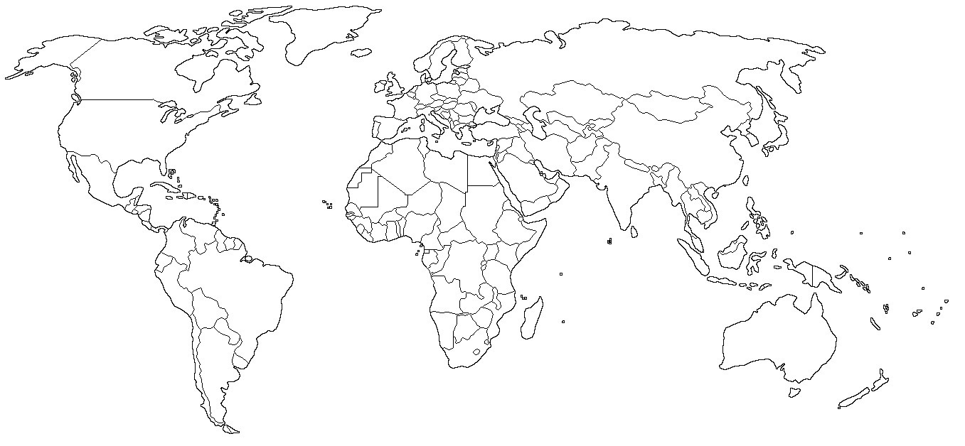
More Practice: HALF-LIFE PROBLEMS

- The half-life of copper-60 is 2.4 minutes. How many grams of Cu-60 in 8.0 gram sample will remain undecayed after 7.2 minutes?

- If an element has a half-life of 30 million years, and there is 3.125% (1/32) of it remaining in a rock, how old is the rock?

- If an element has a half-life of twenty million years, and it has undergone decay for 120 million years, how much of the radioactive element is left?

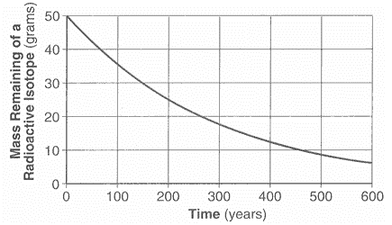
- According the graph on the right, what is the half-life of this isotope?

- You have a sample that contains 7.5 grams (parent remaining) of Californium-249 and 52.5 grams of its daughter product. How old is the lava sample if it has a half-life of 360 days.

