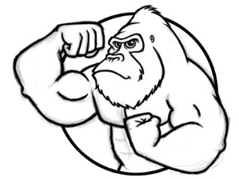
Unit 1 Introduction, Math, and Scientific Analysis
You will notice that in this course we are very busy and we are flying through the content. You must shoulder the responsibility of reading and learning this information (I can’t learn it for you or upload it into your brains like in The Matrix - though I wish I could). Be organized BEFORE the exam: use a daily planner and keep track of when you’re going to work on assignments, read the textbook, study/annotate your chapter/lecture notes, study your facts, read handouts, etc. The most successful students study four to five hours per week.
Introduction (Video 1.1 APES Intro due ______________) (Chapter 1 pages 1-17, 331-333)
  - Environmental Science / the study of how humans and other species interact with one another and the nonliving environment
  - Chief Seattle / all things are interconnected, seeks to be one with nature
  - US Army Corp of Engineers / views nature as a battle, seeks to control nature by building dams, levees…
  - Aldo Leopold / (1949) his work helped to inspire the modern environmental movement; he stated “A thing is right when it tends to preserve the integrity, stability, and beauty of the biotic community. It is wrong when it tends otherwise.” Basically stating all living things have right to live even if humans think otherwise
  - E.P.A. stands for / Environmental Protection Agency, established in 1970 by Republican President Richard Nixon to protect human health and the environment (page 715)
  - Conservation / allows the use of resources in a responsible manner
  - Preservation / setting aside areas & protecting them from human activities
  - Sustainability / the ability to meet humanities current needs without compromising the ability of future generations to meet their needs
  - Non-Renewable / resources that cannot be replenished at rate they are used (human timespans); fuels such as coal, oil and natural gas which form over millions of years and will eventually run out at the rate of use
  - Renewable / resources that can be replenished at rate equal or greater than rate at which used, examples are wind, solar, tidal energy and certain plant/trees species (bamboo products)
  - Abiotic vs. Biotic Environmental Factors / abiotic means nonliving factors like air, rocks, nutrients, sunlight, water, etc.; while biotic means living parts of an ecosystem like insects, animals, plants, etc.
  - Gaia Hypothesis / proposed by James Lovelock; the earth is a living, self-regulating organism which maintains homeostasis by regulating CO₂ levels (atmosphere = skin, core = heart, trees = lungs, rocks = bones, rivers, water = veins and blood, and humans=neurons/cancer/both?)
  - Garrett Hardin / published “The Tragedy of the Commons” in the journal of Science in 1968; argued that rational people will exploit shared resources (commons) and the “Freedom to breed” is bringing ruin to all
  - The Tragedy of the Commons / (1968 paper by ecologist Garret Hardin) Global commons such as atmosphere & oceans are used by all and owned by none. When no individual has ownership, no one takes responsibility. Examples: overfishing in the oceans, over pumping of the Ogallala Aquifer or our school cafeteria/hallways
  - Theodore Roosevelt / U.S. president from 1901-1909, a conservationist who protected vast amounts of land during his presidency, he was an environmental “steward” – he looked after the environment
  - John Muir / founded the Sierra Club in 1892, fought for the creation of national parks (Muir Woods – Redwood forest)
  - Rachel Carson / in 1962 published Silent Spring, which brought attention to problems associated with the use of pesticides
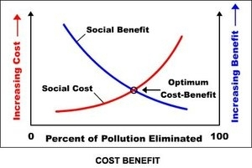
  - Cost – Benefit Analysis (CBA) / comparing estimated costs and benefits for actions such as pollution control regulation, building a dam on a river, preserving an area of forest, etc. Another way to analyze environmental issues.
(Video 1.2 Feedback Loops due ______________) (pages 52-53)
  - Positive Feedback Loop / increasing the intensity of a mechanism (think positive means adding to the problem). For example, as glaciers and ice caps melt less energy is reflected back into space and more is absorbed by the Earth, therefore intensifying the warming effect
  - Negative Feedback Loop / decreasing the intensity on a mechanism (think taking away from the problem) For example, as the Earth’s warms more evaporation occurs, therefore creating more clouds which block solar radiation, therefore decreasing the warming effect

Scientific Process (pg. 14-17) (Video 1.3 Scientific Method due ______________) (pages 19-24)
  - Scientific Method / a systematic way of solving problems; steps include: observe and state a question, research, hypothesize, experiment, collect data, and conclusion (accept or reject the hypothesis)…reproducibility!
  - Hypothesis / is an idea or explanation that is tested through study and experimentation; can either be accepted or rejected never proven! Example: If I lose my socks then it is due to aliens
  - Independent variable/ is the variable you have control over, what you can choose and manipulate. Usually graphed on the x – axis. Example: You are interested in how stress affects heart rate in humans. Your independent variable would be the stress and the dependent variable would be the heart rate. You can directly manipulate stress levels in your human subjects and measure how those stress levels change heart rate.
  - Dependent variable / is what you measure in the experiment and what is affected during the experiment. The dependent variable responds to the independent variable. It is called dependent because it “depends” on the independent variable. In a scientific experiment, you cannot have a dependent variable without an independent variable. Usually graphed on the y axis
  - Scientific Law / statement/math relationship that describes a single concept & is widely accepted by science community, but is not modified over time; can be proven
  - Scientific Theory is a well-founded, over-arching explanation of some aspect of the natural world, based on a body of facts that have been repeatedly confirmed through observation and experiment. Such fact-supported theories are not "GUESSES" but reliable accounts of the real world.
Examples: Theory of evolution, atomic theory, theory of plate tectonics, theory of relativity, etc…

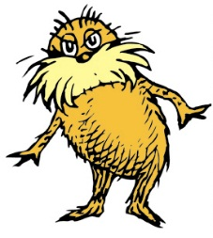
If you missed the Lorax video in class you need to watch it on your own time.
Just search on YouTube: Dr. Seuss: The Lorax (1972) it is about 25 minutes long.
Video: Lorax (Original from 1972)
If you missed the video from class on watch on YouTube

- The Onceler was not an environmentalist and did not realize that he was violating several environmental laws. For each of the following, giving an example from the movie or an example from real life.
A) There is no such thing as a free lunch: ____________________________________________________
______________________________________________________________________________________
______________________________________________________________________________________
______________________________________________________________________________________
______________________________________________________________________________________

B) All things are interconnected: ___________________________________________________________
______________________________________________________________________________________
______________________________________________________________________________________
______________________________________________________________________________________
______________________________________________________________________________________

C) More is not always better: ______________________________________________________________
______________________________________________________________________________________
______________________________________________________________________________________
______________________________________________________________________________________
______________________________________________________________________________________

D) There is no away: ____________________________________________________________________
______________________________________________________________________________________
______________________________________________________________________________________
______________________________________________________________________________________
______________________________________________________________________________________

E) Dilution is not the solution to pollution: ___________________________________________________
______________________________________________________________________________________
______________________________________________________________________________________
______________________________________________________________________________________
______________________________________________________________________________________

- Is the Lorax a preservationist or a conservationist? Give a supporting example from the video.
______________________________________________________________________________________
______________________________________________________________________________________
______________________________________________________________________________________
______________________________________________________________________________________

- Look at the spelling of his name. Why is he called the Onceler? __________________________________
______________________________________________________________________________________
______________________________________________________________________________________
______________________________________________________________________________________
______________________________________________________________________________________

- Was the Onceler’s business sustainable? Why or why not? ______________________________________
______________________________________________________________________________________
______________________________________________________________________________________
______________________________________________________________________________________
______________________________________________________________________________________

- Using the idea of cost-benefit analysis was it worth it to cut down all the Truffula Trees? Explain:
______________________________________________________________________________________
______________________________________________________________________________________
______________________________________________________________________________________
______________________________________________________________________________________
______________________________________________________________________________________
______________________________________________________________________________________

- Why do you think the Onceler didn’t listen to the Lorax until it was too late? ________________________
______________________________________________________________________________________
______________________________________________________________________________________
______________________________________________________________________________________
______________________________________________________________________________________
______________________________________________________________________________________
______________________________________________________________________________________

- Are the Truffula Trees an example of a renewable or non-renewable resource and why? _______________
______________________________________________________________________________________
______________________________________________________________________________________
______________________________________________________________________________________
______________________________________________________________________________________

- In the end, the Onceler gave the boy the last seed and told him to treat the Truffula forest with care and “protect it from axes that hack,” and used the word UNLESS. What do you think he meant?
______________________________________________________________________________________
______________________________________________________________________________________
______________________________________________________________________________________
______________________________________________________________________________________
______________________________________________________________________________________

Reading: CHIEF SEATTLE: THE EARTH IS PRECIOUS Date: _____________

The great Chief in Washington sends word that he wishes to buy our land. The Great Chief also sends us words of friendship and goodwill. How can you buy or sell the sky, the warmth of the land? The idea is strange to us. If we do not own the freshness of the air and the sparkle of the water, how can you buy them?
Every part of this earth is sacred to my people. Every shining pine needle, every sandy shore, every mist in the dark woods, every clearing, and humming insect is holy in the memory and experience of my people. The sap which courses through the trees carries the memories of the red man.
The white man's dead forget the country of their birth when they go to walk among the stars. Our dead never forget this beautiful earth, for it is the mother of the red man. We are part of the earth and it is part of us. The perfumed flowers are our sisters, the deer, the horse, the great eagle, these are our brothers. The rocky crests, the juices in the meadows, the body heat of the pony, and man—all belong to the same family.
We know that the white man does not understand our ways. One portion of land is the same to him as the next, for he is a stranger who comes in the night and takes from the land whatever he needs. The earth is not his brother, but his enemy, and when he has conquered it, he moves on. He leaves his fathers' graves behind, and he does not care. He kidnaps the earth from his children. He does not care. His fathers' graves and his children's birthright are forgotten. He treats his mother, the earth, and his brother, the sky, as things to be bought, plundered, sold like sheep or bright beads. His appetite will devour the earth and leave behind only a desert.
I do not know. Our ways are different from your ways. The sight of your cities pains the eyes of the red man. But perhaps it is because the red man is a savage and does not understand.
I am a savage and I do not understand any other way. I have seen a thousand rotting buffaloes on the prairie, left by the white man who shot them from a passing train. I am a savage and I do not understand how the smoking iron horse can be more important than the buffalo that we kill only to stay alive.
What is man without the beasts? If all the beasts were gone, men would die from a great loneliness of spirit. For whatever happens to the beasts, soon happens to man. All things are connected.
This we know: The earth does not belong to man; man belongs to the earth. This we know: All things are connected like the blood which unites one family. All things are connected.
Whatever befalls the earth befalls the sons of the earth. Man did not weave the web of life; he is merely a strand in it. Whatever he does to the web, he does to himself.
Your destiny is a mystery to us, for we do not understand when the buffalo are all slaughtered, the wild horses are tamed, the secret corners of the forest heavy with the scent of many men, and the view of the ripe hills blotted by talking wires. Where is the thicket? Gone. Where is the eagle? Gone. And what is it to say good bye to the swift pony and the hunt? The end of living and the beginning of survival...
- What is the message of Chief Seattle?

- If the environment where a circle where would Chief Seattle put himself?
POSTIVE OR NEGATIVE FEEDBACK
Directions: Read each scenario or look at the diagram and decide which type of feedback loop is occurring: Positive or Negative.
- A hotter climate means more evaporation which leads to an increase in cloud formation. This leads to more heat radiation from the Earth that gets trapped and sent back to the ground by the clouds resulting in a warmer climate. The warmer temperatures lead to an increase in evaporation which creates even more clouds.

- An increase of carbon dioxide in the blood leads to a decrease in blood pH. The drop in blood pH is detected by chemoreceptors in the aorta and carotid artery. These receptors send nerve impulses to the respiratory center in the medulla oblongata in the brain, which then stimulates increased breathing. Increased breathing helps remove carbon dioxide from the blood, returning blood pH to normal levels.

- After eating a meal, your blood glucose level increases. Islet cells in your pancreas detect the rise in blood sugar, and release insulin into the bloodstream. Insulin binds to receptors on cells throughout the body, allowing the cells to take up glucose from the blood. This lowers blood glucose levels back to a normal level.

- Ice caps at the north and south poles are very reflective -- the ice reflects light and heat rather than absorbing it. If global warming occurs, then the increase in temperature will cause polar ice to melt, and the bare dark ground will absorb rather than reflect heat. This additional absorption of heat will further boost the temperature of the earth.

- Carbon dioxide is considered a "greenhouse gas" since it absorbs heat that would otherwise dissipate out into space. If there is more carbon dioxide in the atmosphere, global temperatures are likely to increase. It is possible that plants will respond to the increased carbon dioxide and increased temperatures with an increase in photosynthesis. Since carbon dioxide is needed for photosynthesis, this could reduce the amount of carbon dioxide in the atmosphere, leading to cooler temperatures.

- We know that warm water holds less dissolved gas -- that's why a soda pop goes flat when it gets warm. Normally, there is a great deal of dissolved carbon dioxide in cold ocean water. If global warming occurs and global temperatures increase, warmer ocean water will hold less dissolved carbon dioxide. Less dissolved carbon dioxide in the ocean means more carbon dioxide in the atmosphere. Since carbon dioxide is a "greenhouse gas," the increase in atmospheric carbon dioxide will further boost global temperatures, making it even warmer.
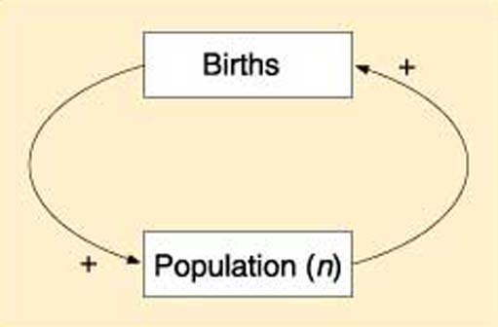

- A room with a thermostat, for instance, stabilizes temperature by turning the furnace on when the room gets too cold and shutting the furnace off when the room gets too hot.

- Once soil has been exposed by removal of vegetation, erosion may become progressively more severe if the forces of water or wind surpass the rate of vegetative regrowth.

- During lactation (milk production), the suckling by the baby stimulates the production of oxytocin, which in turn causes contraction of smooth muscle surrounding the milk duct, causing milk to flow. The flow of milk increases the suckling by the baby and more oxytocin is produced.

- When a microphone picks up sound from a speaker and amplifies it in a cycle that gets louder and louder.

- When the teacher's expectations go up, the student's performance goes up. When the student's performance goes up, the teacher's expectations rise even further.

- When the teacher's expectations for the student go down, the student's performance goes down. When the student's performance goes down, the teacher's expectations drop further.

- An ATVs’ churning tires are designed to grip the Earth, but they also erode the soil and uproot plants. Without vegetation, the soil erodes faster, exposing even more soil. As more soil is exposed, rainwater more easily carves out ruts and gullies. Drivers of ATVs’ then avoid the ruts and gullies by driving on adjacent sections that are not eroded, thus widening the path and further increasing erosion.

Introduction to Scientific Method & Experimental Design
**** PART I: What is the Scientific Method? ****
Scientific Method- It is a 6 part, step by step approach to solving a problem/answering questions.
- State the Problem or Question- A question is asked after making observations about something.
- Gather Information (research) - Information about the problem is collected.
- Form a hypothesis- Create a possible explanation or solution to the problem. Must be an “If…Then…” statement. Your hypothesis should be very clear and exact. Can only be right/wrong.
- Design Experiment- Design an experiment with a control group and at least 3 experimental groups.
- Do Experiment and Collect Data- Conduct an experiment with a control group and an experimental group.
- State a conclusion- Determine whether or not a hypothesis is correct based on data
Quantitative Data: anything that can be measured with numbers (24 horses finished the race, Mr. Miller ate 5 pies, the Flyers scored 3.4 goals per game last month, etc.)

Qualitative Data: Observations not related to quantities or numbers (examples: the horse is brown, Mr. Miller is drawing, the Flyers are awesome, etc.)
__________________________________________________________________________________________________
Example A: The further you sit from Mr. Graham, the less chance you will get caught on your phone.
Hypothesis: If you sit closer to Mr. Graham, then you are more likely to get caught with your phone.

Independent Variable: Distance of your seat to Mr. Graham Dependent Variable: # of times caught w/ phone

Control Group: Back Row Experimental Group: All Rows Closer

__________________________________________________________________________________________________
Example B: 11th Grade girls do better on Integrated Science tests then boys do.
Hypothesis: If you take an Int. Science test and you are a girl, then your score will be higher.

Independent Variable: Whether Guy or Girl taking test Dependent Variable: Test Score

Control Group: Guys Experimental Group: Girls

Below, fill in the rest of the steps of the following example of the scientific method using the info about each step from above…you can make up the answers because this is only hypothetical! Fortune Telling Fish!
  - State the Problem or Question-
  - Gather Information- (What info would you gather and how?)

  - Form a hypothesis- (What is your hypothesis?)

  - Design Experiment- (Actually write out how you perform an experiment)

  - Do Experiment and Collect Data- (What data would you collect)

  - State a conclusion- (How would you make a conclusion and what would you address first in the conclusion)

_________________________________________________________________________________________
Practice Writing Hypotheses: Write a hypothesis for each of the statements and identify the variables, control group, and experimental group.

#1. iPhones batteries last longer than Samsung’s batteries.
Hypothesis: If _______________________________, then _________________________________________

Independent Variable: ___________________________ Dependent Variable: ________________________

Control Group: ________________________________ Experimental Group: ________________________

#2. Mr. Miller is happier around cats then he is around people

Hypothesis: If _______________________________, then _________________________________________

Independent Variable: ___________________________ Dependent Variable: ________________________

Control Group: ________________________________ Experimental Group: ________________________

#3. Make your own problem/statement and fill in the rest…
Problem/statement_________________________________________________________________________.

Hypothesis: If _______________________________, then _________________________________________

Independent Variable: ___________________________ Dependent Variable: ________________________

Control Group: ________________________________ Experimental Group: ________________________
PART II: Experimental Design Practice
Directions: Read the following experiments and fill in the blanks that follow.
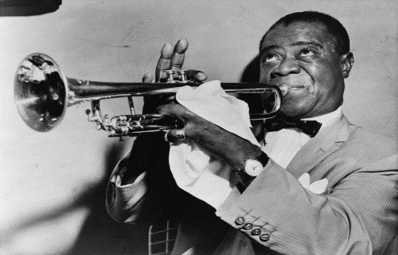
1. A study was created to test the effects of jazz on people’s sleep patterns. The hypothesis of the experiment was that if people listened to jazz music as they fall asleep, they will sleep for longer periods of time. For the experiment, 2 groups of people were created. One group was placed in a quiet room where they went to sleep and they were timed on how long they slept. The other group was placed in a room where jazz music played softly as they began to sleep and played throughout the night. As each group awoke, their sleep times were monitored.

Dependent Variable: ______________________ Control Group: ____________________________
Independent Variable: _____________________ Experimental Group: _______________________

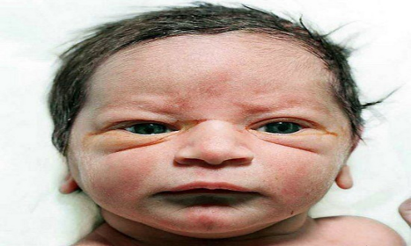
2. A study was created to test the effects of fear in children. The hypothesis of the experimenters was that if babies were exposed to fuzzy bunnies and at the same time a loud cymbal was struck close behind them, then that child would be afraid of all fuzzy things. Another group of children would be exposed to bunnies without any loud noises. The study was carried out as planned and as a result, hundreds of young children developed fear of all cute furry bunny rabbits.
Dependent Variable: ______________________ Control Group: ____________________________
Independent Variable: _____________________ Experimental Group: _______________________

Situations: Read the situation below and design an experiment.
A: John Smith has been hired by the city of Virginia Beach to investigate the recent shark attacks off the resort’s coast. He has a budget of $40,000, a 25 foot boat, and three graduate student assistants to help him. A helicopter has also been donated by a local television station, should he need one.
* * *
1. List 2 hypotheses John and his crew may have come up with for the recent shark attacks.
a. If_____________________________________, then ______________________________________
b. If_____________________________________, then ______________________________________

2. Pick one of the two hypotheses and determine the following:
- Control Group: time of year when elephant seals are not present or another area with no elephant seals

- Experimental Group: times/areas when/where elephant seals vary
- Dependent Variable:________________________________
- Independent Variable:______________________________
3. What type of data do you think John will collect (What will be the results of the experiment)?

B: Suzie Q wants to know the effect of different colors of light on the growth of plants. She believes that plants can survive best in red light. She buys 5 ferns of the same species, which are all approximately the same age and height. She places one in purple light, one in blue light, one in green light, one in red light and one in the closet. All of the ferns are planted in Miracle-Grow and given 20 mL of water once a day for 2 weeks. After the two weeks, Suzie observes the plants and makes measurements.

Hypothesis: If __________________________________, then ______________________________________.

Independent Variable: Dependent Variable:

Control Group: Experimental Group:

What could be the controlled variables?

What types of measurements can Suzie make on the plants to determine how they did in different types of light?

MATH: In APES students are asked to demonstrate their sense of math by calculating their answers by hand and showing work instead of using calculators. Numbers lose their meaning too often when students become completely calculator dependent. IT TAKES PRACTICE to get this math! WATCH VIDEOS!
- Develop a good “math sense” or “math literacy” the answers should make sense. If you calculate the cost of $50 billion per gallon of gas, does this seem right?

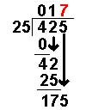
- Add, subtract, multiply, and divide numbers without a calculator. Multiplication and division are usually seen more than addition and subtraction. The math is able to be done without a calculator, but because students use calculators so much, even advanced students can be awkward when doing long division by hand. Watch the proper placement of the numbers. For example can you do this problem? 425/25

- Know simple conversion factors / such as the number of days in a year (365) or hours in a day. Other numbers to know: U.S. population (320 million) and world population (7 billion)
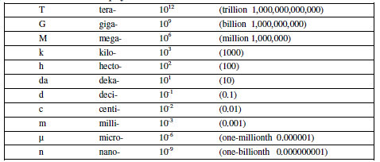
- Know and convert metric prefixes / Remember Kids Hate Doing Math During Class Movies

- Calculate percentages / Example: 80/200 = 40/100 = 0.4 = 40%

- Know how to work with percentages. If given a percentage understand how to calculate its total value

- Percent Change (rate of change is similar just divide by a time and don’t multiply by 100)

- Put very large or very small numbers into scientific notation /
Examples: 310,000,000 = 310 million = 310 x 10⁶ = 3.1 x 10⁸
**To S.N.: 0.00068 6.8 x 10⁻⁴ 6,845 6.8 x 10³
**To Standard 5.56 x10⁻⁶ 0.00000556 5.56 x 10⁶ 5,560,000

- Work with scientific notation problems without a calculator / Multiplication and division will be common. Multiplying numbers in scientific notion requires the exponents to be added. Dividing numbers in scientific notation requires exponents to be subtracted.
**Multiplication add exponents; multiply bases (3 x 10³) ∙ (4 x 10⁵) = 12 x 10⁸ = 1.2 x 10⁹
** Division subtract exponents; divide bases (5.2 x 10⁴) / (2.6 x 10²) = 2 x 10²
**Addition convert both #’s to the same exponent; add bases; exponents stay the same
(3000 x 10⁶) + (14 x 10⁵) = 3001.4 x 10⁶ = 3.0 x 10⁹
**Subtraction convert both #’s to same exponent; subtract bases; exponents stay the same
- 0³) – (1000 x 10²) = 1900 x 10³ = 1.9 x 10⁶

- Be proficient at unit manipulation (AKA dimensional analysis or factor label) / This is one of the most important math skills in APES, because you will have to fit numbers with units together through multiplication and division to get the desired units.

MORE Math Practice!
Metric Conversion: convert the following numbers as indicated.
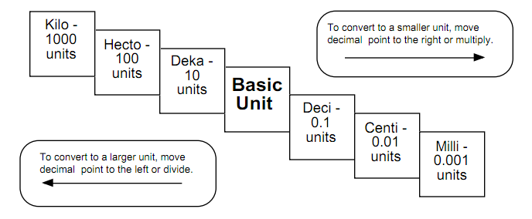
- 25cm = ______________ km
How much does the prefix mega (M) represent?

How much does the prefix micro (µ) represent?

How much does the prefix tera (T) represent?

How much does the prefix nano (n) represent?

How much does the prefix giga (G) represent?

- 0.01km = ______________ mm

- 123m = ________________ dam

Watt (W)
- 578mm = ______________ dm

- 35kW = _______________ W

Percent Change: Use the following equation to assist in solving the next problem.

- Calculate the percent increase in world grain production per person between 1950 and 2000 using the following data.
Year | Per capita world grain production (kg)
1950 | 200
1970 | 223
1990 | 240
2000 | 250

- A major coal fired electrical power plant produces 2.0x10⁴ MW-hr of electrical energy per day.
  - Assuming that 1.0 MW-hr corresponds to 3.4x10⁶ BTU’s, how many BTU’s are produced by the plant each day?

  - Assuming that one pound of coal can produce 4000 BTU’s, how many pounds of coal are used by the plant each day?

- A major coal fired electrical power plant uses 4500 tons of coal each day. Each pound of coal can produce 4000 BTU’s of electrical energy. Given: 2,000 pounds = 1 ton; 3600 BTU’s = 1.0 kW-hr
  - How many kW-hr of electrical energy are produced by the plant each day?

- A family is building a new home in Alaska which experiences severe winters. Assume the following
• The house has 4000 square feet
• 100,000 BTU’s of heat per square foot are required to heat the house for the winter
• Natural gas sells for $5.00 per thousand cubic feet
• One cubic foot of natural gas supplies 1000 BTU’s of heat energy
• 1 kilowatt-hour of electricity supplies 10,000 BTU’s of heat energy
• Electricity costs $50 per 500 kWh
Calculate the following, showing all the steps of your calculations, including units
  - The number of cubic feet of natural gas required to heat the house for the winter

  - The cost of heating the house using natural gas

  - The cost of heating the house using electricity

Extra Space for NOTES

____________________________________________________________________________________________________________________________________________________________________________________________________________________________________________________________________________________________________________________________________________________________________________________________________________________________________________________________________________________________________________________________________________________________________________________________________________________________________________________________________________________________________________________________________________________________________________________________________________________________________________________________________________________________________________________________________________________________________________________________________________________________________________________________________________________________________________________________________________________________________________________________________________________________________________________________________________________________________________________________________________________________________________________________________________________________________________________________________________________________________________________________________________________________________________________________________________________________________________________________________________________________________________________________________________________________________________________________________________________________________________________________________________________________________________________________________________________________________________________________________________________________________________________________________________________________________________________________________________________________________________________________________________________________________________________________________________________________________________________________________________________________________________________________________________________________________________________________________________________________________________________________________________________________________________________________________________________________________________________________________________________________________________________________________________________________________________________________________________________________________________________________________________________________________________________________________________________________________________________________________________________________________________________________________________________________________________________________________________________________________________________________________________________________________________________________________________________________________________________________________________________________________________________________________________________________________________________________________

