Unit 10 Atmosphere Under
Attack!

What’s the difference between weather and climate? What is the greenhouse effect and should we really be worried about climate change? Are we going to have more Hurricanes like Sandy & Irene? What’s the Kyoto Treaty? Did America sign it? Is this stuff current or what? When you signed up for this course, you KNEW we’d be talking about these issues! Hopefully, as you become voting members of the public, you will be able to assimilate the information you read with the information you know and be able to make smart choices when voting.
WATCHING THE VIDEOS PROPERLY IS HIGHLY RECOMMENDED FOR THIS UNIT! NOCLPS

Primary Air Pollutants (Video 10.1 Air Pollution due ____________) (pages 517-526 in Textbook)
- Primary (Criteria) Pollutants / pollutants that come directly from the source without reacting in the atmosphere; Examples: SO_{x}, NO, NO₂, CO, Lead, and maybe…(CO₂?)
- Secondary Pollutants / pollutants that begin as primary pollutants and change form in the atmosphere; Change in a chemical reaction; Examples: PAN’s, H₂SO₄, HNO₃, O₃, (Smog)
- Bhopal, India / December 2, 1984, a pesticide plant, Union Carbide, leaked methyl isocyanate accidentally killed over 15,000 people in the surrounding town
- Technology to Reduce Air Pollution /
  - Electrostatic Precipitator / gives a negative charge to particulates which then are attracted to the positively charged walls and fall into a collector to be disposed off
  - Scrubber / mists of water droplets to removes particulates and gases such as sulfur dioxide; polluted liquid must be safely disposed of
  - Catalytic Converters / are used in automobile exhaust systems; under high temps a catalyst (palladium & platinum) converts CO into CO₂; hydrocarbons into CO₂ and water; and NOx into N₂ and O₂
- Particulate Matter AKA Aerosols(PM₁₀, PM_{2.5}) / Primary Pollutant
Source: incomplete burning of fossil fuels and diesel exhaust, natural sources: volcanoes, forest fires
Effects: reduces visibility, reduces photosynthesis, and respiratory/eye irritation, global cooling,
Reduction: filtering, electrostatic precipitators, alternative energy
- Nitrogen Oxides (NO_{x}) / N₂ (in air) + O₂ → 2NO under high temps Primary; 2NO + O₂ → NO₂ Prim and Sec
Source: auto exhaust and stationary sources of fuel combustion
Effects: acid deposition (rain), acidification of lakes, respiratory irritation, leads to photo smog & ozone
Reduction: Catalytic Converter on automobiles and reduce use of motor vehicles
- Sulfur Oxides (SO_{x}) / Primary Pollutant S + O₂ → SO₂
Source: coal burning power plants (also produces mercury air pollution) & burning of diesel fuel
Effects: acid deposition (rain), acidification of lakes, respiratory irritation, industrial smog
Reduction: scrubbers, burn low sulfur fuels like natural gas
- Carbon Dioxide (CO₂) / Primary Pollutant C_{x}H_{y} + O₂ → H₂O + CO₂
Source: combustion of fossil fuels
Effects: greenhouse gas — major contributor to climate change
Reduction: accomplished by increased fuel efficiency (gas mileage) mass transit
- Carbon Monoxide (CO) / Primary Pollutant
Sources: incomplete combustion of fossil fuels
Effects: binds to hemoglobin reducing bloods ability to carry O₂, formation of photochemical smog Reduction: accomplished by catalytic converters, oxygenated fuel, mass transit
- Lead (Pb) / Primary Pollutant
Source: leaded gasoline and metal refineries
Effects: nervous system damage, contaminated crops, soils, and surface waters
Reduction: ban leaded gasoline and use unleaded gas

Secondary Air Pollution (pages 527-530 in Textbook, see page 10 for AP air pollution formulas! STUDY!)
- Industrial Smog / found in cities that burn large amounts of coal (Beijing, China); consists of mostly sulfur oxides and particulate matter and does not need sunlight to form; in colder climates worse in winter
- Photochemical Smog / brown or orange-brown smog; exists in major cities that are in warm, sunny climates; frequent in Los Angeles, California; Mexico City, Mexico; often in Denver, Colorado
Source: requires sunlight; created by reactions b/t unburned hydrocarbons & nitrogen oxides mobile exhaust, creating secondary pollutants like ozone and PAN’s (see diagram page 458 in textbook; AP chem.)
Effects: burning eyes, coughing, irritates respiratory tract and aggravates asthma
- Ozone (O₃) / Secondary Pollutant (ozone in the stratosphere is super, but trouble in the troposphere)
Equation: NO₂ + UV sunlight → NO + O; O + O₂ → O₃
Effects: respiratory irritant, plant damage
Reduction: catalytic converters in automobiles reduce NOx and VOC emissions
- Peroxyacyl Nitrates (PAN’s) / products of a reaction between nitrogen dioxide, hydrocarbons (HC), and oxygen that uses UV light as a catalyst: HC’s + O₂ + NO₂ + UV light → CH₃COOONO₂ (PAN)
- Temperature or Thermal Inversions / layer of dense, cool air stuck under a layer of warm less dense air, pollution in trapped and bakes usually in a valley; layer may build to harmful levels (photochemical smog)
- Heat Island Effect / occurs when a city containing large amounts of concrete and pavement stores large amounts of heat resulting in a slightly higher average temperature than the surrounding area
- Clean Air Act (1970) / set emission standards for cars and limits for release of air pollutants; amended in 1990 it established a cap-and-trade program for SO₂.

Acid Deposition (Acid Rain) (pages 530-537 in Textbook)
- Acid Deposition / AKA Wet Deposition (Acid Rain) or Dry Deposition (Acidic Particles) / is simply the return of these acids to the ground causing the pH of surface water to decrease and toxic metals to leach
- Causes of Acid Deposition / more than half the acid deposition occurs in SE Canada and Eastern U.S. from coal and oil burning power plants/factories in seven states: Ohio, Indiana, Pennsylvania, Illinois, Missouri, West Virginia, and Tennessee
- Know how acid rain forms / STUDY!
- Equation for nitric acid formation: 2NO + O₂ → 2NO₂ + H₂O → HNO₃ (Nitric Acid)
- Equation for sulfuric acid formation: 2SO₂ + O₂ → 2SO₃ + H₂O → H₂SO₄ (Sulfuric Acid)
- Negative Effects of Acid Deposition / Know at least two!
  - Decline in fish in lakes (harmful when pH < 5.5)
  - Decline in forests (especially red spruce and maple)
  - Toxic metals, i.e. aluminum highly toxic to fish, leached by waters having lower pH
  - Damages statues, buildings, metals and car finishes
  - Birds lay thin fragile shells and calcium is unavailable because it dissolved away in the soil
- Controlling Acid Deposition / Know at least two!
  - Reduce emissions of sulfur by burning less coal, low sulfur coal, or switching to natural gas
  - Remove pollutants from smokestacks using scrubbers, electrostatic precipitators
  - Neutralize lakes with Calcium Carbonate (lime, a base) but its expensive and temporary
  - Reduce energy use or switch to non-fossil fuel energy sources

Indoor Air Pollutants (pages 542-547 in Textbook)
- Asbestos / Source: a fibrous mineral used for insulation and vinyl floor tile, now banned
Effects: lung cancer and mesothelioma (cancer of the chest cavity lining)
- Radon / Source: colorless, odorless, naturally occurring radioactive gas formed from the decay of uranium. Highest levels on the Reading Prong (PA, Northern NJ, and New York)
Effects: increases risk of lung cancer (15% of all cases)
Reduction: Seal up foundation so no gases can enter home, or improve ventilation of basement
- Formaldehyde / Source: colorless, pungent gas that is used in glues/resins, binds plywood-particleboard, and in carpets; Effects: irritation of eyes, throat, and skin; nausea, dizziness and can lead to cancer
- Volatile Organic Compounds (VOCs) / potentially toxic gases organic compounds that can evaporate easily from solid or liquid form, think paint, nail polish, it’s that new car smell!
- Sick building syndrome / presence of air pollution inside office buildings that causes its occupants to suffer persistent systems that disappear when they go outside. Enclosed areas can have air pollution 2 to 5 times greater than outdoors
- How to Reduce Exposure to Indoor Air Pollutants / Know at least two!
  - Regularly open windows
  - House plants like spider plant, aloe Vera and banana (removes carbon monoxide and formaldehyde)
  - Use wood or linoleum floors instead of carpeting
  - Remove shoes before entering house to reduce input of lead, dust, and pesticides
  - Make sure fireplaces and stoves are properly installed, maintained, and vented
  - Don’t store hazardous chemicals inside your home or attached garage
Ozone Depletion (Video 10.2 Ozone Depletion due ____________) (pages 538-540 in Textbook)
- Ozone Depletion / the seasonal thinning of the ozone layer (mostly at the poles), caused by a group of chemicals used in refrigeration and propellants (aerosol cans) called chlorofluorocarbons (CFC’s)
Ex. methyl chloroform (CH₃CCl₃), carbon tetrachloride (CCl₄), Halon: consist of bromine, fluorine, carbon
THIS HAS NOTHING TO DO WITH CLIMATE CHANGE! A Totally Separate Issue!
- Know the ozone depletion reaction with CFC’s / UV light reacts with CFC’s to break a chlorine molecule off. The free chlorine then binds with one oxygen molecule, leaving a CLO and an O₂ which does not block UV radiation. One chlorine molecule can break thousands of ozone molecules
- Negative Impacts of Ozone Depletion /
- Increases the risk of sunburn, cataracts, and skin cancer
- UV exposure impairs photosynthesis, reduces size and productivity of plants
- Some aquatic organism (like frogs) are particularly susceptible to UV radiation and are declining in numbers
- Montreal Protocol / was passed in 1987, an international treaty drastically reducing CFC’s prior to year 2000 (the ozone hole is healing thanks to this ban)
- Global Distillation Effect / certain air pollutants that are persistent (like CFCs, PCBs, DDT) move from the hot equator to the cold poles and are eventually concentrated and deposited at the North and South Poles

Climate Change (Video 10.3 Climate Chane Basics due ____________) (Chapter 19 pages 663-693)
THIS IS THE ISSUE OF OUR TIME!
- Most Significant Greenhouse Gases / CO₂, Methane (CH₄), nitrous oxide (N₂O), CFC’s, H₂O (too short a cycle to have major impact). Traps outgoing infrared long wave radiation (heat) causing Earth to warm
- What is Climate Change (Global Warming) / is simply the increase in the average temperature near earth’s surface caused by human activities (anthropogenic causes); burning fossil fuels
- What is the Difference between Weather and Climate? / weather is the short term atmospheric conditions which change daily, while climate is the LONG-TERM AVERAGE temp and precipitation patterns. That is why it is foolish to state it was really cold this winter, therefore global warming is wrong! Overall the AVERAGE temperature/climate of the ENTIRE Earth is increasing, that is a fact!
- Human activities leading to climate change are / burning of fossils fuels, maintaining livestock (methane gas), and deforestation to name a few
- Albedo / the reflectivity of the certain Earth surfaces. Surfaces such as ice have a high albedo reflecting more energy, while surfaces such as bare rock and soil have lower albedo absorbing more energy
- Positive feedback loop / increasing the intensity of a mechanism (think positive means adding to the problem). For example, as glaciers and ice caps melt less energy is reflected back into space and more is absorbed by the Earth, therefore intensifying the warming effect.
- Negative feedback loop / decreasing the intensity on a mechanism (think taking away from the problem) For example, as the Earth’s warms more evaporation occurs, therefore creating more clouds which block solar radiation, therefore decreasing the warming effect
- Evidence of Climate Change / know at least three!
  - CO₂ is a major greenhouse gas (GHG) and humans produce vast quantities every year by burning fossil fuels (recall soda bottle with CO₂ vs. air lab, which one heated up faster?)
  - Detailed measurements of CO₂ concentrations increasing dramatically since the 1950’s
  - Measurements of ice core data from Vostok, Antarctica depicting much lower CO₂ levels going back hundreds of thousands years
  - Glaciers and sea ice have been melting at increasing rates. Since 1979, more than 40% of Arctic ice cap has receded
  - Precipitation trends are changing some areas becoming wetter and other place like California becoming drier
  - Sea levels have risen slightly mostly due to thermal expansion of the oceans

- Effects of Climate Change / know at least four! (Video 10.4 Climate Chane Effects due ____________)
- Sea level rise; 50% of the world’s population lives within 5 miles of the coast
- Disruption of the ocean’s conveyor belt which would stop redistributing heat from the equator to the poles, which could trigger an ice age
- As permafrost melts methane and ocean temperature rises methane hydrates (23x more potent GHG) is released in large quantities, this is a positive feedback loop which could lead to rapid warming.
- Ocean acidification happens when the ocean absorbs vast quantities of CO₂, the CO₂ forms an acid in the water causing the pH to decrease. The decrease in pH impacts the ability of coral and other organisms with calcium carbonate shells to exist
- Coral bleaching occurs as ocean temperature rise the symbiotic algae leave the coral (for cooler waters) taking on a white appearance which kills the coral shortly after
- Extinction of organisms that cannot adapt or migrate fast enough will eventually die (polar bears)
- Size and strength of storms will increase due to more energy available in the oceans and atmosphere (that does not mean more storms, just more intense)
- Pest and vector species (mosquitoes) have increased their ranges spreading disease and crop loss
- Areas that were once highly productive agriculture lands will shift northward as temperature rise
- Why the Political Inaction/Deception? / know at least three!
  - Oil companies are extremely powerful because they have lots of money and oil is NOT easily replaceable like CFCs where with ozone depletion
  - Science by its very nature is never “settled” and is never 100%, it is constantly changing and adjust to new data. Climate deniers use this fact to make people think scientists are still working on the issue.
  - NIMTOO Not In My Term Of Office – politicians like to tackle issues that have immediate results (like job growth) because most just care about getting reelected, any issue that is decades away does not “matter” as much because their term is 2 to 4 years
  - People by their very nature do not make changes until the issue is in their face or very bad. We are reactive instead of proactive. Example: won’t get a new roof on the house until it leaks…
- Slowing Climate Change / know at least three! (Video 10.5 Environmental Economics due ___________)
- Cap and Trade / is a regulatory system that is meant to reduce certain pollution and to provide companies with a profit incentive to reduce their pollution. Under the system a limit (or "cap") on certain types of emissions or pollutions is set, and companies are permitted to sell (or "trade") the unused portion of their limits (at a profit) to other companies that are struggling to comply.
- Improve efficiency of our homes and transportation systems. The more efficient we are the less fossil fuels we burn and the emissions that go along with it
- Conserve energy by buying local products which don’t have to travel long distances burning fossil fuels, drying clothes outside, walk, bike, public transportation, and carpooling
- Shift to renewable energy resources such as wind, solar, tidal, and geothermal
- Reduce deforestation. Cutting down trees is a double whammy; it removes the carbon sequestering ability (stops photosynthesis) and releases the carbon that was stored in the tree
- Use more natural gas and nuclear power, close or improve the efficiency of coal-fired power plants
- Sequester (capture) the CO₂ by planting more trees, injecting CO₂ into porous rock, and chemically removing CO₂ from exhaust
- Kyoto Protocol / an international treaty that is designed to reduce the emission of greenhouse gases with the goal of reducing climate change (1992). The U.S. initially signed the treaty, but then failed to ratify it in the U.S. Senate. With the U.S. and China not signed it lost much of its significance

Activity Directions:
The color white is now a pollutant. For each item of visible clothing that has ANY white on it, you must pay 1 ticket. Each student is allowed 2 tickets and a packet of Smarties. If you do not have enough tickets to cover your “white pollution,” you will lose 10 points per white pollutant on this activity. You may attempt to “buy” (with Smarties), trade, etc. to gain tickets if you need. You will have 7-10 minutes in which to work to meet your White Pollutant Allowance Limitation.

Reflection questions:
- How many items with the color white are you currently wearing?

- Do you have a surplus, deficit, or equal amount of tickets to cover your White Pollution?

- If you have a surplus, what did you do with it? If you had a deficit, what did you do? If you were equal, just write in “equal.”

- Ask those who had to “buy” tickets… what seemed to be the going rate for purchasing White Pollution Allowances?

- If this experiment continued for a week, how would that affect your clothing choice each morning?

- How does this activity simulate the cap and trade system with regards to air pollution/gasses like carbon dioxide?

CLIMATE CHANGE DEBATE PROOF
Make sure the person you are speaking with understands the definition of climate change:
Climate change simply states that humans are adding CO₂ to the atmosphere by burning fossil fuels, increasing the natural greenhouse effect, causing an OVERALL increase in temperature of the entire Earth.
- Do you believe the fact that carbon dioxide has the ability to trap heat AKA it’s a greenhouse gas? If Yes go to number 2, if no go to 1a and 1b
  - Do or look up experiment on YouTube, type in the search bar “Global Warming CO₂ Experiment” with CO₂ trapping heat in vs. regular air (we did this in class)
  - Ask: How come Venus is the hottest planet in the solar system even though it is further from the sun than mercury?

- Do you believe the fact that humans are emitting large quantities of CO₂ by burning fossil fuels? If yes go to questions 3. If No go to 2a and 2b
  - Go to the next page and show actual data from the Keeling Curve and industrial revolution
  - Explain to them a simple combustion equation:
    - C_{x}H_{y} (fossil fuel, gas, hydrocarbons) + O₂ → CO₂ + H₂O

- Do you believe humans with a population of 7 billion, have the ability to affect Earth’s atmosphere? If yes go to question 4, if NO ask 3a
  - If humans are unable to alter Earth systems what caused the hole in the ozone layer?

- Did you know the fact that during the 2000’s Earth observed less solar output, but surface temperatures still rose? If yes go to question 5, if NO go to 4a
  - http://science.nasa.gov/science-news/science-at-nasa/2009/01apr_deepsolarminimum/

- Did you know that fact that 2016 was the hottest year ever recorded, with all 10 of the warmest years occurring in the past 12 years? If yes go to question 6, if NO go to 5a
  - http://data.giss.nasa.gov/gistemp/graphs_v3/

- Lastly, did you know the fact that scientist have drilled ice core data from Antarctica going back 650,000 years? Each layer is like the rings of a tree. The ice acts like a time capsule trapping gasses from the atmosphere of the past. Scientists then melt each layer of ice and record the amount of CO₂. Scientists found CO₂ levels 25% higher than any other time during the 650,000 year time period and at RATES NEVER observed. Please see the second graph on the next page to illustrate this concept.
If you said yes (or cannot negate the facts) to these questions then you believe the fact that human actions are causing climate change. Climate change simply states that humans are adding CO₂ to the atmosphere, increasing the natural greenhouse effect, causing an overall increase in temperature of the entire Earth. Not just where you live, but it is a global average! That means our winters can be very cold, but overall Earth is warmer.
If you said no, then please do your own research and present data that can counter these observed facts. If you can’t present any data which can refute these observations then you need to ask yourself why you don’t “believe” these scientifically observed facts. Ask yourself why you reject a 97% (nothing is ever 100% in science) scientific consensus but accept others like smoking causes cancer, the Earth is round not flat, or advice from doctors which is based on science. If you are listening to politicians remember they are not scientists and only care about being reelected.

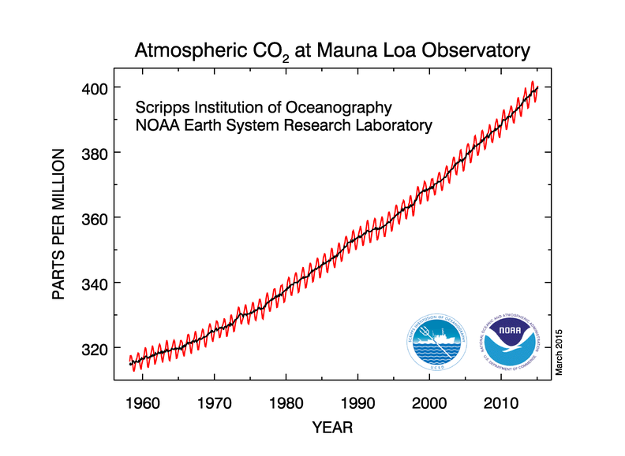
Keeling Curve

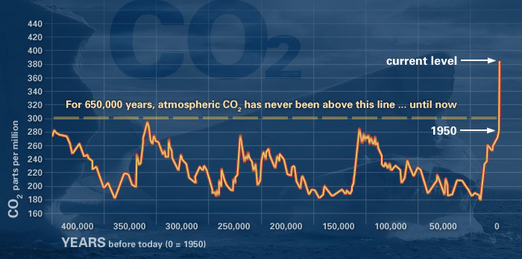
Vostok, Antarctica Ice Core Data
Source: http://climate.nasa.gov/evidence/

Common Climate Change Denier Arguments
- “Climate has changed before or it’s a natural cycle.” | True, but it has never changed this fast and has never been caused by humans. No known natural force fits the fingerprints of observed warming except anthropogenic greenhouse gases. 4 out of the 5 past mass extinctions had climate change as a main factor!
- “The sun is the reason the Earth is getting hotter” | The sun’s output has been extremely constant over this recent warming, so it cannot be the sun.
- “If the Earth gets hotter it will be good for the Earth and humans, we could have warmer weather in NY and it will be great.” | Give them all the extreme changes that can happen with a hotter Earth. It is scary! Sea level rise, ocean acidification, rapid release of methane gas a super greenhouse gas, shutdown of ocean circulation…etc.
- “Animals and plants will adapt to the changes.” | Most stationary animals like plants and corals cannot adapt at the current rates of change because they are slow growing. Our entire society depends on these organism to sustain itself.
- “Glaciers and/or Antarctic sea ice is growing.” | Glaciers worldwide are in rapid decline. However there is more Antarctic sea ice because the ice on the land is melting and floating into the ocean, therefore making more sea ice.
- “It freaking freezing out!” or “There is an insane amount of snow out there” | Local cold weather has little to with long-term climatic changes. That is why it is called climate change and not weather change! Also with more heat there is more evaporation, therefore more water vapor in the air leading to more snow.
- “Carbon Dioxide (CO₂) is what we exhale and plants use it for photosynthesis, it is not a pollutant.” | What you said is true of CO₂, however it is primary gas in the greenhouse effect and is a small percentage of our atmosphere so adding the quantities we add is increasing the greenhouse effect greatly.
- “Humans are only a tiny portion of CO₂ produced globally most comes from volcanoes and other natural sources.” | Incorrect, human produce about 30 billion tons of CO₂ annually while volcanoes 300 million tons a year, it isn’t even close. We account for about 25% of the total CO₂ currently in the atmosphere!
- “The science isn’t settled.” This is the NEW current political answer!!! | Human CO₂ is causing global warming it is known with high certainty, peer-reviewed data, & confirmed by mountains of observations. Science by its very nature is never settled it is constantly collecting new data, it will never be settled.
- “We would destroy the economy if you regulate CO₂” | The fossil fuel industry would take a hit and could slow our economic growth in the short-term, however if we do nothing the cost will be much worse and harder in the future. By switching to more sustainable energy sources it will create more jobs which last infinitely and will improve our economy long-term
- “Humans are too insignificant to have any effect on Earth’s climate.” | There are currently 7 billion people on planet Earth. In just a few years humans have been able to cause a massive hole in the ozone layer by releasing chemicals humans have made. We cause extinctions of many animals species...causing the current 6th mass extinction...we have immense power
Climate Change vs. Ozone Depletion
Climate Change | Ozone Depletion
Source(s) of Climate Change: | Source(s) of Ozone Depletion:
Chemicals Involved: | Chemicals Involved:
Environmental/Human Impacts: | Environmental Impacts:
 | Human Impacts:
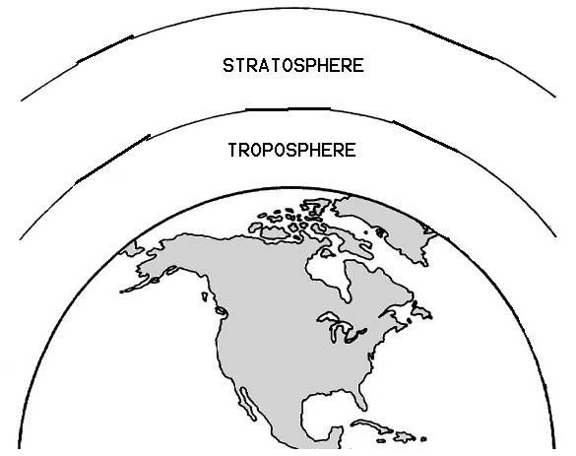  Layer and Type of Light Wave: | Layer and Type of Light Wave:
International Agreements: | International Agreements:
AIR POLLUTION CHEMISTRY
Air Pollution in the Troposphere

→ All fossil fuels contain large amounts of carbon (from the molecules of decomposed lifeforms). The combustion of fossil fuels (reaction with oxygen) produces carbon dioxide and carbon monoxide:
C + O2 → CO2 (the #1 man-made greenhouse gas)
2C + O2 → 2CO (incomplete combustion)
→ Coal may also contain sulfur which reacts during combustion:
S + O2 → SO2
→ During combustion, the nitrogen that composes 80% of the air in the troposphere reacts:
Photochemical Smog: Tropospheric Ozone (this is the hardest part of APES)
- Nitric oxide is formed in the car engine
N2 + O2 → 2NO
- In the air, nitric oxide combines with molecular oxygen to form nitrogen dioxide
2NO + O2 → 2NO2 (causes orange-brownish haze)
- Nitrogen dioxide absorbs UV energy and splits to form nitric oxide and atom oxygen
NO2 + UV light → NO + O followed by:
- In sunlight, the atomic oxygen combines with oxygen gas to form ozone
O + O2 → O3 (O3 is ozone and is irritating to animals and destroys plant tissue in the troposphere!)
- Hydrocarbons emitted by cars reacts with nitric oxide producing PAN’s
Hydrocarbons + O2 + NO2 → PANs (peroxyacyl nitrates cause burning eyes and damages vegetation)

Acid Precipitation
3NO2 + H2O → 2HNO3 + NO (HNO3 is nitric acid and causes acid precipitation)
2SO2 + O2 → 2SO3 followed by:
SO3 + H2O → H2SO4 (sulfuric acid)
→ Acid deposition can be neutralized by the addition of lime (CaCO3) which is a base (a base will neutralize an acid)

Stratospheric Ozone Formation and Destruction:

The reaction that is supposed to happen, with the decomposition of ozone and then its formation:
O₂ + UV(C) light (breaks O₂ into single oxygen molecules O and O) → O₂ + O → O₃

This is the decomposition of CFCs (follow the chlorine!)
CCl3F (CFC) + UV light → CCl2F + Cl followed by the destruction of stratospheric ozone:
Cl + O3 → ClO + O2 followed by:
ClO + O → Cl + O2 (same as second step above) followed by: (these reactions are repeated thousands of times to destroy thousands of ozone molecules)

POLLUTANT | PRIMARY or  SECONDARY | SOURCE | HUMAN EFFECTS | ENVIRONMENTAL EFFECTS | REDUCTION
Particulate Matter | Primary | Incomplete combustion, exposed soils, natural sources like volcanoes/forest fires | Eye irritation, lung damage, asthma | Global cooling, reduced visibility, reduced photosynthesis | Filter smokestack emissions, electrostatic precipitators
Sulfur Dioxide (SO₂) | Primary | Burning of coal, burning of diesel fuel | Respiratory irritation | Leads to acid rain; industrial smog | Wet Scrubbers, burn low sulfur coal; burn natural gas
Mercury (Mg) | Primary | Burning of coal | Toxic to the nervous system | Bioaccumulation and biomagnification | Burn less coal, “clean” coal, alternative energy
Carbon Monoxide (CO) | Primary | Incomplete combustion of fuel: auto exhaust, furnaces, heaters, wood stoves | Out competes O₂ for hemoglobin, potentially Death | Contributes to ground level (tropospheric) O₃ | Catalytic converters in car exhaust system
Carbon Dioxide (CO₂) | Primary | Combustion of any organic material, gasoline, coal, natural gas, biomass. Also respiration | ____ | Primary greenhouse gas, CO₂ absorbs thermal radiation and re-emits it at lower wavelengths. | Reduce fossil fuel use; alternative energy
Nitric Oxide (NO) | Primary | Transportation and factory exhaust; High heat of engine causes O₂ + N₂ → NO | Respiratory irritation | Leads to acid rain and photochemical smog | Catalytic converters
Nitrogen Dioxide (NO₂) | Both | Transportation and factory exhaust; 2NO + O₂ → NO₂ | Respiratory irritation | Leads to acid rain and photochemical smog | Catalytic converters
Lead (Pb) | Primary | Leaded gasoline exhaust; Smelters (metal refineries) | Brain damage, mental retardation | Contaminates soil, crops and surface waters | Ban leaded gasoline
Tropospheric Ozone (O₃) | Secondary | Reaction of NO from auto exhaust, VOCs with sunlight, heat and O₂ | Respiratory and eye irritation, emphysema asthma | Major component of photochemical smog, damage to plants and trees, reduces visibility | Reduce NOx and VOCs  Catalytic converter
Volatile Organic Compounds (VOC’s) | Both, mostly primary | Automobile exhaust, solvents, industrial processes, household chemicals | Some are carcinogenic, some harm respiratory system | Contributes to ground level (tropospheric) O₃ | Catalytic converter
Peroxacyl Nitrates (PAN’s) | Secondary | Transportation exhaust NO₂ + hydrocarbons/VOCs reacts with light → PANs | A strong respiratory and eye irritant. Potentially mutagenic | Damages vegetation, reduces photosynthesis, part of photo. smog | Reduce NOx and VOCs  Catalytic converter
Sulfuric Acid (H₂SO₄) | Secondary | 2SO2 + O2 → 2SO3 then  SO3 + H2O → H2SO4 | Respiratory irritation | Acid Deposition Effects | Burn less coal
Nitric Acid (HNO₃) | Secondary | 3NO2 + H2O → 2HNO3 + NO | Respiratory irritation | Acid Deposition Effects | Reduce NOx  Catalytic converter

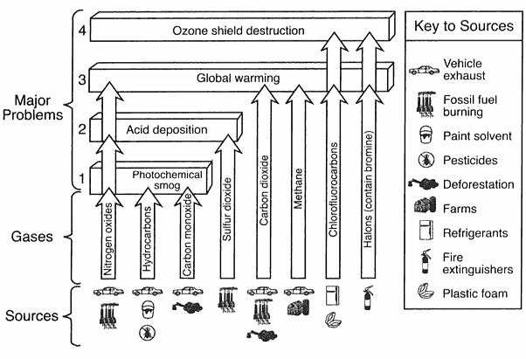
Summary of air pollutants, sources, and the part of the atmosphere they affect

