Name: __________________________________ APES
Quiz
(14pts)
Completeness
(10pts)
GRADE:
Mr. Crisci
Lab: SOIL ANALYSIS Date: _________

Introduction:
Soil consists of rock particles, water, dissolved chemical substances, decaying organic matter, and a large assortment of microorganisms, roots, and insects. Soil constitutes an important type of ecological community.
In these labs, you will explore the physical and chemical makeup of a soil sample.

Through the process of weathering, rocks are weathered into fine particles of clay (<0.002 mm in diameter),
silt (0.002 to 0.05 mm), and sand (0.5 to 1.0 mm). The relative amounts of the different sizes of particles control two very important properties of soil; its fertility and its ability to hold water.

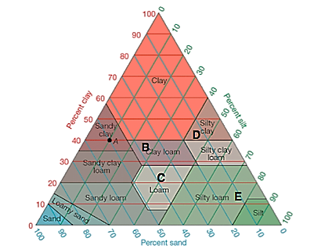
**Soil fertility is measured by the amount of nutrients available for plant growth. These nutrients in soils are usually found in the form of positively charged ions, such as sodium, calcium, and potassium. Since the tiny particles of clay often have a negative charge, the positive ions attach to the clay particles. The larger particles of silt and sand do not have this negative charge. Therefore, soils with more clay tend to be more fertile.**

A. Soil Texture Triangle
- Examine Figure 1, which shows the classes of soil textures based on their percentage proportions.
- Determine the name and percent composition of points B, C, D, and E.

B is ____________________ and has ____% clay, ____% silt, & ____% sand.

C is ____________________ and has ____% clay, ____% silt, & ____% sand.

D is ____________________ and has ____% clay, ____% silt, & ____% sand.

E is ____________________ and has ____% clay, ____% silt, & ____% sand.

PART 1- FIELD (OUTSIDE) SOIL TESTS

Procedure:
B. Soil Permeability/Infiltration/Percolation Test
- Obtain a permeability cylinder from your teacher.
- Using a hammer and block of wood drive the cylinder into the ground leaving about an inch of the cylinder exposed at the surface. Use a ruler to make sure it is as close to an inch as possible.
- Pour water to the top of the cylinder careful not overflow it. Start the timer as soon as you are done pouring. Let it run for as long as possible if it hits an hour stop.
- Measure how much the water has dropped and the time it took to drop that amount
- Record it in the table below:

Data Table 1: Infiltration Data Chart
Amount Water Level Dropped in inches | Time it Took to Drop That Amount

- Calculate how much the water will drop in a 1 hour (60 minutes). Show your work in the space provided below.

- Classify the rate using the infiltration chart below

Classification | Infiltration Rate (inches/hour)
Very Slow | Less than 0.06
Slow | 0.06 to 0.2
Moderately Slow | 0.2 to 0.6
Moderate | 0.6 to 2.0
Moderately Rapid | 2.0 to 6.0
Rapid | 6.0 to 20.0
Very Rapid | Greater than 20.0

- How would you classify the infiltration rate of the soil you tested based on your calculations?

C. Qualitative Soil Test – Ribbon Test
- Using the flow chart called “Estimating Soil Texture” (Figure 2) perform the ribbon test to determine the texture of your soil sample.
- Refer to the soil triangle on page 1 to determine approximate percentages of sand, silt, and clay for your sample.
- Record all results in Data Table 2.
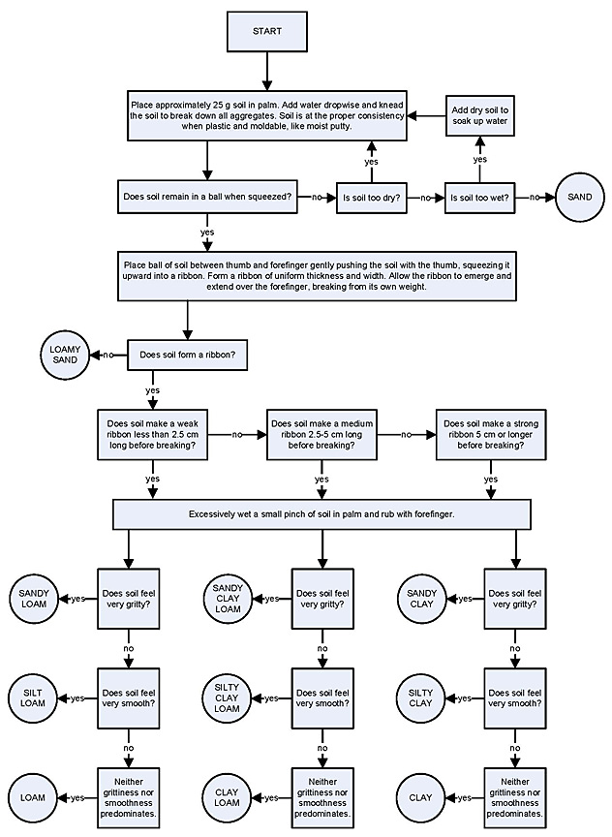
Figure 2 - Estimating Soil Texture (Ribbon Test)
Data Table 2: Ribbon test observations
Note: Refer to the soil triangle on page 1 to determine approximate percentages of sand, silt, and clay for your sample.
Description of where you found your soil sample. (What horizon?)
Percentage of Sand
Percentage of Silt
Percentage of Clay
What type of soil is this based on the soil ribbon test?

D. Soil Horizons
- Observe the soil profile closely. Use nails to mark the different soil horizons. Using a ruler measure the depth of each horizon and record it in your data table.
- Next take a sample from the horizon of your choosing to test in lab. Make sure you remove any twigs and pebbles. Use a soil sieve if one is provided.

Data Table 3: Soil Horizons Depth
Depth of O Horizon | Depth of A Horizon | Depth of B Horizon
Observations and Descriptions of Layer (color, organisms, etc.) | Observations and Descriptions of Layer (color, organisms, etc.) | Observations and Descriptions of Layer (color, organisms, etc.)

PART 2- CLASSROOM SOIL TESTS

E. Quantitative Soil Test
- In a graduated cylinder, place 40 to 50 mL of your soil sample. Tap the bottom of the tube gently against your hand to pack soil and eliminate any large air pockets. Add more soil if necessary.
- Add tap water SLOWLY to the level of threads in the container
- Now tightly cover, using parafilm, to seal it and shake the whole apparatus until the soil and water completely mix to make a free-moving slurry. Be sure to break up any lumps in the soil. Do this for at least one minute.
- Place the cylinder LABELED on the table and let it sit overnight.
- When the soil has settled out there should be three reasonably distinct layers of sand, silt, and clay.
- Measure the volume of each layer and divide each layer by the total volume using the formula below. Multiply your answer by 100 to get a percentage. Record your results in Data Table 4.
Calculate the percentages of each soil sample using the following formula:

$(Amount of Sand/Silt/Clay)/(Total Amount of Soil)$ x 100 = % of sample

- To check your calculations, add the percentage of sand, silt, and clay. The total percentages should add up to 100.
- Use the Soil Triangle to determine the name of your soil type. Record the name in the chart.
- Do the percentages from your qualitative & quantitative tests match?

Data Table 4: Quantitative Soil Test
Note: Refer to the soil triangle on page 1 to determine approximate percentages of sand, silt, and clay for your sample.
Height of all 3 segments (not including any extra water) together
Percentages of Sand
Percentages of Silt
Percentages of Clay
What type of soil is this?

F. Soil Nutrient and pH Test
Procedure:
- Follow the guidelines in your packet to perform the following tests on your sample:
    - Nitrate-Nitrogen test
    - pH test
    - Phosphorus test
  - Record all results on Data Table 5.

Data Table 5: Chemical Composition of Soil
Description of where you found your soil sample. (What horizon?)
Nitrate-Nitrogen Test
pH Test
Phosphorous Test

Lab Questions:
- What is the importance of having a soil with a pH close to neutral?

- Discuss the role of nitrogen in promoting plant growth. (think nitrogen cycle and why it is important)

- If the rate of top soil for a temperature deciduous forest (where you live and this soil was samples) is 1in/225 years, how long would it take for this soil horizon to develop?

Depth in inches of the A horizon you measured = ________________

Number of years to develop = ___________________

- What problems can occur in a soil that has:
  - Too much sand?

  - Too much clay?

- Based on the results of ALL of your tests what conclusion would you reach about the fertility of you soil sample? Support your answer with data obtained from the tests you performed.

