Quiz
(14pts)
Completeness
(10pts)
GRADE:
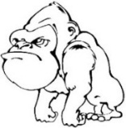
Name: __________________________________ APES
Mr. Crisci
Lab: NITROGEN CYCLE CANDY STORYBOARD Date: _________

Nitrogen cycles through the environment in a number of forms: Nitrogen gas (N₂) ammonia (NH₃)/ammonium (NH₄+), nitrate (NO₃), nitrite (NO₂) and as a protein. The proteins are composed of amino acids. While all living things utilize this element, the primary mediators of its movement and availability are BACTERIA. Various species of bacteria use each of the forms listed. More complex forms of life such as plants and animals use nitrogen to manufacture protein, plants can make use of ammonia/ammonium and nitrate, while animals must receive the nitrogen as part of protein, and can make no use of the other compounds.

Element Color Code
Oxygen =
Nitrogen =
Hydrogen =
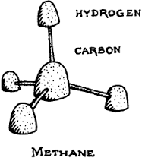

Procedure:
- Wash your hands!
- Obtain candy **You must choose what each color represents**
- Obtain toothpicks and break the toothpicks in half.
- Create a model of EACH nitrogen containing compound in the chart on next page using the candy, color code table, and toothpicks.
- Then draw a similar scene to the one in this lab on the provided whiteboard, or a scene provided to you by your teacher
- Using arrows and the models of each nitrogen compound you made place them on the whiteboard and be able to explain to the teacher the source, the effects, and how to reduce it. Use your verbal quiz packet for this unit and textbook pages 89 – 97 as a reference.
- When you feel confident your ENTIRE groups knows all the pollutant information. Call your teacher over so he/she can assess your learning and approve your drawing/models. If you cannot meet his/her approval you have to keep trying until you get them all correct in order to move on to the next step.
- You can copy your results from your whiteboard onto the nitrogen cycle diagram in this lab.
- YOU MUST INLCUDE ALL THE NUTRIENTS AND PROCESSES IN THE ATTACHED NITROGEN CYCLE

Teacher Signature: _________________________________________

COMPOUND | STRUCTURE | WHAT PROCESS OF THE NITROGEN CYCLE PRODUCED THIS COMPOUND? | CHEMICAL FORMULA | CAN BE USED DIRECTLY BY?  Animals/Plants/  Bacteria
Atmospheric Nitrogen
Ammonia | 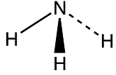
Ammonium | 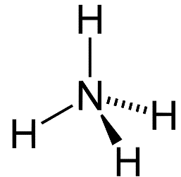
Nitrite | 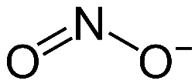
Nitrate | 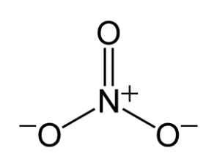

In each of the blank circles fill in the nitrogen containing compound in the correct spot:
Nitrogen gas (N₂), ammonia (NH₃), ammonium (NH₄+), nitrate (NO₃), nitrite (NO₂)

Label the arrows with the correct process (Note: some are used twice x2): Denitrification, Assimilation, Nitrogen Fixation (on legume root and in the soil) x2, Nitrification x2, Ammonification.

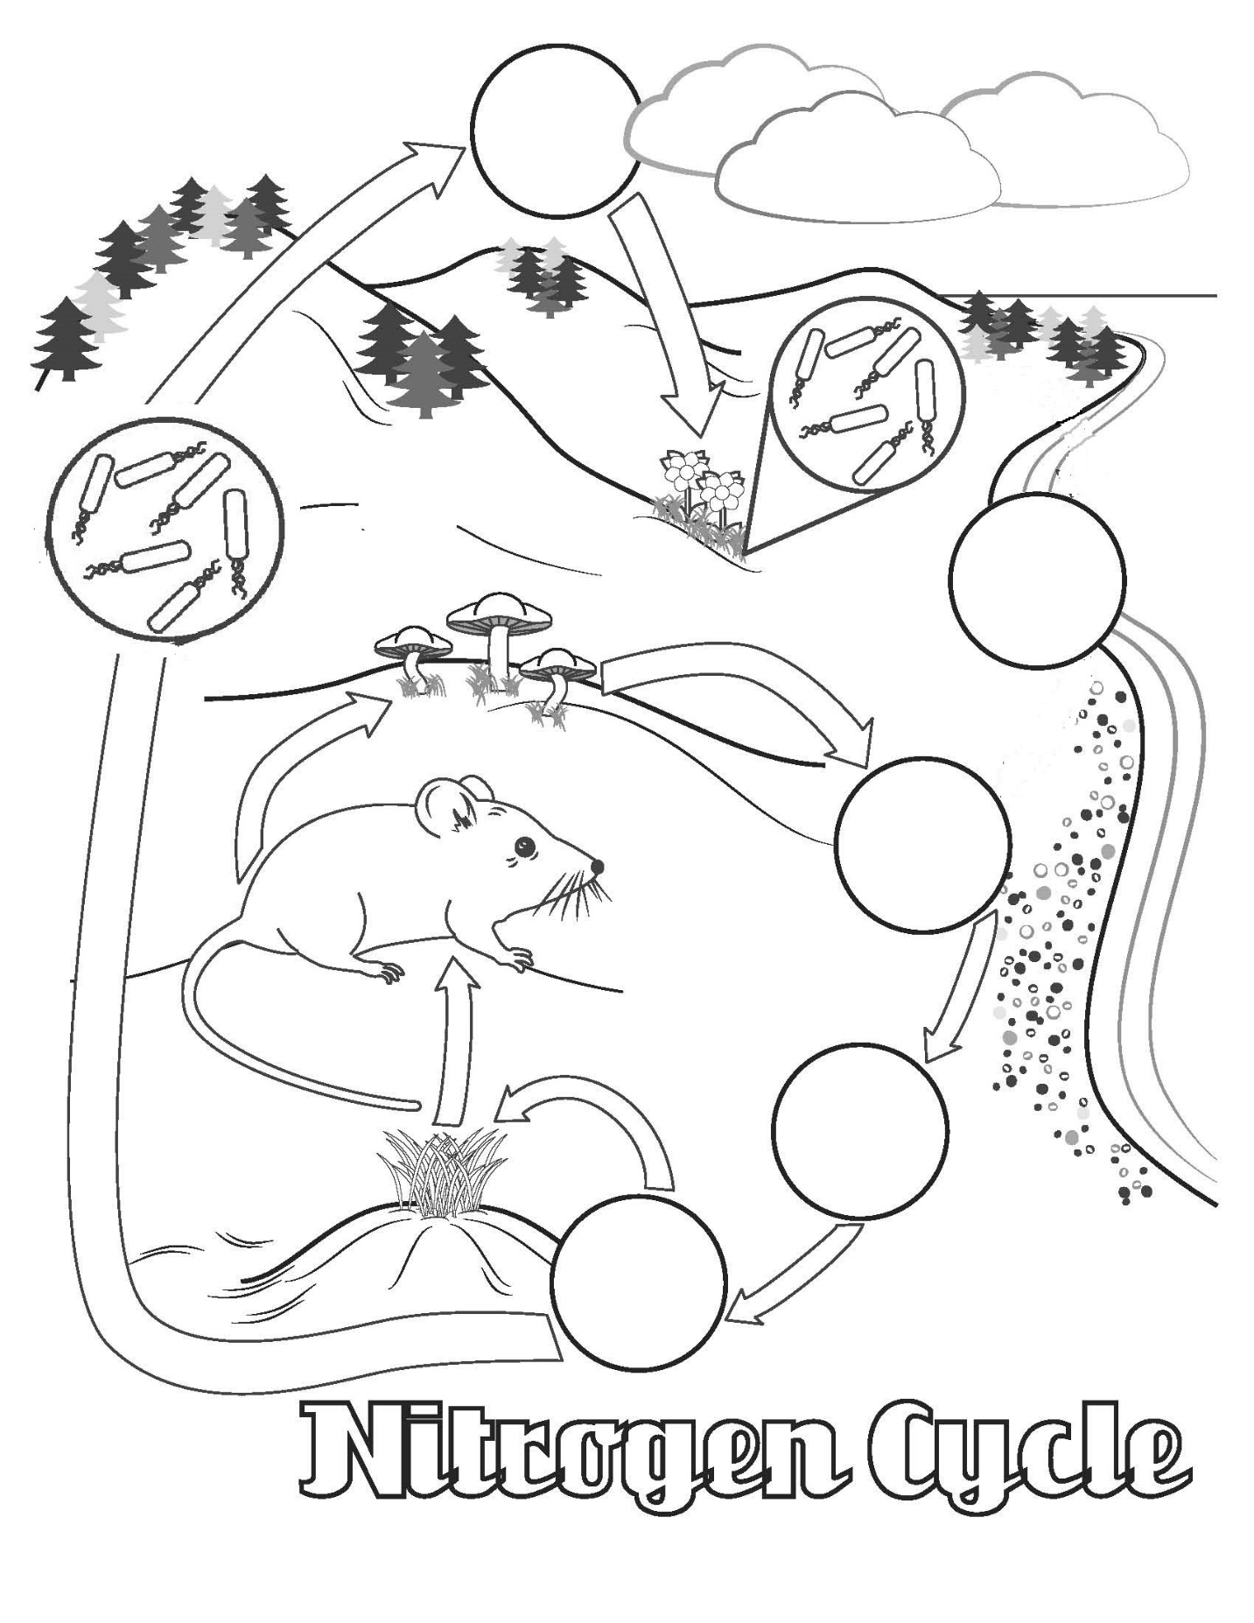
Fill in some arrows with these processes: Death/decomposition/detritus/waste, and consumption/eating
Questions:
- What is the major sink/resviour for nitrogen on Earth?

- What is the purpose of nitrogen in the human body?

- How do humans alter the nitrogen cycle?

- How do humans and animals get nitrogen into their bodies?

- Nitrogen is known as a limiting factor to plant growth. How do most plants obtain nitrogen from the environment?

- What are the name of the type of plant that can take in nitrogen directly from its roots? ________________
How come these plants can do this while most others cannot?

- There is another way nitrates can be made besides what was listed in the nitrogen cycle on the previous page. Explain that way below:

Ask yourself do you know each part of the nitrogen cycle enough to take a lab quiz on this? If not go back and relearn each step with your lab partner until you get it because you have a quiz on this!

