SACHEM EAST HIGH SCHOOL
Parent Permission/Information for Science Field Labs

Name ________________________________ has my permission to go on field trips by foot to local sites over the course of the 2017-2018 school year. We will be walking to sites just off campus. A local pond located at Brookhaven town hall and back woods doing soil sampling (see back for map). All field work will be done on well-maintained trails, avoiding high grass, and under constant teacher supervision/instruction.
Teacher: John Crisci – jcrisci2@sachem.edu
Outdoor Labs
Science classes benefit from laboratory experiences conducted on the grounds surrounding Sachem East High School. These experiences involve a class leaving the building and going into areas in the immediate vicinity of the school. These are laboratory exercises and all laboratory safety rules are in effect. Because we will be out of the classroom, it is prudent to inform parent(s) and obtain permission for student participation in these activities.
Each activity is designed with a purpose to fulfill course objectives. Students will be supervised at all times. There are risks such as insect bites/stings (mosquitos, ticks, bees, spiders, etc.), scratches, getting dirty, irritating plants (poison ivy, poison sumac, etc.), a little wet, and even, at times encountering wildlife. Because of these risks, however slight, it is important that we are notified if your child has any condition that would preclude his/her participation in these exercises. An alternative, topic related, task will be provided for any student unable to participate and the student will be under normal teacher supervision. Students will NOT be penalized for not attending an outdoor lab activity.
Proper clothing is MANDATORY in order to safely participate in these field experiences. Students MUST WEAR closed-toed shoes and pants that cover their legs. If they are not properly dressed they cannot participate and the student will remain inside under normal teacher supervision.
Students and parents are asked to read, sign and date this form at the bottom and return to their science teacher. Students will not be allowed to participate until this slip is returned.

Please specify medical concerns (i.e. medicine, dietary needs, allergies and physical restrictions) ____________________________________________________________________________________________________________________________________________________________________________________
PLEASE CHECK YES OR NO:
My child has an inhaler and will carry it with him/her (if needed). []Yes []No
My child has an Epi Pen and will carry it with him/her (if needed). []Yes []No
My child has my permission to use the insect repellent and sunscreen provided. []Yes []No

CHECK OR SIGN BELOW:
_____ No, my child does NOT have my permission to participate in outdoor laboratories.

I acknowledge that, despite the school’s precautions and supervision, participation in this field trip may involve some risk or property damage greater than that associated with a classroom based activity, and I consent to my child’s participation with that knowledge.
In the event that I cannot be reached in a medical emergency, I authorize in advance any necessary medical treatment for my child, under the nurses’ guidance, while he/she is participating in this field trip.

Parent/Guardian Signature __________________________________________________ Date___________
If you have any questions or concerns, please do not hesitate to contact me: jcrisci2@sachem.edu

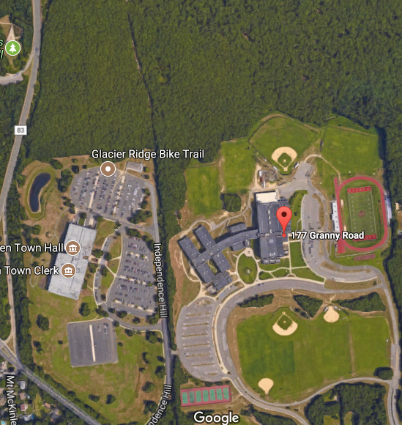
SOIL SITE:
Location of second off campus lab
POND:
Location of first off campus lab

