Name: __________________________________ APES
Quiz
(14pts)
Completeness
(10pts)
GRADE:
Mr. Crisci
Lab: ISLAND BIODIVERSITY Date: _________

Prelab:
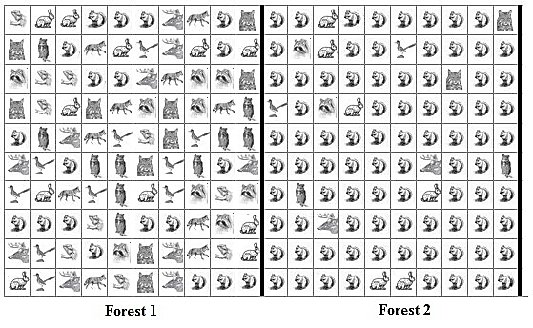
Forest 1 Species Richness (number of species): _________ Forest 1 Species Evenness: High – Medium – Low

Forest 2 Species Richness (number of species): _________ Forest 2 Species Evenness: High – Medium – Low
Forest 2 Diversity Calculation:
Forest 1 Diversity Calculation:
D = 1 - ∑ (n/N)²
Species | Forest 1  number (n) | Calculate Forest 1 (n/N)² | Forest 2  number (n) | Calculate Forest 2  (n/N)²
Lizard
Rabbit
Squirrel
`Deer
Fox
Bobcat
Blue jay
Owl
Raccoon
Total | N= | ∑(n/N)²= | N= | ∑(n/N)²=
Part I: Island Biogeography
Procedures:
- You are standing on the mainland and located in front of your four islands. There are two large islands and two small islands located at varying distances from the mainland. You cannot leave the mainland for this activity.
- From the end of the lab table, mark off a distance of one meter. At one end place the large container the other side of the lab table should be a small cup
- Obtain 3 ping pong balls from the lab supplies from each color for a total of 15. You will simulate colonization by standing behind the tape mark and attempting to throw/bounce the ping pong balls into the buckets. Toss one ball at a time; only balls that fully settle into a cup in the carton count as becoming established.
- Students will go to each island and count the species that have managed to colonize the island.
- The remaining students will go rescue the species that are drowning in the ocean (that means clean-up everything that missed an island).

Data Table 1:

Species | Island 1  Small and Close  number (n) | Calculate Island 1 (n/N)² | Island 2  Large and Close  number (n) | Calculate Island 2 (n/N)² | Island 3  Small and Far  number (n) | Calculate Island 3 (n/N)² | Island 4  Large and Far  number (n) | Calculate Island 4 (n/N)²
Blue Bird
Green Bird
Red Bird
Yellow Bird
Pink Bird
Total | N= | ∑(n/N)²= | N= | ∑(n/N)²= | N= | ∑(n/N)²= | N= | ∑(n/N)²=

Based on the data you gathered in the above chart, calculate the Simpson’s Diversity Index for each island using the formula to the right. You can use a calculator. Circle the island that has the highest diversity.
D = 1 - ∑ (n/N)²

The value of D ranges between 0 and 1. With this index, 1 represents infinite diversity and 0, no diversity.

Data Table 2:
 | Island 1  Small and Close | Island 2  Large and Close | Island 3  Small and Far | Island 4  Large and Far
Calculated Diversity Index

Part II: Biodiversity Importance
Preserving a diversity of life on Earth has come to be an accepted goal for many people. But when that goal comes into conflict with other goals, such as economic development, the question becomes, “How much diversity and at what cost?”
Statements regarding the Ethical Basis for Preserving Biodiversity
- Statement #1: The world is an interdependent whole made up of natural and human communities. The well- being and health of any one part depends on the well-being and health of the other parts. Humanity is part of nature, and humans are subject to the same irreversible ecological laws as are all other species on the planet.

- Statement #2: Recycling and storage of nutrients, combating pollution, and stabilizing climate, protecting water resources, forming and protecting soil and maintaining balance.

- Statement #3: Landscapes and species should all be conserved because they are beautiful and enrich the lives of humans. Human culture must be built on a profound respect for nature, a sense of being at one with nature. Activities like bird watching, fishing, trekking etc. It inspires musicians and artists.

- Statement #4: The well-being of future generations is a social responsibility of the present generation. Therefore, the present generation should limit its consumption of nonrenewable resources to the level that is necessary to meet the basic needs of society and ensure that renewable resources are nurtured for their sustainable productivity.

- Statement #5: No one knows what humans may need in the future. If species have become extinct, humans can never benefit from them. Provision of medicines and pharmaceuticals, food for the human population and animals, ornamental plants, wood products, breeding stock and diversity of species, ecosystems and genes.

- Statement #6: 80% of human food supply comes from 20 kinds of plants. But humans use 40,000 species for food, clothing and shelter. Biodiversity provides for variety of foods for the planet. Biological sources provide many industrial materials. These include fiber, oil, dyes, rubber, water, timber, paper and food.

Using the Values Table that follows, which statement (or statements) from the argument for preserving biodiversity is implied by the type of value given? Write the number of the statement in the right column. A statement may fit into more than one category.
Type of Value | Source of Value of Living Organisms | Statement #(s)
Ethical/Religious | The fact that they are a living breathing creature / Having been created by a supernatural being or force.
Aesthetic | Their beauty and the rewards we derive from their beauty. The sense of awe and wonder they inspire in us
Economic/ Recreational | The direct and indirect ways in which they benefit us. Sport, tourism, and other recreations.
Ecological/ Intellectual | Their contributions to the health of the ecosystem. What they can contribute to knowledge.

Which “Type of Value(s)” from the previous page, could be used to support preservation of:
- All 1200 (most likely more) species of beetles in the tropical rain forest?

- Sharks?

Conclusion Questions:
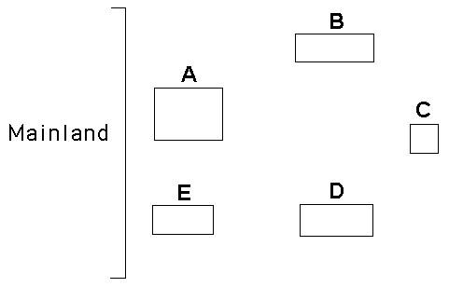
- Bases on what you learned from this lab look at the image of the islands to right which one would be the most diverse? Which one would be the least?

- Would a habitat of 10 species (10 individual of each) be more or less diverse than a habitat containing 1 species with 85 individuals and 9 other species with 1 representative of each? Explain:

- What two factors influence the biodiversity of an island?

- An island habitat does not have to be a literal island surrounded by a body of water. Explain how humans have created island habitats.

- Imagine you are working on designing a reserve, but the final site has not yet been decided, and you must choose between two sites. Site 1 has a very low community diversity value because it is largely dominated by a single species; however, one of the rare species found there is so rare it is found in only one other park. Site 2 lacks this particular rare species, but has much higher diversity values because it contains more species than Site 1 and none of the species is particularly dominant. Which site would you choose for the reserve and why?

