Name: __________________________________ APES

|  |  |
| --- | --- |
| Quiz  (14pts) |  |
| Completeness  (10pts) |  |
| **GRADE:** |  |

Mr. Crisci

**Lab: COUNTING POPULATIONS** Date: **_________**

**Procedure:**

***Part 1 – Measuring Weed Population Density of a Football Field***

Record the number of clovers and plantains in each quadrant and record each number in the table below:

**Total of your groups square meter:**

Clover:

Plantain:

|  |  |
| --- | --- |
| Clover:  Plantain: | Clover:  Plantain: |
| Clover:  Plantain: | Clover:  Plantain: |

|  |  |  |
| --- | --- | --- |
| **Class Data** | **Clovers** | **Plantains** |
| Group 1 |  |  |
| Group 2 |  |  |
| Group 3 |  |  |
| Group 4 |  |  |
| Group 5 |  |  |
| Group 6 |  |  |
| Group 7 |  |  |
| Group 8 |  |  |
| **Averages:** |  |  |

Now take your totals and multiply it by **5,351.2 m2** because that is how many square meters are in football field:

Clovers in field:

Plantains in field:

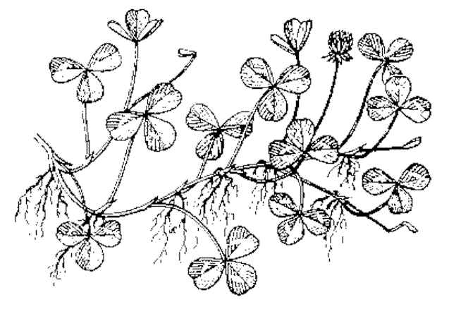

Clovers

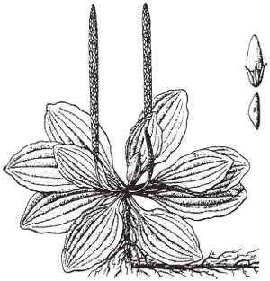

Plantain



1. The graphs on the previous page represents various graphs of rate populations. Use this graph to answer the following questions:
   1. Which letter represents logistic growth?
   2. Which letter represents linear growth?
   3. Which letter represents the carrying capacity of the rate population?
   4. Which letter represents how the rat population overshoots the carrying capacity?
   5. Which letter represents the biotic potential of the rats if they had unlimited resources (exponential growth)?
2. The area of Farmingville, New York is 3.3 square miles. According to the most recent study there are 1,118 male and 1,280 female rats living there. **Calculate the total population density of Farmingville in rats / square mile. Show work and circle your final answer.**
3. What type of population dispersion (clumped, random, or uniform) would you say these weeds exhibit? Explain why you chose this type:
4. How would you count a mobile population, such as rats or geese (use the previous article as a guide)?
5. Why did the rat population overshoot the carrying capacity at letter B?

***Part 2 – Survivorship of Bubbles***

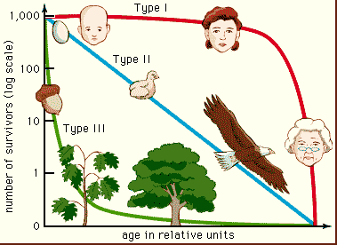**Procedure:**

**Part 1: Soap Bubble Survivorship – Bubble Population #1 (nurturing)**

1. Get a cup of bubble solution and a wand. Dip the wand into the solution and blow gently through the wand.
2. Once a bubble leaves the wand, group member’s wave, blow, or fan in an effort to keep the bubble in the air and prevent it from popping (dying).
3. Note the “age at death” of the bubble and keep a tally of these times.
4. Blow 30 bubbles this way.

**Part 2: Soap Bubble Survivorship – Bubble Population #2 (sink or swim babies)**

1. Get a cup of bubble solution and a wand. Dip the wand into the solution and blow gently through the wand.
2. Once a bubble leaves the wand, group members do NOTHING prevent it from popping (dying).
3. Note the “age at death” of the bubble and tally of survivorship times.
4. Blow 30 bubbles this way.

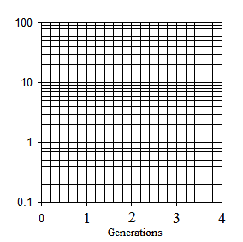

|  |  |  |  |  |
| --- | --- | --- | --- | --- |
| Soap Bubble Population Data: Population One | | | | |
| Age at Death (seconds) | Tally each Bubble that Dies | **Total** **Number Dying** at this Age | Total Number Surviving  ***(Total Surviving at previous Gen. start - Dead)*** | Percent Surviving to this Generation  ***(Total Surviving /30) x 100*** |
| 0 |  |  | X | X |
| 1 |  |  | X | X |
| 2 |  |  | X | X |
| 3 |  |  | X | X |
| 4 |  |  | X | X |
| 5 |  |  | X | X |
| Totals for Generation 0 | |  |  |  |
| 6 |  |  | X | X |
| 7 |  |  | X | X |
| 8 |  |  | X | X |
| 9 |  |  | X | X |
| 10 |  |  | X | X |
| Totals for Generation 1 | |  |  |  |
| 11 |  |  | X | X |
| 12 |  |  | X | X |
| 13 |  |  | X | X |
| 14 |  |  | X | X |
| 15 |  |  | X | X |
| Totals for Generation 2 | |  |  |  |
| 16 |  |  | X | X |
| 17 |  |  | X | X |
| 18 |  |  | X | X |
| 19 |  |  | X | X |
| 20 |  |  | X | X |
| Totals for Generation 3 | |  |  |  |
| 21 |  |  | X | X |
| 22 |  |  | X | X |
| 23 |  |  | X | X |
| 24 |  |  | X | X |
| 25+ |  |  | X | X |
| Totals for Generation 4 | |  |  |  |

|  |  |  |  |  |
| --- | --- | --- | --- | --- |
| Soap Bubble Population Data: Population Two | | | | |
| Age at Death (seconds) | Tally each Bubble that Dies | **Total** **Number Dying** at this Age | Total Number Surviving  ***(Total Surviving at previous Gen. start - Dead)*** | Percent Surviving to this Generation  ***(Total Surviving /30) x 100*** |
| 0 |  |  | X | X |
| 1 |  |  | X | X |
| 2 |  |  | X | X |
| 3 |  |  | X | X |
| 4 |  |  | X | X |
| 5 |  |  | X | X |
| Totals for Generation 0 | |  |  |  |
| 6 |  |  | X | X |
| 7 |  |  | X | X |
| 8 |  |  | X | X |
| 9 |  |  | X | X |
| 10 |  |  | X | X |
| Totals for Generation 1 | |  |  |  |
| 11 |  |  | X | X |
| 12 |  |  | X | X |
| 13 |  |  | X | X |
| 14 |  |  | X | X |
| 15 |  |  | X | X |
| Totals for Generation 2 | |  |  |  |
| 16 |  |  | X | X |
| 17 |  |  | X | X |
| 18 |  |  | X | X |
| 19 |  |  | X | X |
| 20 |  |  | X | X |
| Totals for Generation 3 | |  |  |  |
| 21 |  |  | X | X |
| 22 |  |  | X | X |
| 23 |  |  | X | X |
| 24 |  |  | X | X |
| 25+ |  |  | X | X |
| Totals for Generation 4 | |  |  |  |

**Summarize your ALL your bubble data:**

1. Count the number of checks (bubbles dying) at each GENERATION.
2. Subtract the number dying at each age from 30, determine and record the number surviving at each age. For example, if five bubbles broke (died) during the first generation (0), then 30-5=25 survived at least to the 1st generation. So use the remain 25 to start off the next generation, if 7 died in that generation then do 25-7=18 in the total surviving column. 18 for gen. 2 etc…
3. Calculate the percentage surviving at each age. Since at birth (the moment the bubble left the wand) thirty bubbles were alive at generation 0. Use the following formula:

%Survival at this generation = 100% * number Surviving/30

**Table 1: SUMMARY Bubble Population Data**

|  |  |  |
| --- | --- | --- |
|  | **Bubble Population 1**  **(Nurturing)** | **Bubble Population 2**  **(Sink or Swim babies)** |
| **Generation** | **% Surviving** | **% Surviving** |
| 0 (0-5 secs) |  |  |
| 1 (6-10 secs) |  |  |
| 2 (11-15 secs) |  |  |
| 3 (16-20 secs) |  |  |
| 4 (21-25+ secs) |  |  |

**Lab Questions:**

1. Compare the curves of the graph you drew with the idealized survivorship curves for Type I and III.
2. Which type of survivorship curve describes a population of organisms that produces a high fecundity (ability to reproduce), but most of the offspring die at a very early age? Give an example of such a species.
3. Would you expect a population in which most members survive for a long time to produce few or many offspring? Give an example of such a species.
4. Suppose a human population exhibits a Type III survival curve.
   1. What would you expect to happen to the curve over time if a dramatic improvement in medical technology takes place?
   2. What would you expect to happen to the curve over time if medical technologies suddenly fails?
5. How are humans “breaking the rules” in terms of their survivorship strategy/curve?
6. How would a species population change if their birth rate is about equal to the death rate?