Name: __________________________________ APES
Quiz
(14pts)
Completeness
(10pts)
GRADE:
Mr. Crisci
Lab: FOODPRINT/LABELING Date: _________

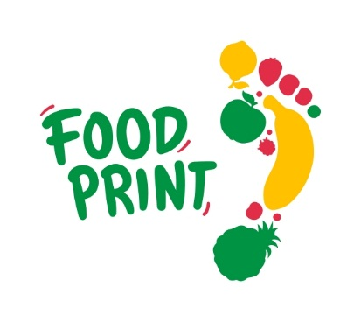
PART 1: Study each poster and fill in the table. Determine the relative environmental impacts (high, medium, low) in each of the countries based on their diet and weekly food choices.
Diet 1: Their diet consists of some fast food like burgers, chicken, or pizza. They have a large proportion of prepackaged processed foods which have been transported large distances. High levels of sugar/sweeteners and meat products as their food staples with less fruits and vegetables than recommended by health institutions. High levels of saturated fats.

Diet 2: This diet choice has some fast foods and processed foods but less than in diet 1. Less consumption of meat and dairy and more fruits and vegetables than in diet 1.

Diet 3: Mostly fruits, vegetables and grains. Some animal proteins like meats, cheeses, and dairy, but food is minimally processed or not at all. Food is grown within a few miles of those who consume it.

Diet 4: Minimal nutrition, consisting mainly of grains like rice, wheat, and corn. Food is gathered or grown locally. They have just enough nutrition to sustain life.

Part 1: World Food Choices
 | France | Mali | India | Kuwait
Diet Type from above description
$ Spent on Food per Week
Sugar/Sweeteners
Animal Proteins/Dairy
Estimated Water Use
Estimated Land Use
Estimated Amount of Fossil Fuels Used
Estimated Food Miles Traveled
Estimated Foodprint
 | United States | China |  | Ecuador | Australia
Diet Type from above description |  | City | Rural
$ Spent on Food per Week
Sugar/Sweeteners
Animal Proteins/Dairy
Estimated Water Use
Estimated Land Use
Estimated Amount of Fossil Fuels Used
Estimated Food Miles Traveled
Estimated Foodprint

Part 2: Personal Foodprint: CIRCLE which diet is most like your daily choices. Be honest with yourself! If you have any land left over, use it to build a house, a barn, a park, a wildlife habitat, a recreation area or any other use of the land you feel is necessary to have a satisfactory life.

Diet Choices Sheet
from 'Diet for a New America' Study Guide
Diet 1 - You go out to fast food places for burger, chicken or pizza whenever you can.
Breakfast: Pancakes, sausage or bacon, orange juice, toast with butter and jam
Lunch: Ham and cheese sandwich, apple, milk, carrot sticks
Snack: Cheese and crackers, chips
Dinner: Roast Beef, potatoes, gravy, peas, milk, bread, butter, salad, ice cream

Diet 2 - A couple times a week you decide to have burgers or chicken from the local fast food place.
Breakfast: Pancakes, orange juice, toast with butter and jam
Lunch: Cheese sandwich, apple, milk, carrot sticks
Snack: Cheese and crackers
Dinner: Chicken, potatoes, gravy, peas, milk, bread, butter, salad, ice cream

Diet 3 - You have eliminated or eat 1-2 meat dishes a week. You still eat some dairy products.
Breakfast: Pancakes, orange juice, toast with butter and jam
Lunch: Cheese sandwich, apple, milk, carrot sticks
Snack: Crackers and chips
Dinner: Fish, vegetable stew or pasta, salads, bread, butter, fruit cocktail

Diet 4 - You have become a Vegetarian or Vegan. You don't eat meat and most animal products.
Breakfast: Hot cereal with soy milk, orange juice, toast with margarine and jam
Lunch: Peanut butter and jelly sandwich, apple, juice, carrot sticks
Snack: Green smoothies, celery with peanut butter
Dinner: Vegetable stew, pasta, bread, margarine, salad, fruit cocktail
PART 2: Land Use Assessment of Diet Choice:
from 'Diet for a New America' Study Guide
Please remember that the WORLD uses about HALF of all of its land surface for food purposes. The grid below represents 100% all of the land used for agriculture and feeding livestock

Diet 1: Because of these choices you need to raise cows for meat and milk products. You need to use 48 squares of your land to grow crops to feed your cows and to have land to graze them on. Draw and color pictures representing what you eat in the 48 squares. You must build the living quarters for you and your animals on whatever land is left.
Diet 2: You have cut down on the amount of meat you are eating by about 50%. You still eat a lot of dairy products, so you still need extra land for raising dairy cows. Draw and color pictures representing what you eat in the 30 squares. On the rest of your land you must build your houses and barns. If you have any land left over you can use it for other activities.
Diet 3: You have eliminated or reduced your meat consumption drastically. You still eat a lot of dairy products, so you still need extra land for raising dairy cows. Draw and color pictures representing what you eat in the 16 spaces. On the rest of your land you must build your houses and barns. If you have any land left over you can use it for other activities.
Diet 4: You don't eat meat and reduced your animal products (cheese and milk). Draw and color pictures representing what you eat in the 4 squares. On the rest of your land you have to build your houses and barns. If you have any land left over you can use it for other activities.

Land Use Grid

PART 3: Today packaging has such a wide variety of labels it is almost impossible to keep track of them all. Organic, all natural, grain feed, cage free, what does it all mean? Here is a guide to help you straighten things out the next time you and your parents go shopping.
Station #1
- This 100% all natural vegetarian-fed chicken lists 7 claims on its packaging. Using the supplemental materials provided to you by your teacher, pick 3 of the claims and explain why they are misleading. Make a list in the space below:

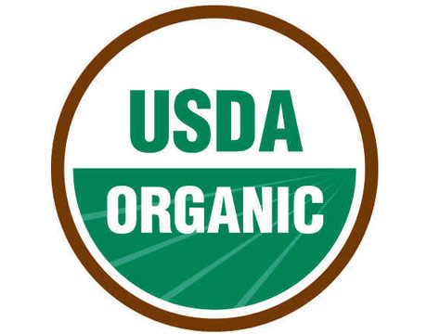
Station #2A, 2B, and 2C
- 2A and 2B have an organic label. What must farmers under this category not use on their crops? What can they use?

- 2C is labeled “pesticide free” using the supplemental materials provided to you by your teacher explain if this term is regulated and the claims are true.

Station #3A and 3B
- This station contains “natural” products and ingredients. Using the supplemental materials provided to you by your teacher detail why this labeling is misleading.

Station #4A and 4B
- Station 4B is an organic ground beef from Costco. Station 4A has two essential labels located on the upper left side of the packaging. Detail the differences in the two meat products, explaining how the animals were treated and the food they were fed different.

Station #5
- Station 5 is a Non-GMO label. Using the supplemental materials provided to you by your teacher explain whether this label holds any legal or regulatory meaning in the United States.

Station #6
- Does the free-range label mean the animals went outdoors?

- This labeling is also misleading in two other ways find ONE and describe it.

Station #7
- Besides the chicken and rooster wearing boots, this label is littered with misinformed designed to confuse and portray a perception that this chicken is better for you than other chicken products. Pick TWO and describe how this is misleading, using the materials provided by your teacher for help.

Station #8A and 8B
- Station 8A has a cage-free label, does this mean the animals went outdoors?
How is this label misleading?

- Station 8B are certified humane eggs, which means they are certified by a third party organization. What standards must be met to get the certified humane label?

Conclusion Questions:
- Developing nations typically have periodic shortages of food. Thus they try to maximize food production from each square meter of land. You can see why developing nations would tend to grow crops like wheat, rice and corn rather than cattle, chickens and sheep; they can feed more people. But what about Japan, which is a very industrialized and rich nation? The average person in Japan eats very little beef in one year: perhaps the equivalent of one 10 ounce steak. Why do you think Japan’s beef consumption is low even though it is a developed nation?

- What are TWO ways to reduce your impact on the world’s food supply?

- Why do meat products require more land than plants for comparable number of calories? Include information from previous chapters to support your answer and what you know about energy transfer in food chains.

- The amount of land used for crops is not the only factor in considering the environmental footprint of diet choices. Describe the energy input of various types of diets, including production and shipping costs. Use the term “food miles” in your answer.

- Based on the information in these charts and in discussions with classmates with different dietary choices, will you change your eating habits? If yes, explain why you have chosen this change.

