Quiz
(14pts)
Completeness
(10pts)
GRADE:
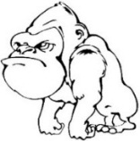
Name: __________________________________ APES
Mr. Crisci
Lab: ELECTRIC MOTOR Date: _________

Background: Simple electric motors run on the principle of electromagnetics. Electrons are built up by a flowing into a coil of wires where they encounter a magnetic field (“+” and “-“poles). When the current of electrons is switched on and off an axle is able spin the coil of wire in the magnetic field to create a torque. Torque is the tendency of a force to rotate an object about an axis.

The first thing you should know about an electric motor is that magnets are the reason anything moves at all, and that’s because magnets have poles such as north and south. Opposites attract and likes repel is true with any magnet.
When electricity is ran through the loop or coil you have made the electricity passes through the magnetic field. The magnet having both a north and a south pole attracts and repels the current through the rotor causing it to spin. This repetitive attracting and repelling can thus go on continuously as long as a stable current goes through it.

Goal: You are going to create a simple electric motor.

Materials: | D-cell battery | magnet | magnet wire (already done by teacher)
Procedures: | Large safety pins (2) |  | tape or rubber band
- Place the magnet on the battery as shown in the diagram.

- 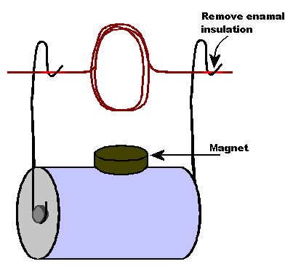Set the wire coil on the clips as shown in the diagram. Be sure the bare copper wire is making contact with the paper clips.

- Give the loop a spin and it should start rotating on its own. Slight adjustments may need to be made to get the motor to function.

- Show me your working motor: I must sign off on it

_______________________________________

Mr. Crisci will provide you with a second challenge using a nail, electrical tape, and some wire

Questions:
- What provides the flow of electricity for the motor? Is this kinetic of potential energy?

- Why does the motor spin? Why do you need the magnet to get the motor to move?

Label the power plant using the word bank below:
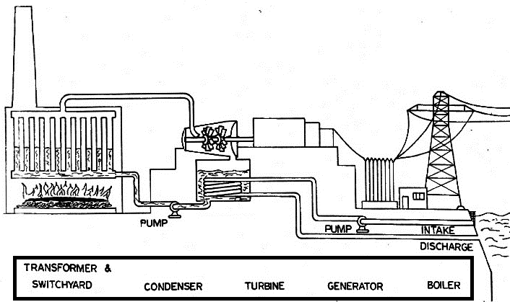

- Describe the function of the boiler:

- Describe the function of the turbine:

- Describe the function of the generator:

- Why use a condenser in the power plant?

- Describe the function of the water intake:

Energy Dimensional Analysis Practice

Energy Content of Fossil Fuels (Btu/ton) (Note: all these conversions have been rounded off to make the math easier to do by hand)
Coal (Anthracite & Bituminous) 25,000,000
Peat 3,500,000
Gasoline 40,000,000
Natural gas 50,000,000
Crude Oil 40,000,000
Conversion Chart for Energy Units (Note: all these conversions have been rounded off to make the math easier to do by hand)
1 calorie = 4.0 joules
One Btu = .25 kilocalorie
One kilocalorie = 4.00 Btu
One kilowatt-hour = 4,000 Btu
One barrel of oil (40 US gallons) = 1,500,000 kilocalories
One barrel of oil = 1,562.5 kilowatt-hours
QUESTIONS: Please circle your final answers
- Convert 4.80 kilojoules to joules. Then convert this to calories:

- How many kilowatt-hours of electricity could you get from a ton of peat?

- How many kilowatt hours of electricity could you get from a ton of coal?

- How many barrels of oil would give you the same energy as a ton of coal?

- How many kilocalories are there in one gallon of oil?

- How many ton(s) of coal would be needed to produce 10,000 kilowatt-hours of electricity?

- How many ton(s) of crude oil would be needed to produce 2,000,000 kilocalories of heat energy?

