Name: __________________________________ APES
Mr. Crisci
Lab: MINING FOR THE GOOD STUFF Date: _________

Part I
Coal “Chip” Mining Activity
PURPOSE:

The purpose of this activity is to give you an introduction to the economics of mining. This is accomplished through buying "property", purchasing the "mining equipment", paying for the "mining operation" and finally paying for the "mining reclamation". In return you receive money for the "ore mined". The objective of the activity is to make as much money as possible.

INSTRUCTIONS:

- Each person receives a Cookie Mining sheet and a sheet of grid paper.

- Each person must buy their own "mining property". Only one "mining property" per person.

- Cookie mines for sale: Mines and values may vary
  - Low Grade “Land” $3.00
  - High Grade “Land” $10.00
- After the cookie is purchased, place the cookie on the grid paper and use a pencil to trace the outline of the cookie.

- Each person must buy their own "mining equipment". More than one piece of equipment may be purchased. Equipment may not be shared between players.
Mining equipment for sale:
- Toothpick - $2.00
- Popsicle stick- $4.00
- Paper clip- $6.00

- When you are ready, note the time and then utilize your mining tools to extract ore from the Earth. As you mine, separate your “ore” from your crumbled cookie.

- Consider the process complete when you have excavated as much “ore” as possible for the amount of time and effort you wish to invest (this is cost-benefit analysis!).

- After the cookie has been "mined", the cookie should be placed back into the circled area on the grid paper. This can only be accomplished using the mining tools. Reclamation costs are charged for cookie that is outside of the original circle. On your data table, record the number of extra squares your cookie covers.

- On your data table, record the amount of time you spent mining/reclaiming.

- On your data table, record the amount of “ore” you were able to extract.

- Total up your spreadsheet to see how much/little profit you earned.

RULES:

- A player can purchase as many mining tools as the player desires and the tools may be of different types.

- If the mining tools break, they are no longer usable and a new tool must be purchased.

- All of the players win at the end of the game because they get to eat the remains of their cookie!!

COAL “CHIP” MINING SPREADSHEET
Price of Cookie (Land) |  |  | A: $
Size of Cookie (Land) |  | No. of squares covered _______
Equipment |  | Toothpick  Popsicle stick  Paper clip | _____ x $2.00 = _____  _____ x $4.00 = _____  _____ x $6.00 = _____
Total Equipment Cost |  |  | B: $
Mining Cost | No. of minutes ____ x $1.00 = |  | C: $
TOTAL COST OF MINING (A+B+C) |  |  | D: $
Chip removal  (Check with teacher for your ore quality, is your ore “clean” or do you have extra cookie on the chips if so the price you get will not be $10 it will be less!) |  | Chip mass (g) _____ x $10.00 =  Teachers initials: _____________ | E: $
Reclamation (Reclaim the contour of the original cookie, any tailing outside your initial circle will be charged) |  | No. of squares _____ x $1.00 = | F: $
PROFIT/LOSS (E-(D+F)) |  |  | G: $

The Mineral Area Grid contains:
- 41 Water squares / 33 Trees / 12 Areas rich in topsoil / 10 Deer / 9 Beautiful Vistas
Because the water flows from north to south, water that is compromised upstream can have an effect on water quality downstream. For any water square compromised (having a crumb/smudge), all connecting water downstream (below) is also impacted. Record how many areas are affected in the chart below. Put X’s through all polluted water icons on the mining area grid.
Natural Attribute | Quantity Impacted by Placement/Mining | Remaining Healthy Natural Attributes
Tree
Deer habitat
Rich Topsoil
Water
Beautiful Vista

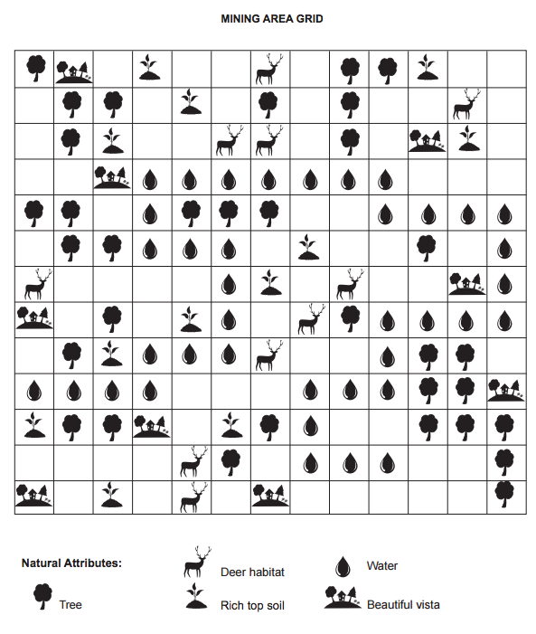
Questions:
- What is the difference between the terms overburden and tailings?

- Your goal was to make as much profit as possible. If you had an added goal of protecting the environment as much as reasonably possible, would you have changed anything? Explain:

- The average copper ore mined in 1900 was 5% copper by weight (high-grade ore). Today the average copper ore is 0.5% copper (low-grade ore). What factors could account for this difference?

- Let’s say you decide to mine gold on federal lands. The National Environmental Policy Act (NEPA) of 1969 requires you to do what first before you can start the mining process?

- In your own words, explain at least TWO harmful effects of strip mining on the environment.

- Describe the steps involved in acid mine drainage:

- Explain The Surface Mining Control and Reclamation Act. What does this act require coal-mining companies to do?

