Quiz
(14pts)
Completeness
(10pts)
GRADE:
Name: __________________________________ APES
Mr. Crisci
Lab: OZONE DEPLETION & SUNSCREEN Date: _________

The human body’s natural defense against harmful UV radiation from the sun is to tan or produce melanin. The sun actually emits large amounts of UV radiation, but thankfully, the Earth’s atmosphere protects us from it. Most have heard of the ozone layer and without it the Earth would be bathe in so much UV radiation that it would kill most life that exists on it today. There was cause for alarm when it was discovered that there where major holes in it. Ozone was being “attacked” by substances called chlorofluorocarbons (CFCs) which broke three oxygen molecules (ozone) down into O₂ and just O. Ozone has the ability to absorb harmful UV radiation whereas O₂ cannot; allowing more of the harmful UV energy in. The CFCs are produced by humans and used in cooling and aerosol cans. Therefore, the worldwide community got together in the late 1980’s and signed a treaty called the Montreal Protocol which banned CFCs from their production to disposal. Consequently, the ozone holes have been stabilizing and show signs of improving. Even with the ozone layer enough harmful radiation reaches the surface to affect humans. Hence, it is essential to avoid long-term exposure to UV radiation without being protected.

Procedure Part I:
Element Color Code
Red/Orange – Oxygen | Green – Chlorine
Flourine – Purple | Yellow – Carbon
- Wash your hands!
- You should know what to do by now!
- Obtain toothpicks and break the toothpicks in half.
- Use your PAGE 10 in your verbal quiz packet.
- Then draw a similar scene to the one in your packet on the provided whiteboard, draw in the sources of various ozone depleting substances (ODS).
- When you feel confident your ENTIRE groups knows all the pollutant information. Call your teacher over so he/she can assess your learning and approve your drawing/models. If you cannot meet his/her approval you have to keep trying until you get them all correct in order to move on to the next step.
- You can copy your results from your whiteboard onto the last page in this lab.

Teacher Signature for Part I: _________________________________________

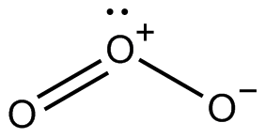
Ozone Depleting Substances (ODS)
- CFCs and HCFCs - mostly used in refrigeration, air conditioning and heat pump systems. Only HCFCs can continue to be used for a limited period of time.
- Halons - used historically as fire suppression agents and firefighting, but now only allowed in very limited situations.
- Carbon tetrachloride (Tetrachloromethane) - limited solvent use in laboratories and chemical and pharmaceutical industry.
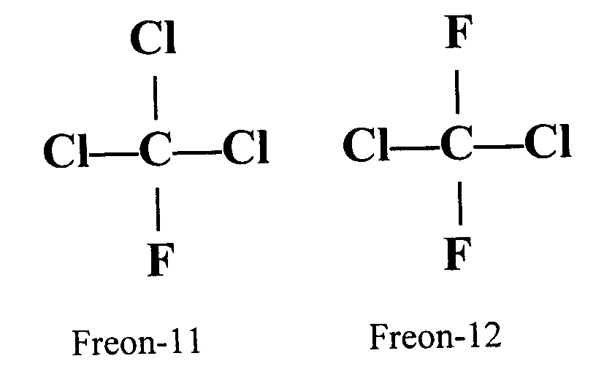
- 1,1,1, - trichloroethane - limited solvent use in laboratories, chemical, and pharmaceutical industry.
- Methyl bromide - historically used in fumigation, soil treatment, pest control, quarantine, market gardening.
- Hydrobromofluorocarbons - historically used in fire suppression systems and firefighting.
- Bromochloromethane - historically used in the manufacture of biocides.

Consumer Reports Article:

SPF: Sun-protection factor, a measure of UVB sunburn protection on treated skin as compared with untreated skin. (Put simply, if skin normally takes 10 minutes to turn red, SPF 30 lengthens that time to about 300 minutes.)

Broad spectrum: Implies that the product blocks UVA and UVB radiation, but doesn't indicate how effective the blocking is.

Water resistant: Maintains the claimed SPF after 40 minutes in water.

Very water resistant: Maintains the claimed SPF after 80 minutes in water. "Waterproof" has no FDA-accepted definition, but some manufacturers use it to mean very water resistant.

Getting started:
You can't always rely on the SPF number, a measure of protection from burning ultraviolet B (UVB) radiation, which causes sunburn and contributes to skin cancer. We also tested for protection against ultraviolet A (UVA) rays, which tan and age skin, and also contribute to skin cancer. We found seven sunscreens that did well enough against both UVA and UVB to recommend.

What's in sunscreens?
Skin cancer is the most common cancer in the U.S., and the benefits of sunscreens outweigh potential risks from their ingredients. That said, animal studies have raised some concerns about what's inside these sunscreens.
Products that contain the active ingredients titanium dioxide and zinc oxide may contain nanoparticles. These compounds have been linked to reproductive and developmental effects in animals.
Retinoids, part of the vitamin A family and an inactive ingredient in some sunscreens, have caused an increase in skin cancers in mice. There's also a risk of birth defects in people taking oral acne medications containing retinoids, though they differ from the retinoids in sunscreens. As a precaution, pregnant women may want to choose a sunscreen without the ingredient retinol palmitate or retinyl palmitate.

Sun protection:
Research shows that people who rely on sunscreens alone tend to burn more than those who stay in the shade and wear long sleeves. Avoid the sun or stay in the shade when the sun is the strongest (10 a.m. to 4 p.m.), and dress right for the occasion. Wear a hat and clothing that's made from tightly woven fabric. (Dark colors are better at blocking UV rays.) Hold clothing up to the light; if you can see through it, the UV rays can get through, too.
When using sunscreen:
- Use enough. Apply sunscreen 15 to 30 minutes before you go outside. For lotions, use 2 to 3 tablespoons. For sprays, apply as much as can be rubbed in, then repeat. Regardless of which kind you use, reapply every 2 hours and after swimming or sweating.
- Use spray sunscreens carefully. The FDA has said it is exploring the risks of inhaling spray sunscreens. Until we know more, our experts say to avoid using sprays on children, and do not spray them directly on your face. Instead, spray sunscreen onto your hands then apply it to your face. Sprays are flammable, so let them dry before going near an open flame.
What we found: We found a wide variability of effectiveness against UVA rays. Seven sunscreens and one moisturizer tested just fair for UVA protection and two sunscreens tested Poor. In our tests, 18 out of 20 sunscreens did not provide the SPF (UVB) protection promised on their labels. (We found differences between the claimed SPF and the actual SPF in our tests last year as well.) That doesn't mean the sunscreens aren't protective, but you may not be getting the protection you think you are. We can't say why our test results differ from the manufacturers' claims, but they show that SPF isn't always carved in stone.
Questions:
- How does the role of ozone differ when in the stratosphere versus the troposphere?

- What are some of the main sources of ozone depleting substances (ODS)?

- What protocol banned the use of CFCs and other ozone depleting chemicals? ________________________

- Why does the ozone hole develop over the poles even though none of the ODS are created there?

Questions from the Consumer Reports Article:
- What are the effects of UVA radiation on humans?

- What are the effects of UVB radiation on humans?

- Most people do not apply sunscreen properly, what are they doing wrong?

- How long can your stay outside in the sun with an SPF of 40? __________________

- What sunscreen do you use? ________________________. What was its overall rating out of 100? ______

- Are you going to change your sunscreen? If so to what? Why or why not?

- There are some ingredients in sunscreen which could cause negative health effects. What are the names of those chemicals and what effects do they have on humans?

- Instead of using sunscreen what precautions should you take to avoid the risk of skin cancer?

