Quiz
(14pts)
Completeness
(10pts)
GRADE:
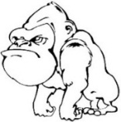
Name: __________________________________ APES
Mr. Crisci
Lab: AIR POLLUTION STORYBOARD Date: _________

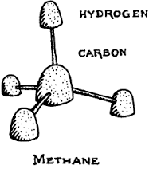
Five major types of materials are considered to be primary pollutants. Carbon monoxide (CO), a colorless gas, is produced when organic material such as gasoline, coal, wood, and trash is incompletely burned. Smoking tobacco also produces large amounts of CO. In addition to CO, automobiles emit a variety of hydrocarbons (HC). Hydrocarbons are either evaporated from fuel supplies or are remnants of the fuel that did not burn. Particulates (PM) constitute the third largest category of air pollutants. Particulates frequently receive a great deal of public attention because they are so readily visible. Sulfur dioxide (SO₂) is a compound containing sulfur and oxygen that is produced when sulfur-containing fossil fuels are burned. SO₂ has a sharp odor and irritates respiratory tissue. Oxides of nitrogen (NO and NO₂) are the fifth type of primary air pollutants. Nitrogen compounds produce a reddish brown color in the atmosphere and react with other compounds to produce photochemical smog. Air pollution can be detected and in some cases diagnosed by using the senses of sight, smell, and touch. In this exercise you will produce various primary air pollutants and secondary air pollutants using candy and tooth picks to simulate their makeup, sources and effects.

Part 1: Particulate Matter (PM) Testing
Materials:
Petroleum jelly Petri dishes Tape
Stereoscope Popsicle stick

PM Test Slides and Procedure:
  - Collect at least TWO petri dishes.
  - Apply a THIN layer of petroleum jelly to the center area that is not covered by the tape.
  - Repeat step 2 for the other petri dish.
  - When done, place the dishes in each of the designated areas, one indoors and one outdoors. Get an index card or on the back of the tape write the following on the card: “Environmental experiment in progress. Please DO NOT DISTURB! Thank you.” Write the location of the sampling site and your name.
  - Leave the dishes out for at least twenty four hours.
  - Collect the dishes from the areas, place a clean petridish over the petroleum jelly to protect the collected particles.
  - Using a stereoscope, count the number of particles on the petroleum covered area. Record the results in the table on page 3. Also note any distinguishing particles, sizes, or PM or interest.

Part 1 Questions:
- Describe the effect that particulate matter (PM) AND ozone can have on human health?

- Describe how ozone AND particulate matter PM can affect plant life.

- How can we lower or eliminate particulate matter PM in our atmosphere, give an example of a piece of technology that helps us achieve this goal.

- Compare your particulate matter results to those of other lab groups. Where they similar? Why or why not?

- Why are the concentrations of pollutants found indoors much greater than concentrations of the same pollutants generally found outdoors?

- What organization sets the permissible limits of exposure on those common air pollutants?

Particulate Matter Data Table:

Location Description(s): |  | Approximate # particles:
Description of Particle Type(s) | Radius Size(s)  Large, Med, Sm | Possible Source(s) | Anthropogenic or Natural
Procedure Part 2:
Element Color Code
Red – Oxygen | Pink – Particulates
Orange – Nitrogen | Yellow – Sulfur
Green – Lead | Black – Carbon
White – Hydrogen
- Wash your hands!
- Obtain candy **Each color represents a different element**
- Obtain toothpicks and break the toothpicks in half.
- Create a model of EACH air pollutant in the chart on next page using the candy, color code table, and toothpicks. You may need to cut up the black licorice into 1cm sizes.
- Draw a similar scene to the one in this lab on the provided whiteboard.
- Using arrows and the models of each primary pollutant you made place them on the whiteboard and be able to explain to the teacher the source, the effects, and how to reduce it. Use your verbal quiz packet for this unit and textbook pages 455 – 460 as a reference.
- When you feel confident your ENTIRE groups knows all the pollutant information. Call your teacher over so he/she can assess your learning and approve your drawing/models. If you cannot meet his/her approval you have to keep trying until you get them all correct in order to move on to the next step.
- You can copy your results from your whiteboard onto the cloud labeled primary in this lab.

Teacher Signature for Part I (Primary Pollutants): _________________________________________

Procedure Part 3 Making a Secondary Pollutants AKA SMOG:
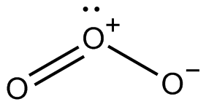
- Now you are going to create secondary pollutants. Again use your verbal quiz packet, especially page 10, to help you understand the reactions. (you need to know each step!!!!!!)
Ozone
- To first create ozone using your nitrogen oxide (NO) molecule, create nitrogen dioxide.
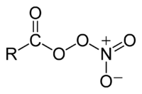
- Then react NO₂ to create ozone you have to draw in UV light reacting and create an O₂ molecule to create the final O₃ (Ozone) molecule. I NEED TO SEE EACH STEP CREATED
- (Optional) Lastly, take your hydrocarbon, make another NO₂ and O₂ and to create a component of smog called peroxyacyl nitrates or PAN’s (structure to the right, don’t include the R). You can copy your results from your whiteboard onto the scene in this lab.
PAN’s

Teacher sign off on your Part II reactions and check for group understanding: ________________________
POLLUTANT | STRUCTURE | SOURCE | HUMAN EFFECTS | ENVIRONMENTAL EFFECTS | REDUCTION
Particulate Matter | N/A
Lead (Pb) | N/A
Carbon Monoxide (CO)
Carbon Dioxide (CO₂) | O=C=O
Nitric Oxide (NO)  Nitrogen Dioxide (NO₂) | N=O  O=N–O
Sulfur Dioxide (SO₂) | 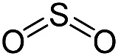
Volatile Organic Compounds (VOC’s) | 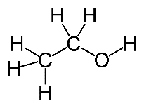
Hydrocarbons | 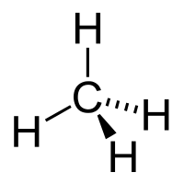 |  |  | Production of photochemical smog

Primary
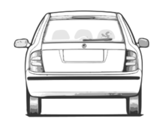
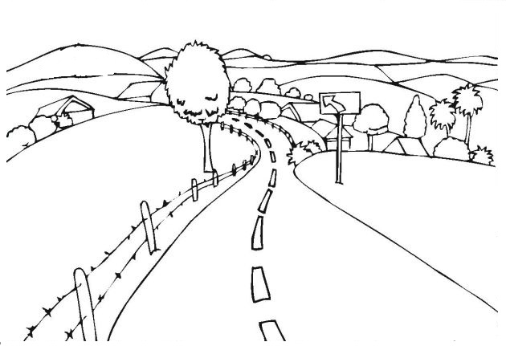
Secondary
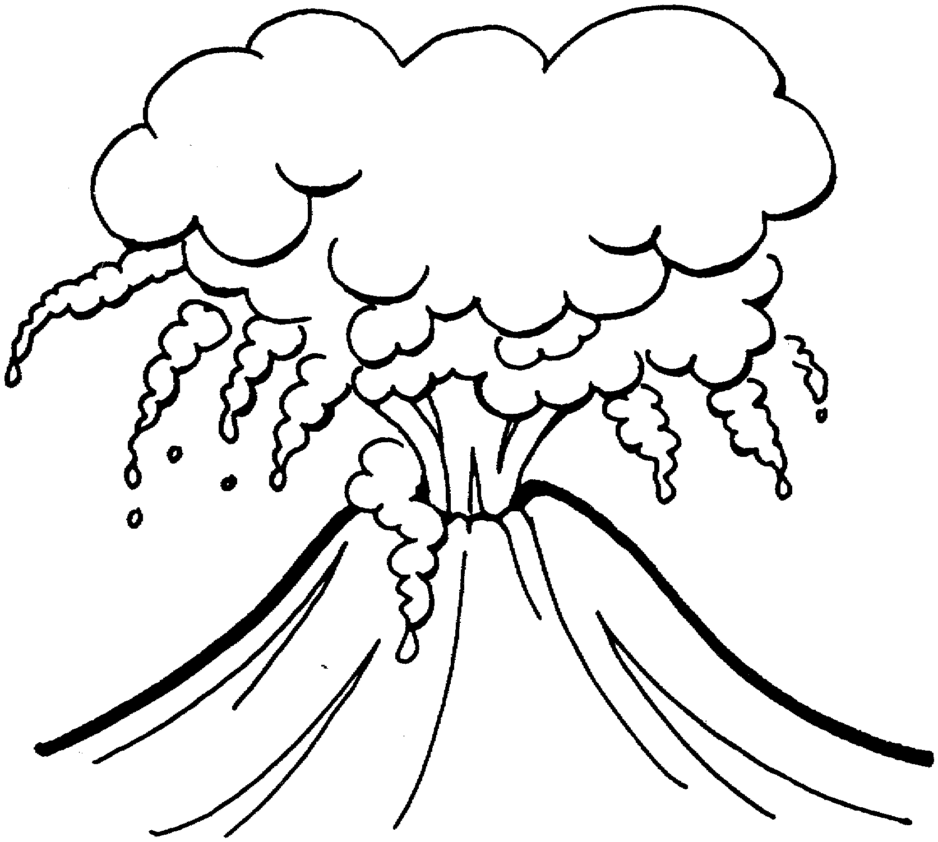
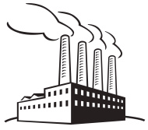

Questions:
- What effect does Smog (troposheric ozone, PAN’s, NO₂ etc) have on humans?

- What effect does Smog (tropospheric ozone, PAN’s, NO₂ etc) have on the environment?

- Atmospheric nitrogen combines with oxygen gas to form part nitric oxide (also known as nitrogen monoxide), a primary pollutant. Write out the two step equation showing the formation of nitrogen dioxide, the red-brown toxic gas found in smog.

- Using the nitrogen dioxide from above, write out the two step equation for the formation of ground level (tropospheric) ozone.

- Using your verbal quiz notes on page 10 or better yet verbal quiz fact 12, write out the equation for the formation of PAN’s.

- What is the difference between ozone in the troposphere (ground level) and ozone in the stratosphere?

Ask yourself do you know each primary pollutant source/effect and the secondary pollutant equations enough to take a lab quiz on this? If not go back and relearn each step with your lab partner until you get it because you have a quiz on this.

