Quiz
(14pts)
Completeness
(10pts)
GRADE:
Name: __________________________________ APES
Mr. Crisci
Lab: ACID DEPOSITION STORYBOARD Date: _________

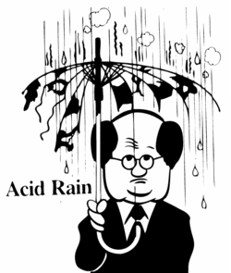
Natural rainwater (precipitation) is acidic and has a pH of about 5.6. Acid rain refers to rain with a pH of less than 5.6. Acid rain is produced when sulfur & nitrogen compounds are released into the atmosphere where they combine with water to form sulfuric and nitric acids. Sulfur compounds may come from such natural sources as decomposing organic matter, volcanoes and geysers. The environmental problem known as acid deposition, however, does not arise from natural sources. It is caused primarily by fossil fuel combustion. When coal, oil and gas are burned, large amounts of sulfur and nitrogen are released as gases and combine with water to make the rain more acidic than usual. Acid deposition has many effects on the ecosystem.

Procedure:
Element Color Code
Red/Pink – Oxygen | Green – Aluminum
Orange – Nitrogen | Yellow – Sulfur
Hydrogen – White
- Wash your hands!
- Obtain candy **Each color represents a different element**
- Obtain toothpicks and break the toothpicks in half.
- Create a model of EACH air pollutant in the equations below using the candy, color code table, and toothpicks.
- Then draw a similar scene to the one in this lab on the provided whiteboard.
- Using arrows and the models of each the pollutants you made, place them on the whiteboard and be able to explain to the teacher the source, formation, effects, and how to reduce it. Use your verbal quiz packet for this unit as a reference.
- On your whiteboard place a green candy with an arrow to indicate the mineral that is leached out of the soil into the lake.
- When you feel confident your ENTIRE groups knows all the pollutant information. Call your teacher over so he/she can assess your learning and approve your drawing/models. If you cannot meet his/her approval you have to keep trying until you get them all correct in order to move on to the next step.
- You can copy your results from your whiteboard onto the cloud labeled primary in this lab.

Teacher Signature for: _________________________________________

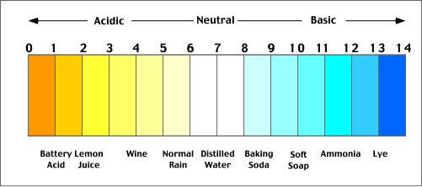
Equations for Acid Rain:

2NO + O₂ → 2NO₂ + H₂O → HNO₃ (Nitric Acid)

2SO₂ + O₂ → 2SO₃ + H₂O → H₂SO₄ (Sulfuric Acid)

NO | NO₂ | O₂ | H₂O | HNO₃ | SO₂ | SO₃ | H₂SO₄
N=O | O=N–O | O=O | 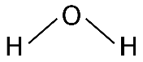 | 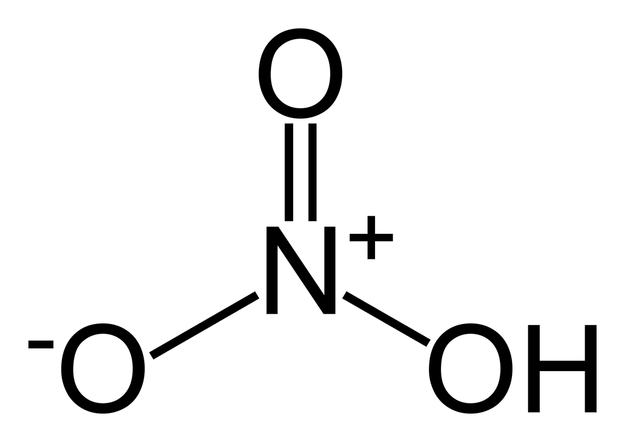 | 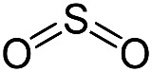 | 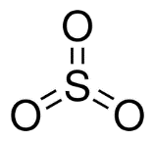 | 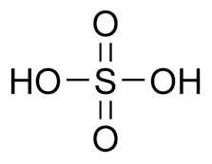

Quick Experimental (Smoke from a Match)
Procedure:
- Fill the plastic jar to the 10-mL line with distilled water. Using a Beral-type pipet, add 5 drops of indicator solution.
- Swirl the solution and record the initial color.
- Light a match and place it in the solution in the sampling container and immediately close the lid. Try to capture all of the smoke from the match in the plastic jar.
- Swirl the solution so that it can interact with the fumes. Record all observations and the pH of the resulting solution.
- Rinse jar with distilled water.

Initial appearance, color and pH

Observations after match was placed in the jar.

Acid rain causes a cascade of effects that harm or kill individual fish, reduce fish population numbers, completely eliminate fish species from a waterbody, and decrease biodiversity. As acid rain flows through soils in a watershed, aluminum is released from soils into the lakes and streams located in that watershed. So, as pH in a lake or stream decreases, aluminum levels increase. Both low pH and increased aluminum levels are directly toxic to fish. In addition, low pH and increased aluminum levels cause chronic stress that may not kill individual fish, but leads to lower body weight and smaller size and makes fish less able to compete for food and habitat.
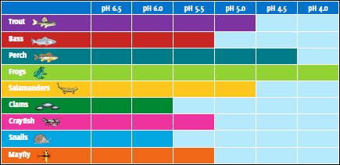
Some types of plants and animals are able to tolerate acidic waters. Others, however, are acid-sensitive and will be lost as the pH declines. Generally, the young of most species are more sensitive to environmental conditions than adults. At pH 5, most fish eggs cannot hatch. At lower pH levels, some adult fish die. Some acid lakes have no fish. The chart below shows that not all fish, shellfish, or the insects that they eat can tolerate the same amount of acid; for example, frogs can tolerate water that is more acidic (i.e., has a lower pH) than trout.

Questions based on the above paragrph and your knowledge:
- Based on the paragraph above, when acid rain flows through soils what mineral(s) get leached out?

- Based on the paragraph above, what effects does this substance have on fish and trees?

- Based on the above chart which organism(s) can tolerate the lowest pH? _____________________

- Based on the above chart which organism(s) can only tolerate the highest pH? _____________________

  - What do the organism(s) that cannot tolerate very low pH’s have in common (why are they so sensitive to the lower pH)?

- What effect does acid rain have on buildings, statues, and tombstones made of limestone and marble?

- When birds lay eggs their shells are thinner than normal. Explain acid rains role in this:

- Over time what will happen to the overall pH of the lake? ________________________

- Why do places like upstate New York and southeast Canada experience the worst acid rain (lowest pH) but are not the ones producing the pollution?

- What can be done to the lake to buffer (increase the pH) of this body of water?

  - Is this a long term or short term solution? ____________ Why?

