Quiz
(14pts)
Completeness
(10pts)
GRADE:
Name: __________________________________ APES
Mr. Crisci
Lab: BIOMAGNIFICATION/TOXICITY Date: _________
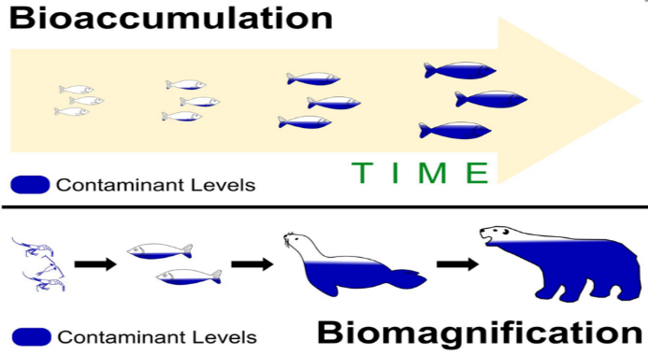
Materials/Identification:
- Silver paper clips represent DDT
- Blue paper clips represent algae (producers)
- Orange/Pink represents the shrimp that eats algae
- Gold represents a small fish which eats the shrimp
- White large fish - like a bass which eats the small fish
- Green represents osprey eating the bass (large fish)
Procedure:
- Roll a die - this tells you how much DDT your single algae ingests or absorbs through its environment. Record this number in the producer’s level of the trophic pyramid.
  - Ex. if you roll a 2 (attach 2 Silver paper clips to a blue paper clip because your algae will have 2 Silver paper clips on it)
- Roll die, this is how many ALGAE your shrimp (RED/PINK) eat. Record the total number of DDT (Silver paper clips) of the trophic pyramid the first level consumers have ingested.
  - Ex. if you roll a 3 (you will have to make 2 MORE algae paperclips with 2 Silver DDT paperclips on EACH one)
- Roll die, this is how many SHRIMP your little fish (minnow) (GOLD) eat. Record the total number of DDT (Silver paper clips) of the trophic pyramid the first level consumers have ingested.
  - Ex. if you roll a 3 (you will have to make 2 MORE shrimp (Red/Pink) which each having the Blue and Silver paperclips)
- Roll die, this is how many LITTLE FISH (minnow), your BASS (WHITE) eats. Record the total number of DDT (Silver paper clips) of the trophic pyramid the first level consumers have ingested.
  - Ex. if you roll a 5 (you have to make 4 MORE Gold organisms with the same number of Pink/Orange, Blue, and Silver paperclips)
- Roll die, this is how many LARGE FISH (bass), your OSPREY (GREEN) eats. CALCULATE the total number of DDT (Silver paper clips) in the fourth level consumers have ingested.
  - Ex. if you roll a 6 (you have to make 5 MORE White organisms with the same number of White, Gold, Pink/Orange, Blue, and Silver paperclips)
  - OPTION: YOU DON’T ACTUALLY HAVE TO DO THIS STEP WITH THE PAPERCLIPS JUST CALCULATE IT!
Summary Data Table:
 | DDT Ingested (ppm) | Total Energy at Trophic Level  (kcal) | Name of Trophic Level/Feeding Relationship
Phytoplankton |  | 2,000,000 kcal
Shrimp
Minnow (small fish)
Bass (large fish)
Osprey
Conclusion Questions:
- Draw a generic pyramid of the energy flow and of the DDT flow through food chain. Include each organisms and the feeding level (example first level is producer, second level is….)

- Why does a substance like Caffeine not bioaccumulate but heavy metals like mercury and lead do? Identify where these toxins are stored in the human body.

- Compare the amount of DDT found in the osprey with the amount of toxin found in one phytoplankton. Specifically, how many more times DDT is in the osprey.

- What is the difference between the terms biomagnification and bioaccumulation?

- The FDA suggests that all people limit the amount of larger predator fish that are consumed, such as tuna, swordfish, and shark. Based off the results of this, why would that advice be prudent? Why is it especially prudent for pregnant women and children?

Part 2: WHAT’S THE RISK?
PART 1: GOOGLE: Good Guide or Go to http://www.goodguide.com
.
Product Type and Name | Overall Score | Ingredient(s) of Concern | Level of Concern (H,M,L,?) | Ingredient(s) Human Health Impact | SAFER Alternative Product
- Shampoo/Conditioner
- Toothpaste
- Deodorant
- Hair Styling Product
- Hand Soap
- Body Shower Soap
- Shaving Cream
- Dishwashing Soap
- Laundry Detergent
- Lip Balm/Chap Stick
- Mouthwash
- Sunscreen
- Moisturizer
- Makeup

PART 3: Calculate your own mass in kg. Calculate the human LD₅₀ for the compounds in the data table on below. How many total g would be required to kill 50% of perfect duplicates of yourself? Use the LD₅₀ values in the table below. (1 kg = 2.2 lbs.) Example if you weigh 175 lbs. divide it by 2.2 to get your weight in lbs.

Your weight in kg: _______________________

Substance | LD₅₀, oral, Rat (mg/kg) | LD₅₀, oral, human (g/person)  SHOW WORK IN SPACE PROVIDED
Benzladehyde (almond flavor) | 1300
Propyle glycol (moisturizer) | 20,000
Caffeine | 192
Diazinon (ant dust killer) | 139
Parathion (pesticide) | 4.0

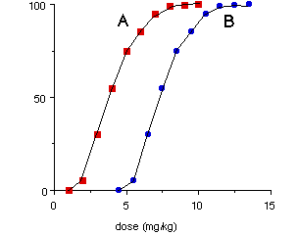
- What is the LD₅₀ of graph A?

- What is the threshold dose for graph A?

- What is the LD₅₀ of graph B?

- What is the threshold dose for graph B?

PART 4: GOOGLE: EPA radiation dose calculator and click on the SECOND link
What is your yearly radiation dose: ________________ mrem.
- The average American is exposed to 620 mrem are you over or under that figure?

- Copy down your radiation percent exposure WITHOUT radon using the pie chart to the right:

PART 5: Please rate the risks on a 1 to 10 scale: a ten being an activity or event which you perceive as a great risk, not to yourself, but, to the average citizen of the United States, and a one being an activity or event which you perceive as a minor risk to the average citizen of the United States:
 | Natural disasters | Structure fires | Drowning | Driving an automobile | Drinking tap water | Tobacco use | Bicycling | Indoor air pollution | Outdoor air pollution | Alcohol use | Medical X-rays | Flying commercial airlines | Being overweight | Pesticide residues on food | Terrorism | AIDS | Living with a smoker | Toxic waste | Drug abuse | Living in poverty
You Think
Actual Risk

Conclusion Questions:
- Identify one ingredient in the product you use on a daily basis that is the most toxic to your health and you should stop buying immediately:

- Research the LD₅₀ of that ingredient:

- How is LD₅₀ different from ED₅₀?

